**Python for Bioinformatics**

Exercise 1

**I-Title: Programs demonstrating use of Data types, Operators**

1.     W.a.p for demonstrating the usage of built-in number functions in Python

Answer: Some of the Built-in Number Functions in python are-

Algorithm:-

Step1→ start

Step2→ usage of built-in number functions in Python

Step3→stop

1. max = The largest of its arguments: the value closest to positive infinity

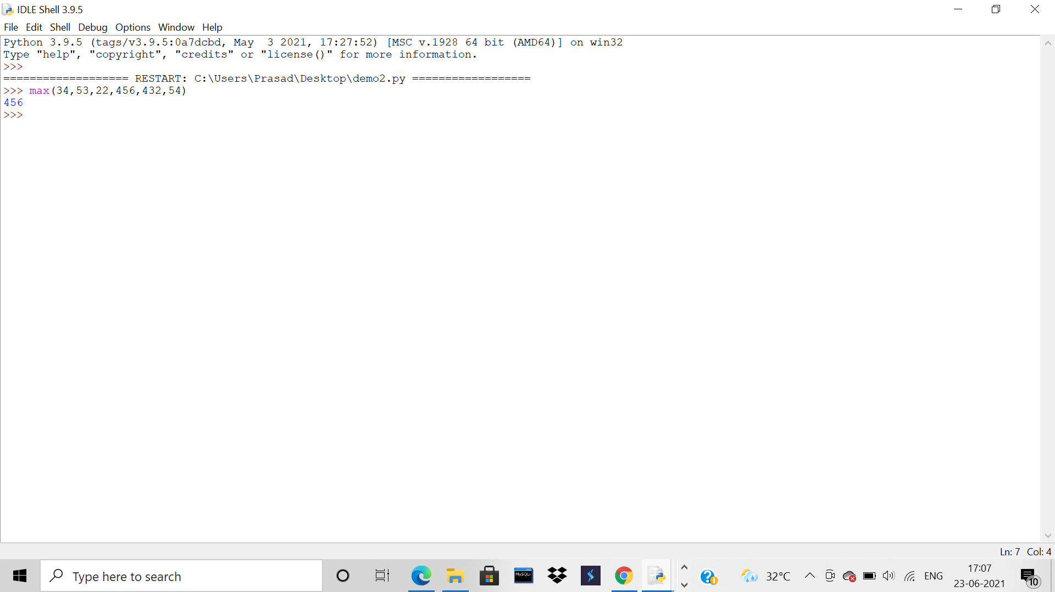

1. min = The smallest of its arguments: the value closest to negative infinity

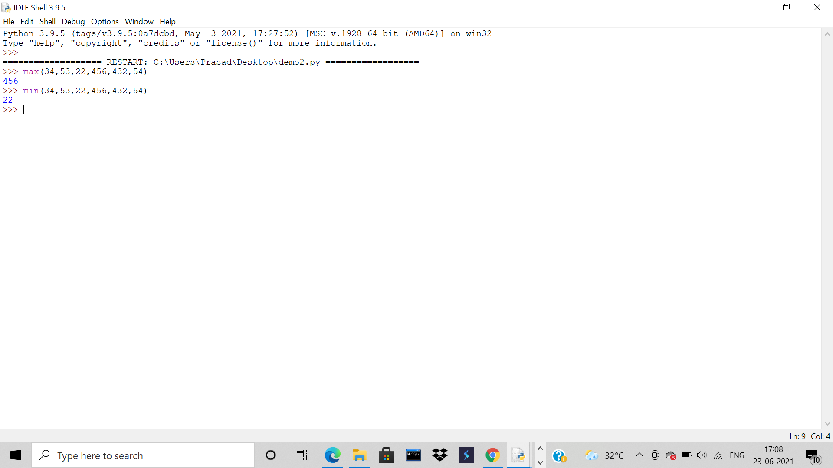

1. round = x rounded to n digits from the decimal point. Python rounds away from zero as a tie-breaker: round(0.5) is 1.0 and round(-0.5) is -1.0.

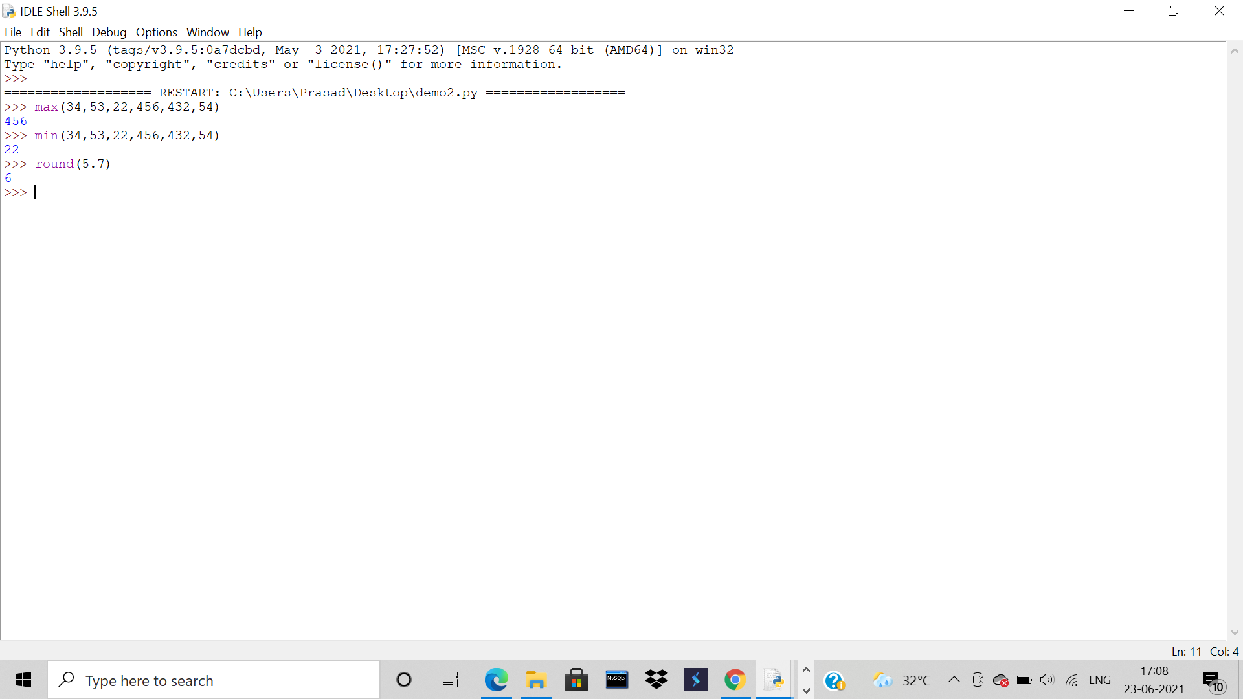

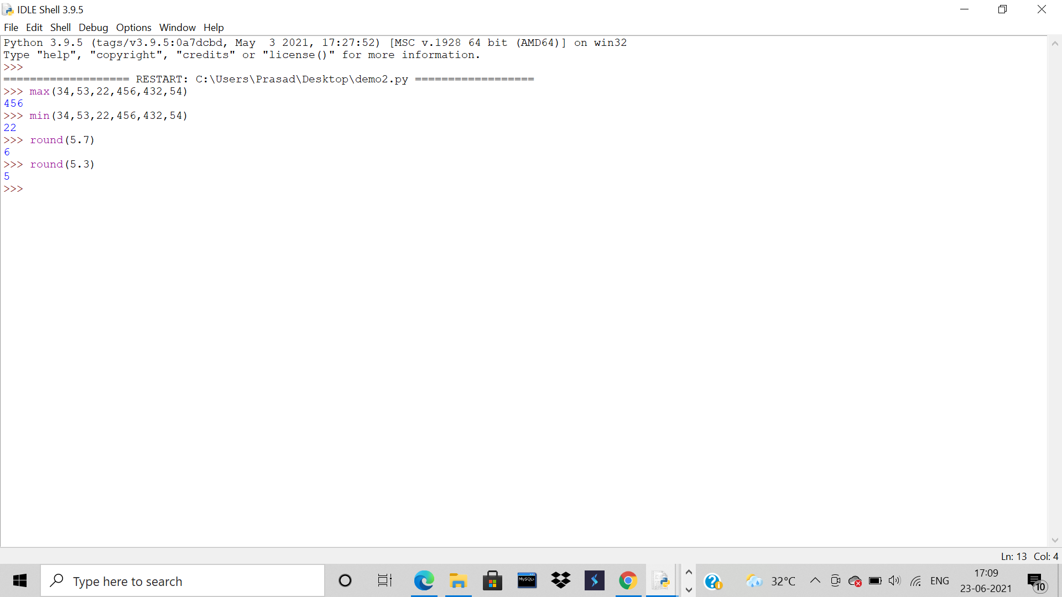

2.     W.a.p for demonstrating the usage of escape characters in strings.

Algorithm:-

Step1→ start

Step2→Using escape characters before special characters

Step3→stop

Answer: To insert characters that are illegal in a string, use an escape character. An escape character is a backslash \ followed by the character you want to insert. So basically, placing a ‘\’ in front of one of these special or reserved characters will tell Python to just treat it as text, ensuring your code is valid and behaves as you’d expect.

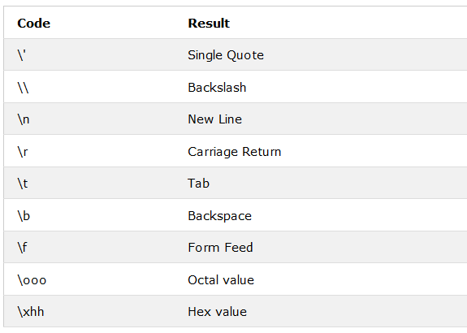

1. Code = \n

Algorithm:-

Step1→ start

Step2→Using escape characters before special characters

Step3→stop

Output: \n is used to print word on next line.

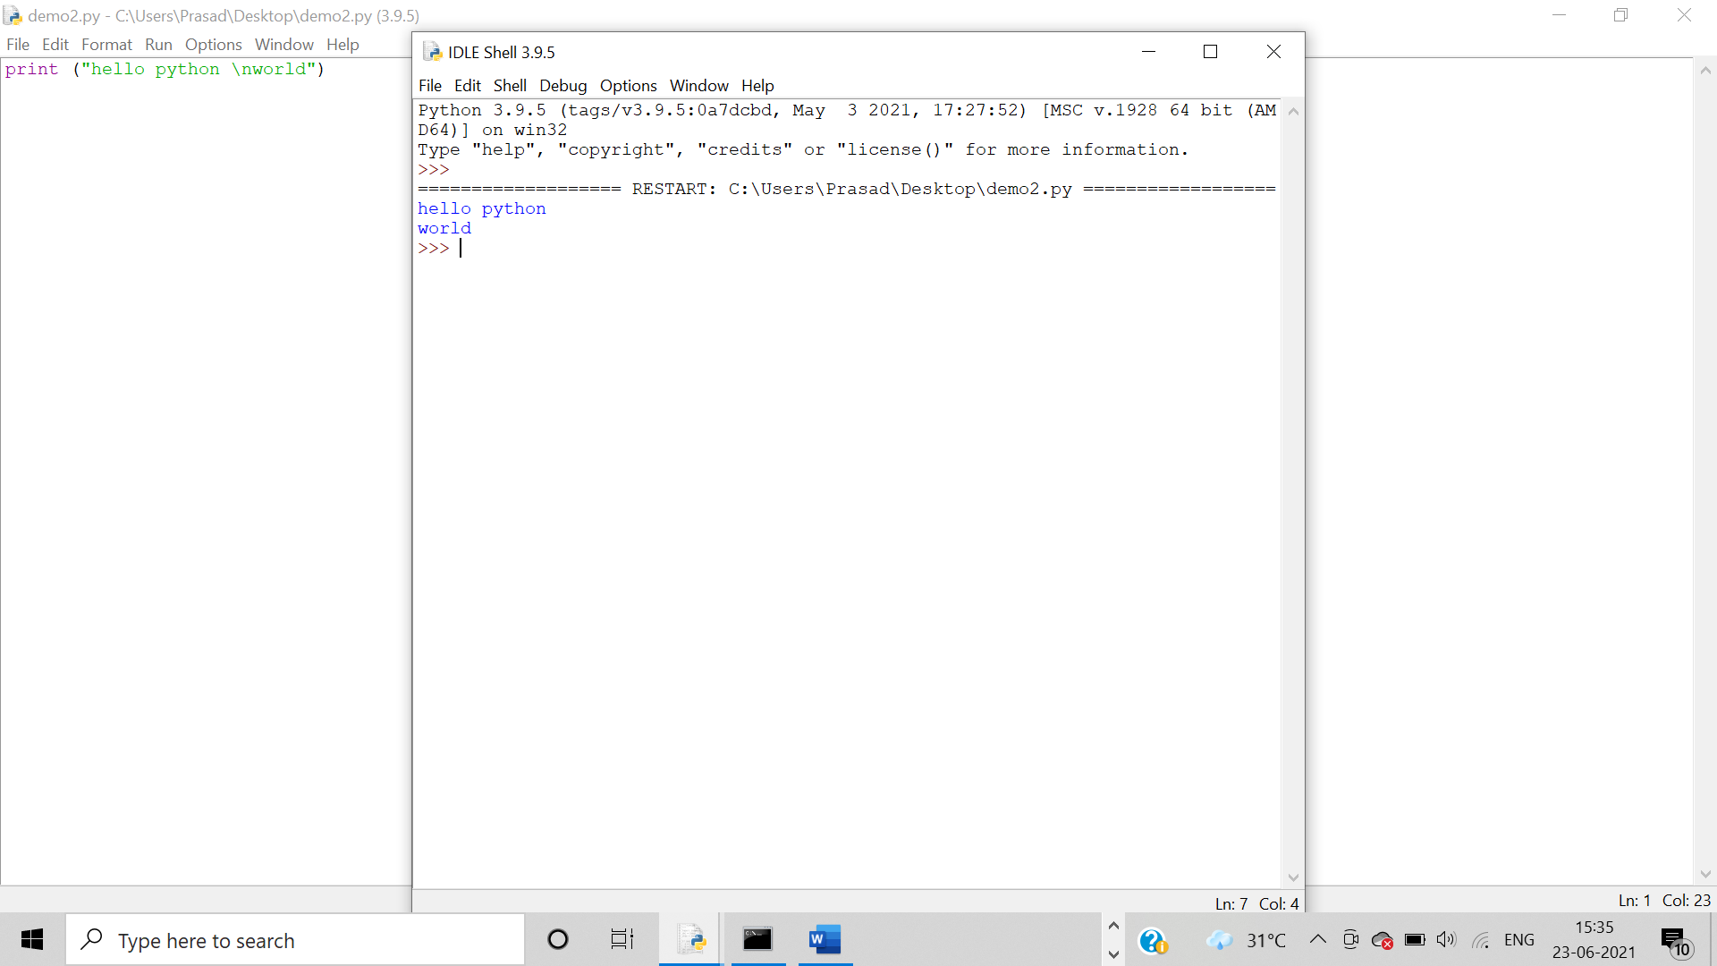

1. Code = \\

Algorithm:-

Step1→ start

Step2→Using escape characters before special characters

Step3→stop

Output: **\\**is used to print a single backslash.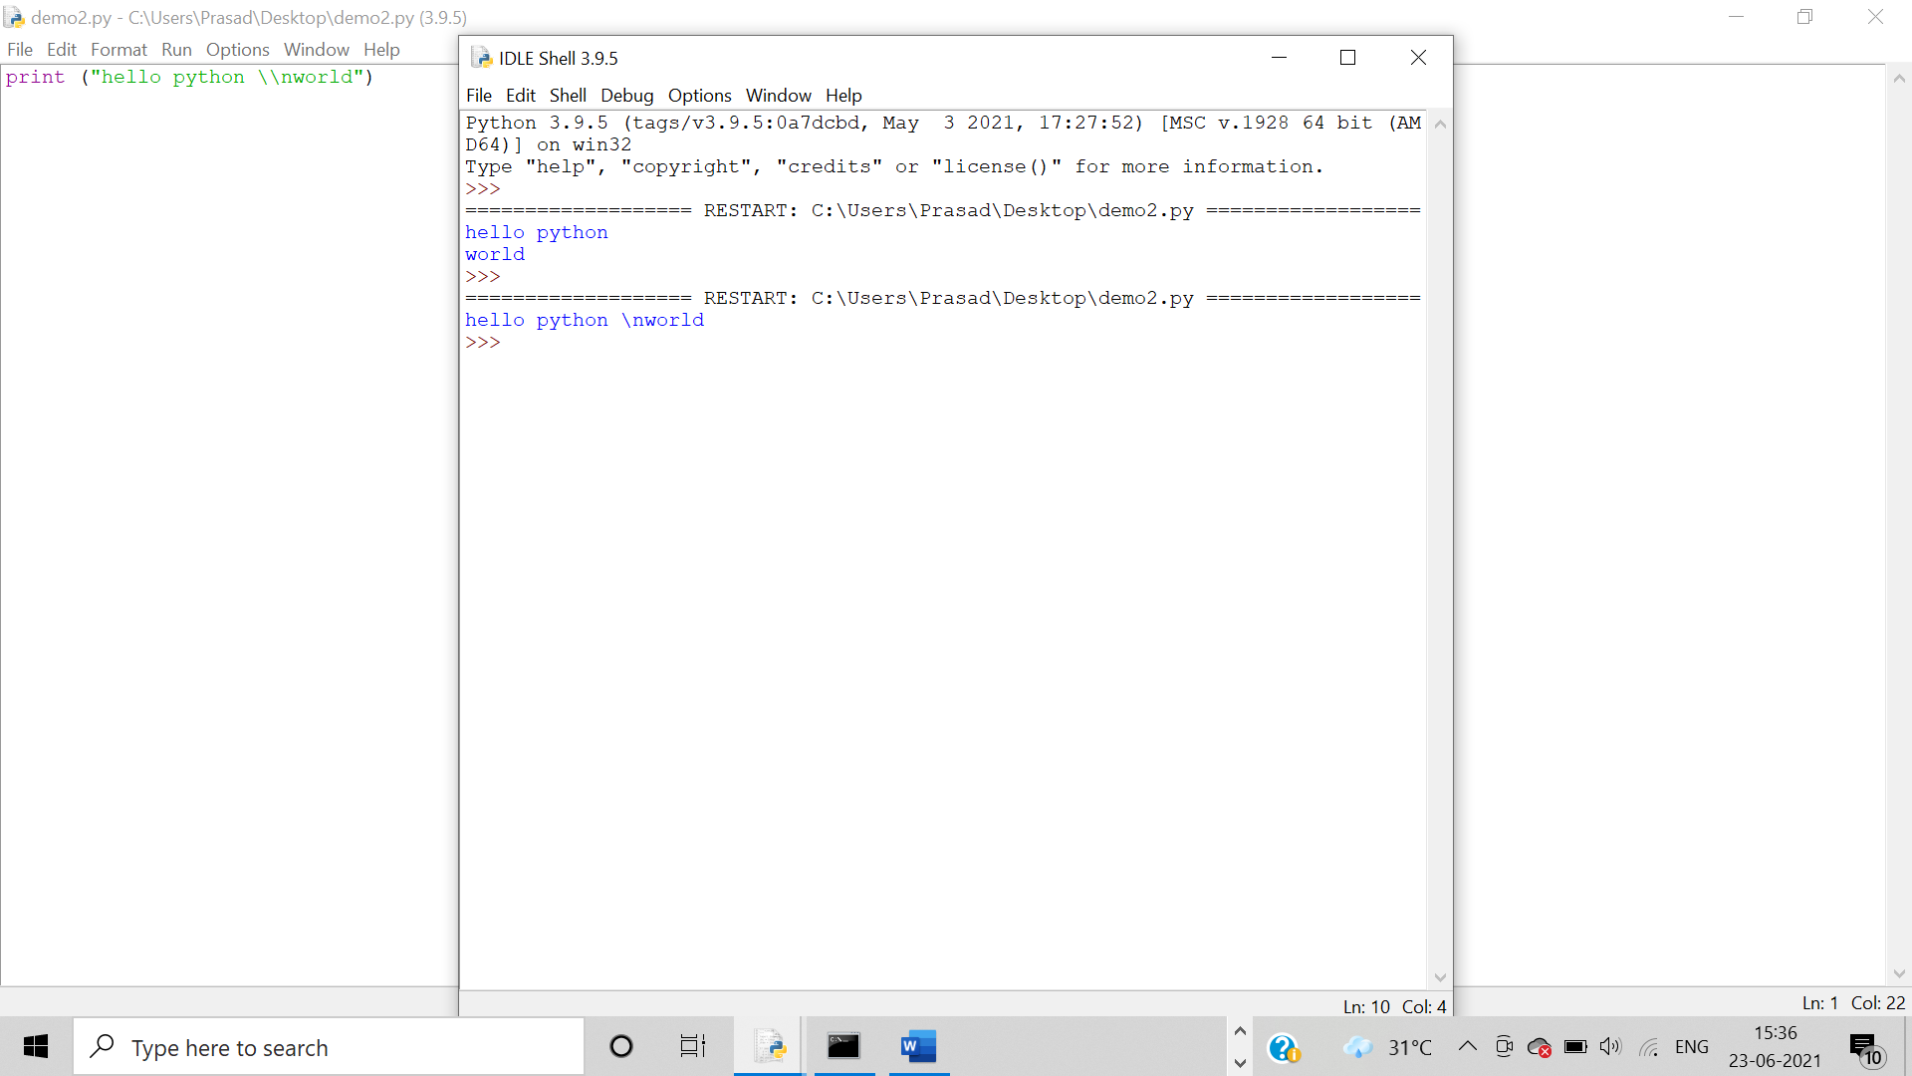

1. Code = \

Algorithm:-

Step1→ start

Step2→Using escape characters before special characters

Step3→stop

Output:

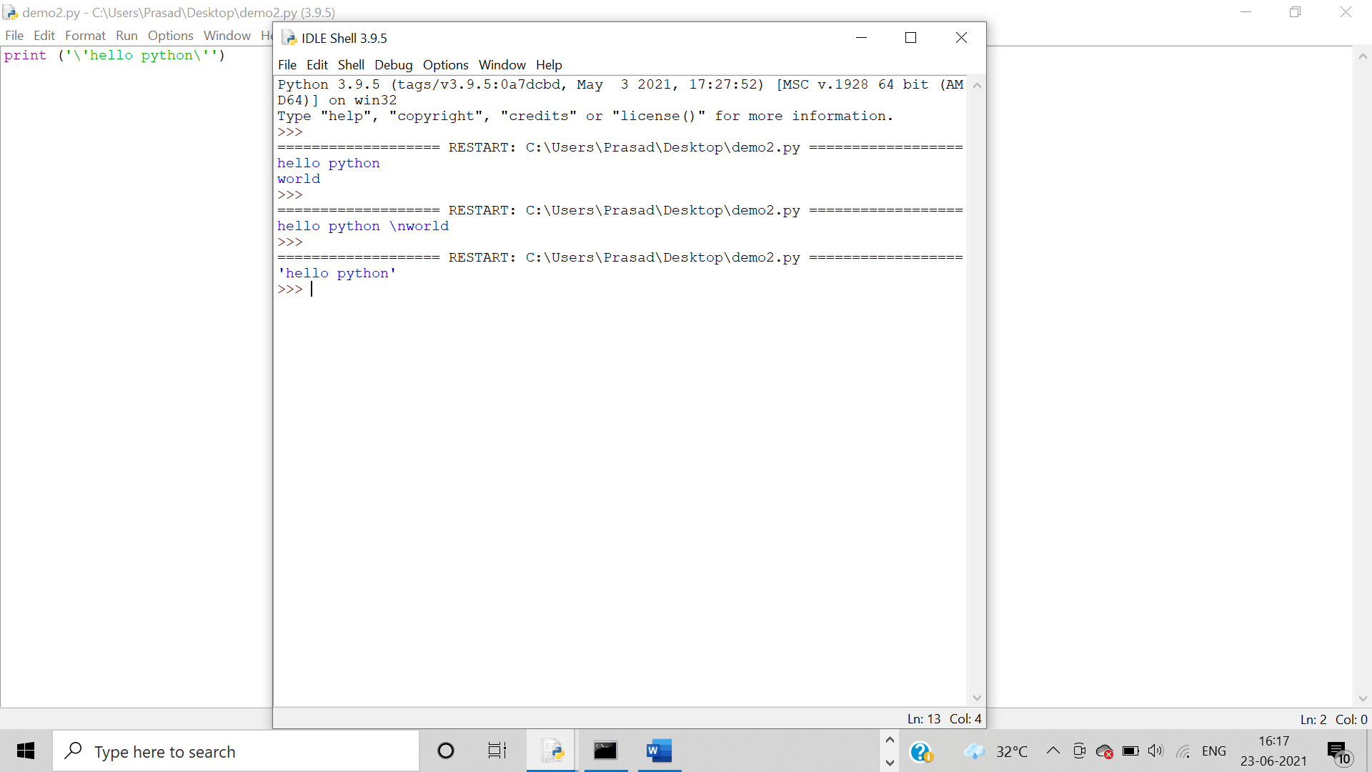

1. Code =\t

Algorithm:-

Step1→ start

Step2→Using escape characters before special characters

Step3→stop

Output: **“\t”** is usedto get space between the words.

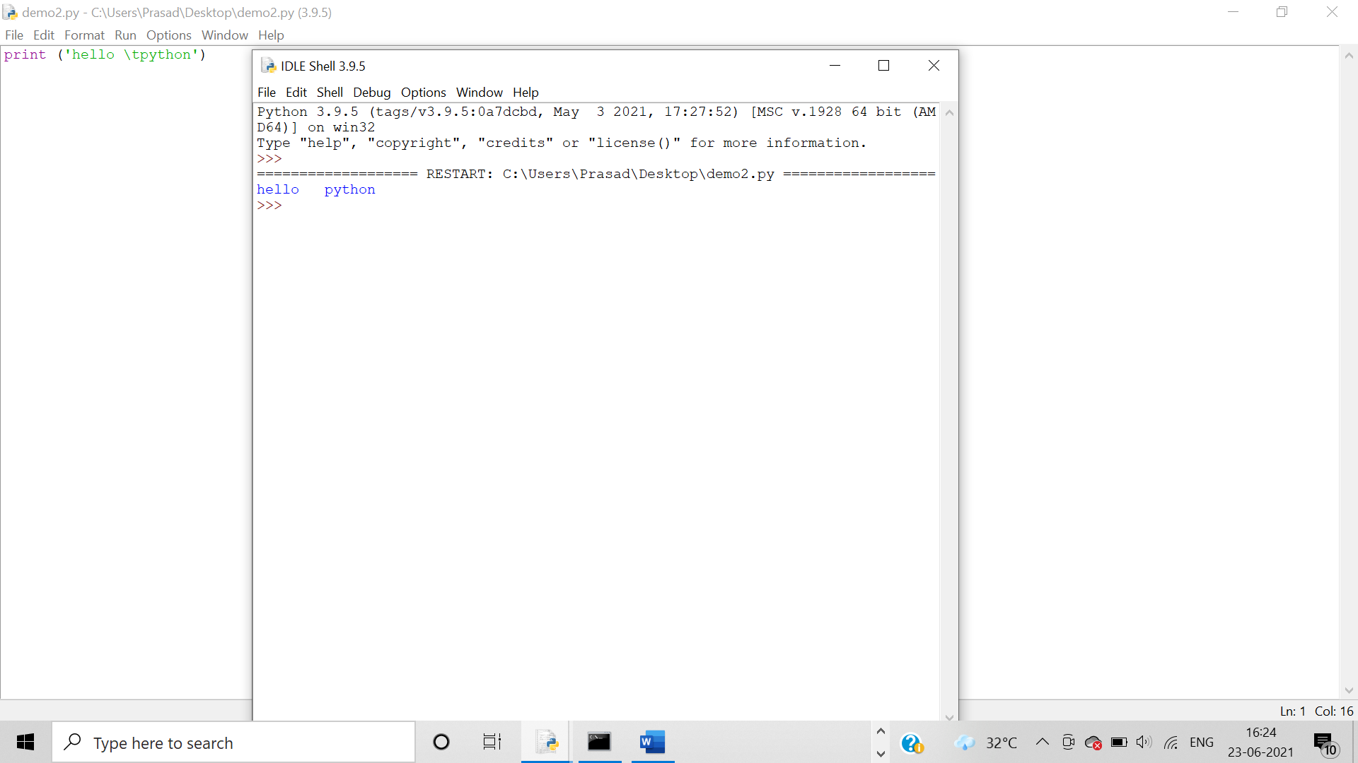

1. Code = \b

Algorithm:-

Step1→ start

Step2→Using escape characters before special characters

Step3→stop

Output: **“\b”**is usedto remove the space between the words in Python.

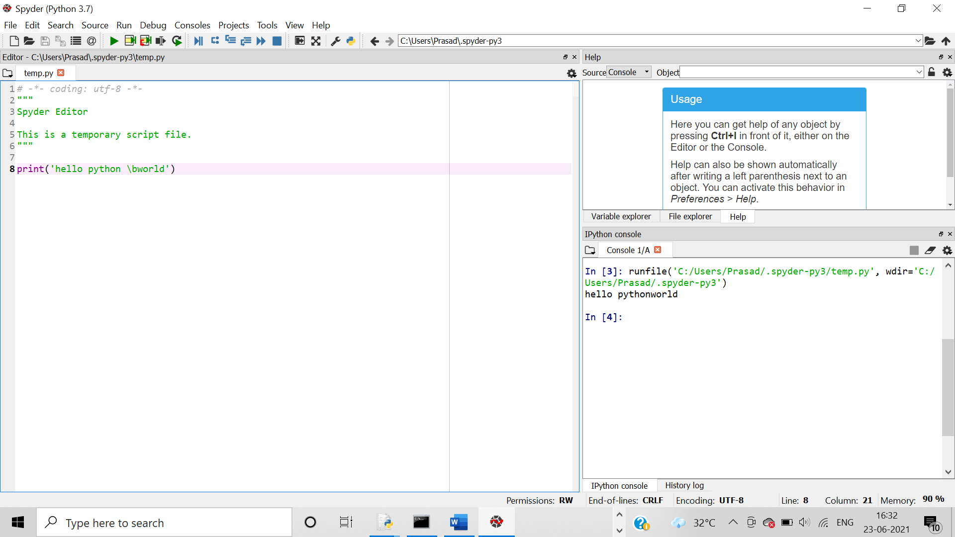

1. Code = \r Carriage return

Algorithm:-

Step1→ start

Step2→Using escape characters before special characters

Step3→stop

Output:

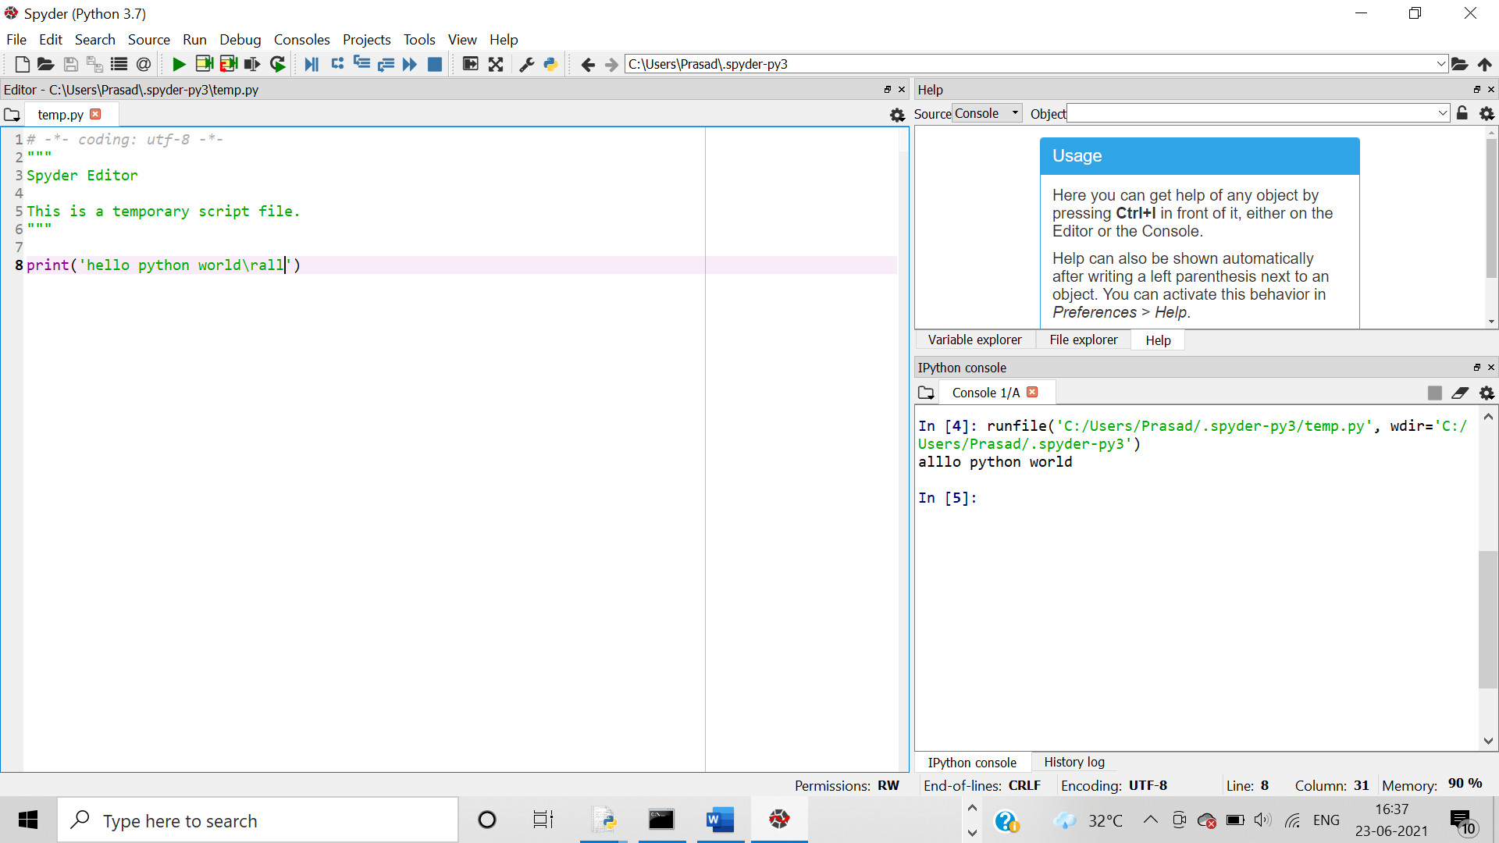

1. Code = \ooo Octal Values (\110\145\154\154\157)

Algorithm:-

Step1→ start

Step2→Using escape characters before special characters

Step3→stop

Output:

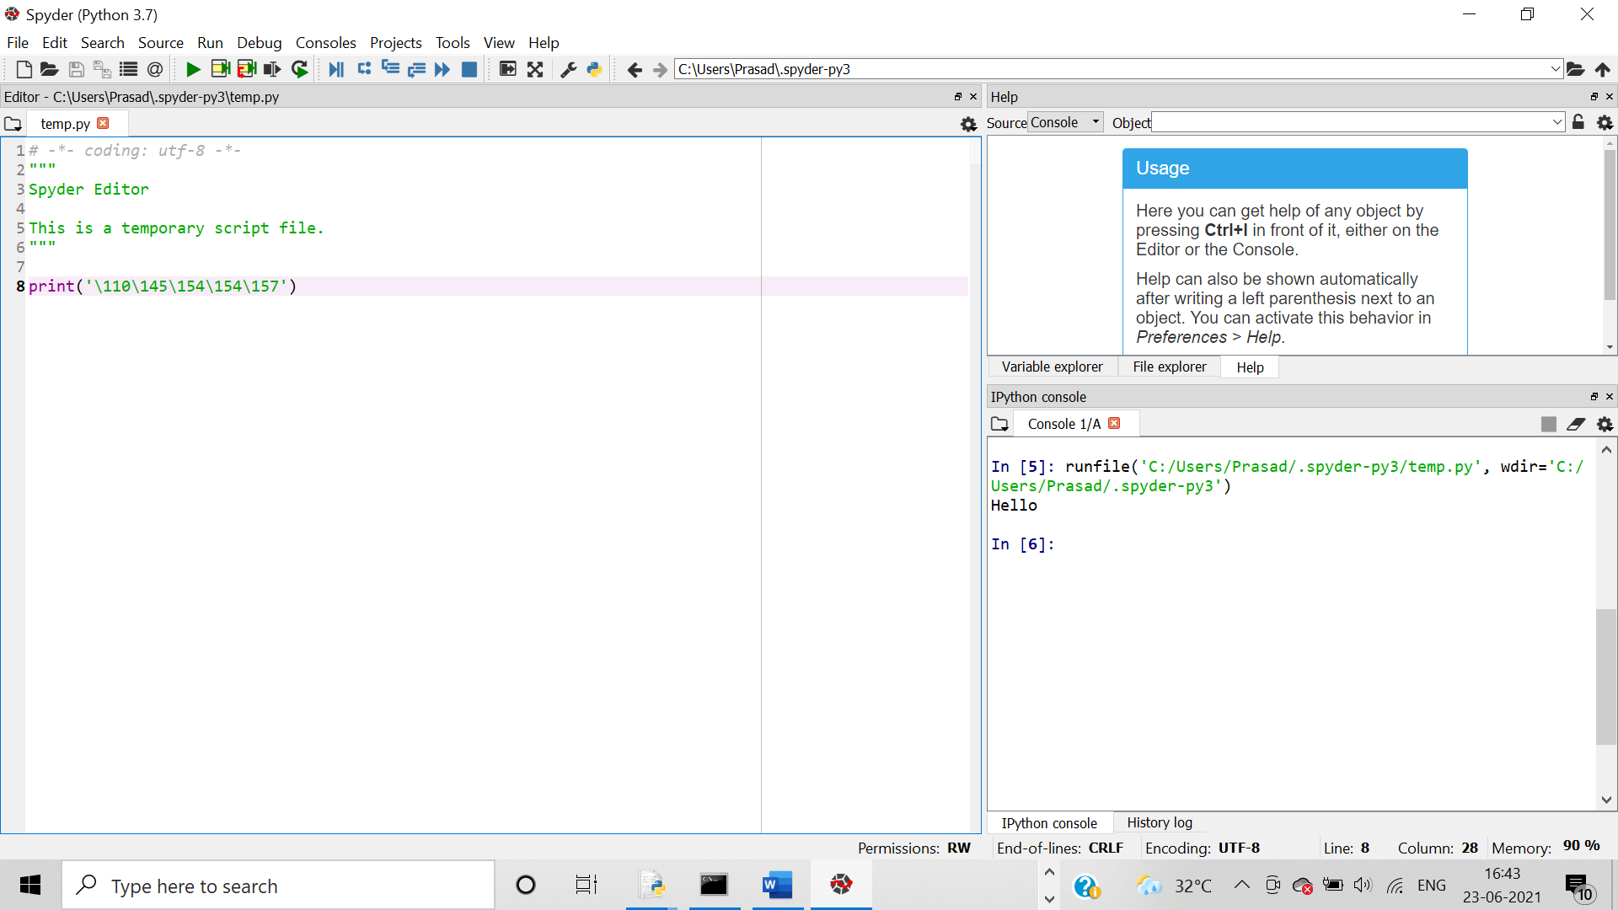

1. Code = \xhh Hex value (\x48\x65\x6c\x6c\x6f)

Algorithm:-

Step1→ start

Step2→Using escape characters before special characters

Step3→stop

Output:

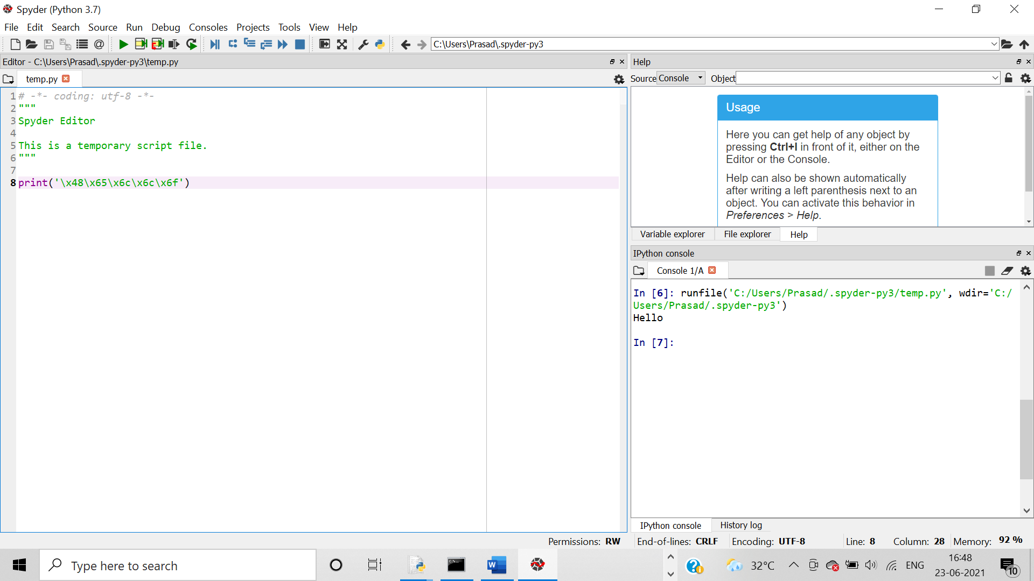

3.     W.a.p for demonstrating the usage of string function and string operators

Algorithm

Step1→ start

Step2→initialize a=string,b=string

Step3→print(a+b),print(a*b),print(a[2]),print(b[1:3])

Step4→print i,j,a

Step5→stop

Output:-

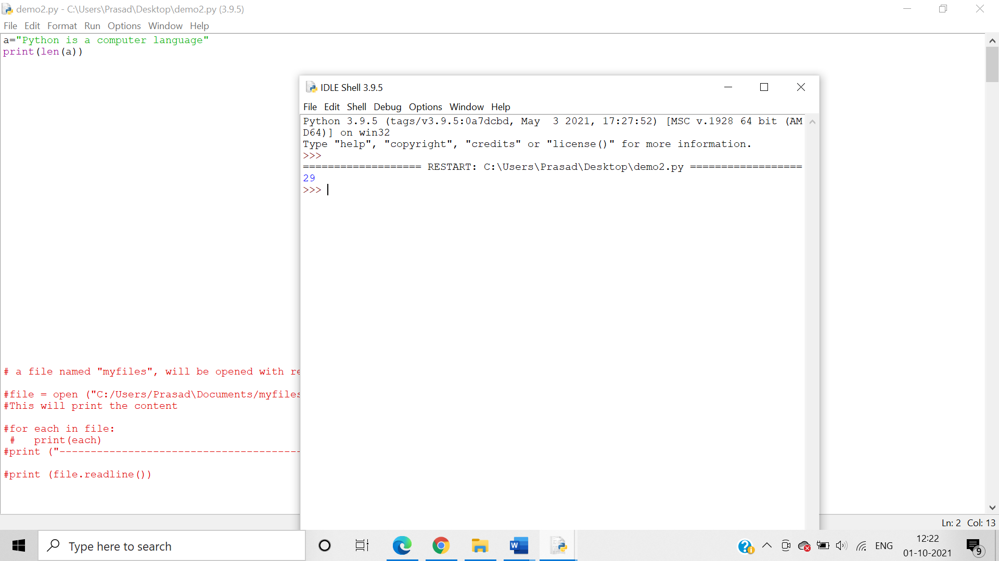

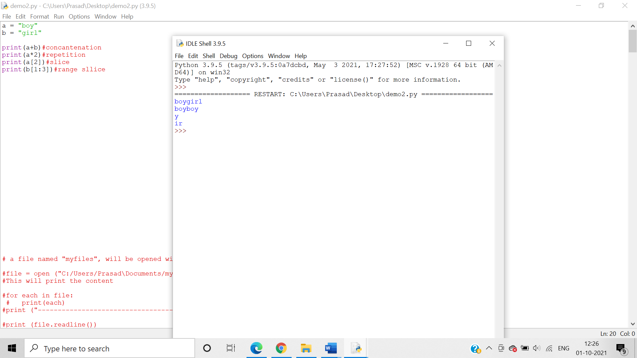

4.     W.a.p for demonstrating the usage of format method

Algorithm

Step1→ start

Step2→initialize a =”string{}”,b=integer

Step3→print(a.format(b))

Step4→stop

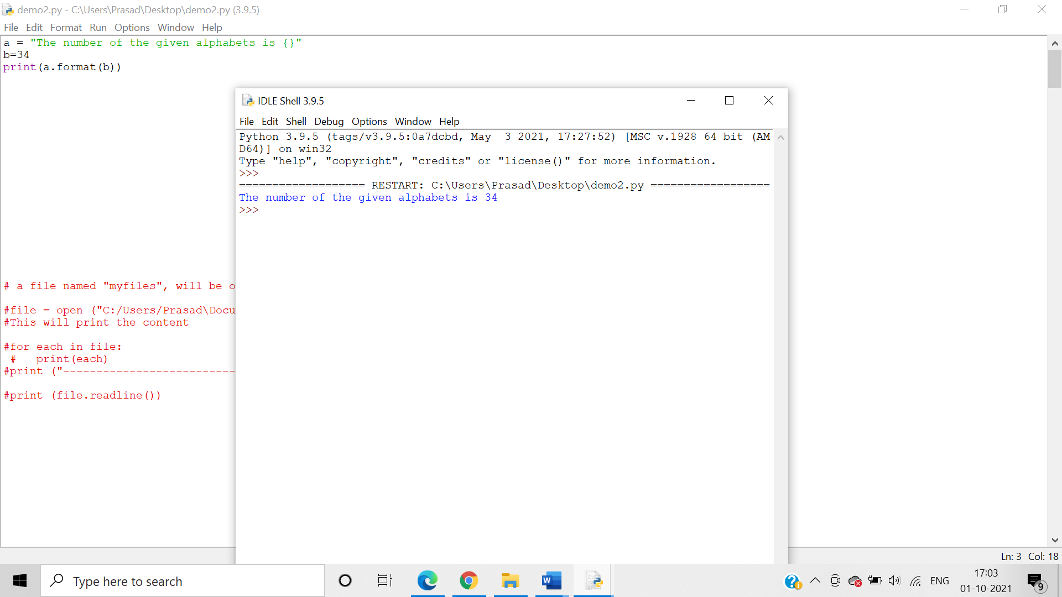

Write set of programs for demonstrating the usage of following String Methods along with its variants-

1. capitalize(), lower(), upper(), title(), casefold(), swapcase()

Algorthim:- Use the capitalize(), lower(), upper(), title(), casefold(), swapcase() string methods to alter and modify the given strings.

* capitalize()

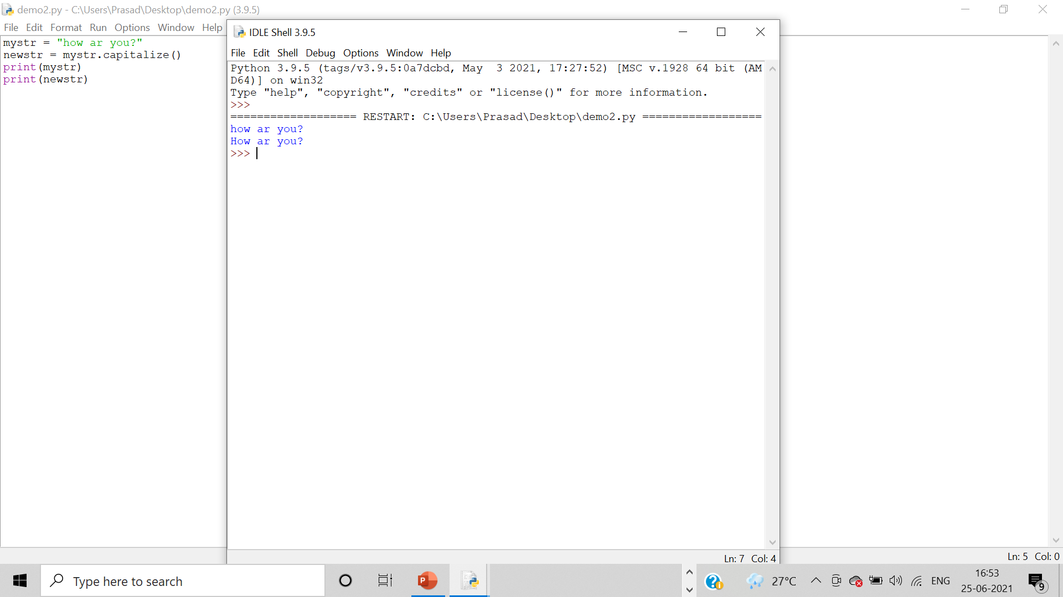

* casefold()
* lower()

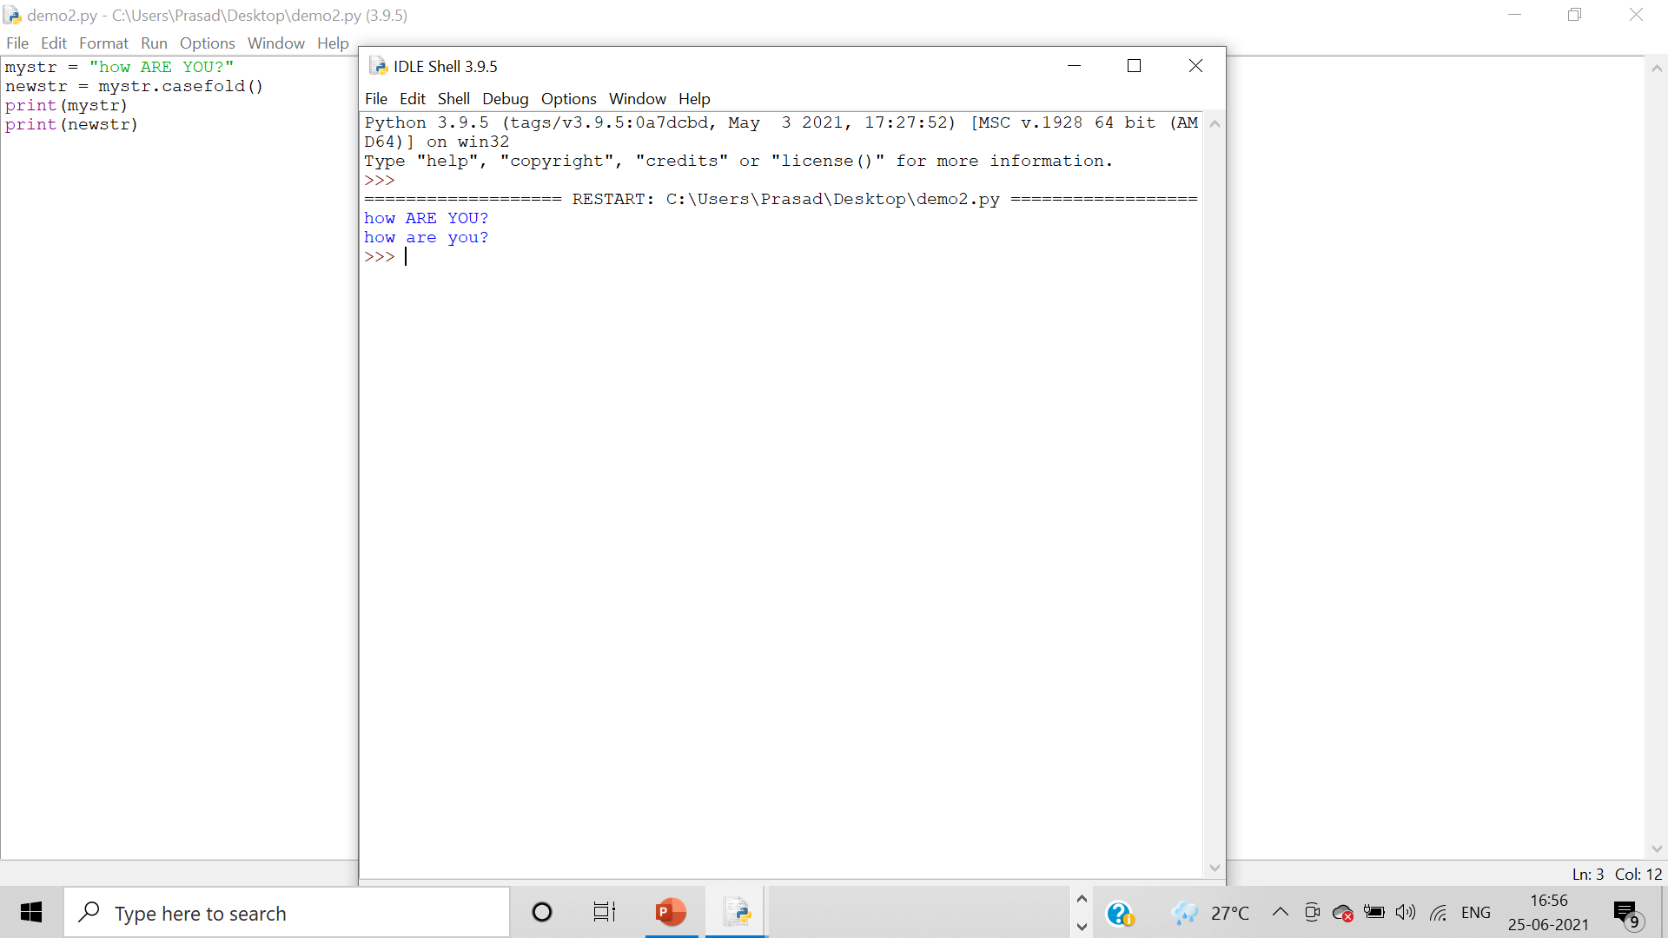

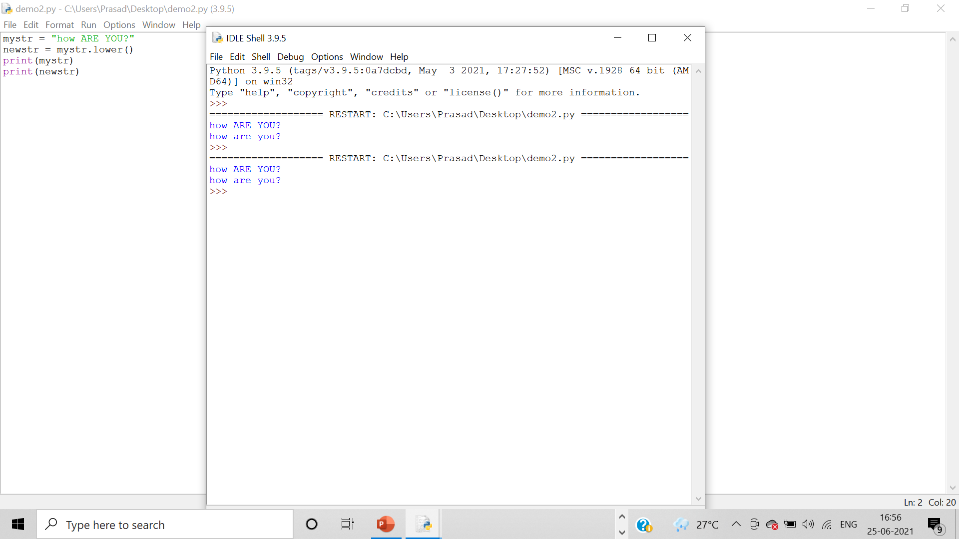

* upper()

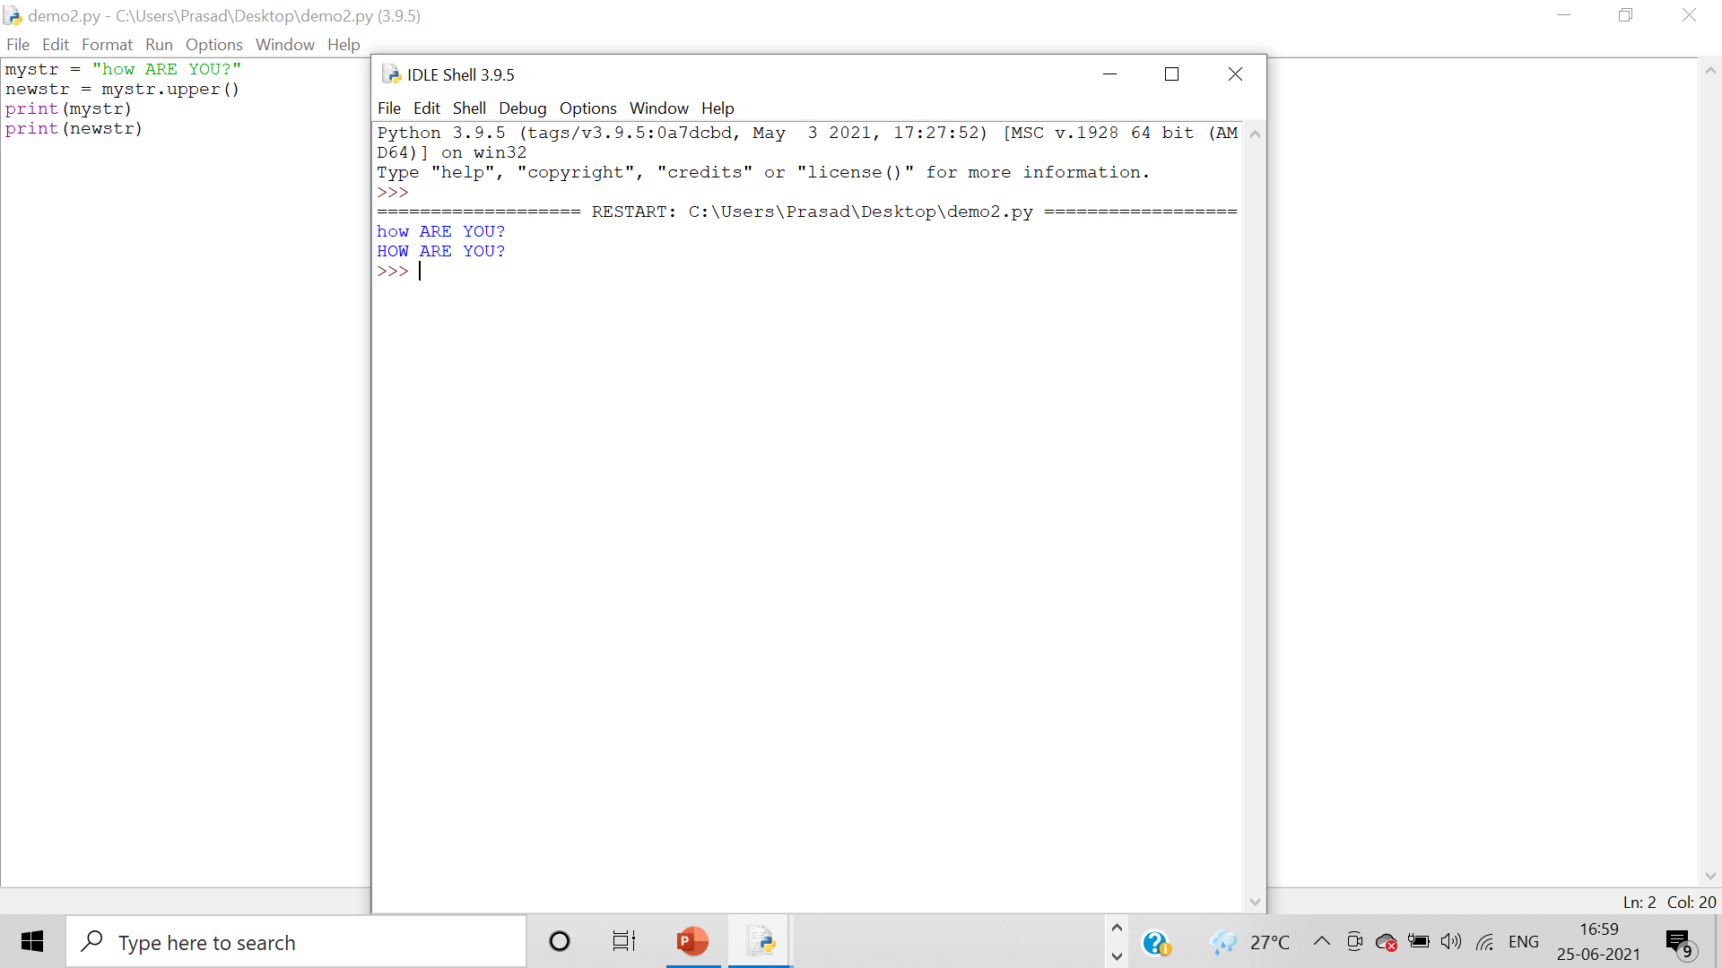

* title()

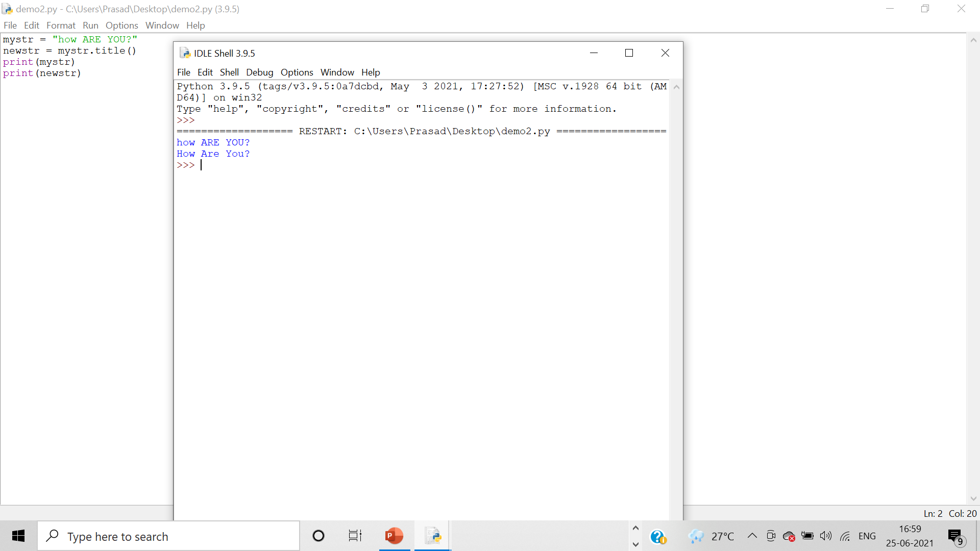

* swapcase()
* uppercase

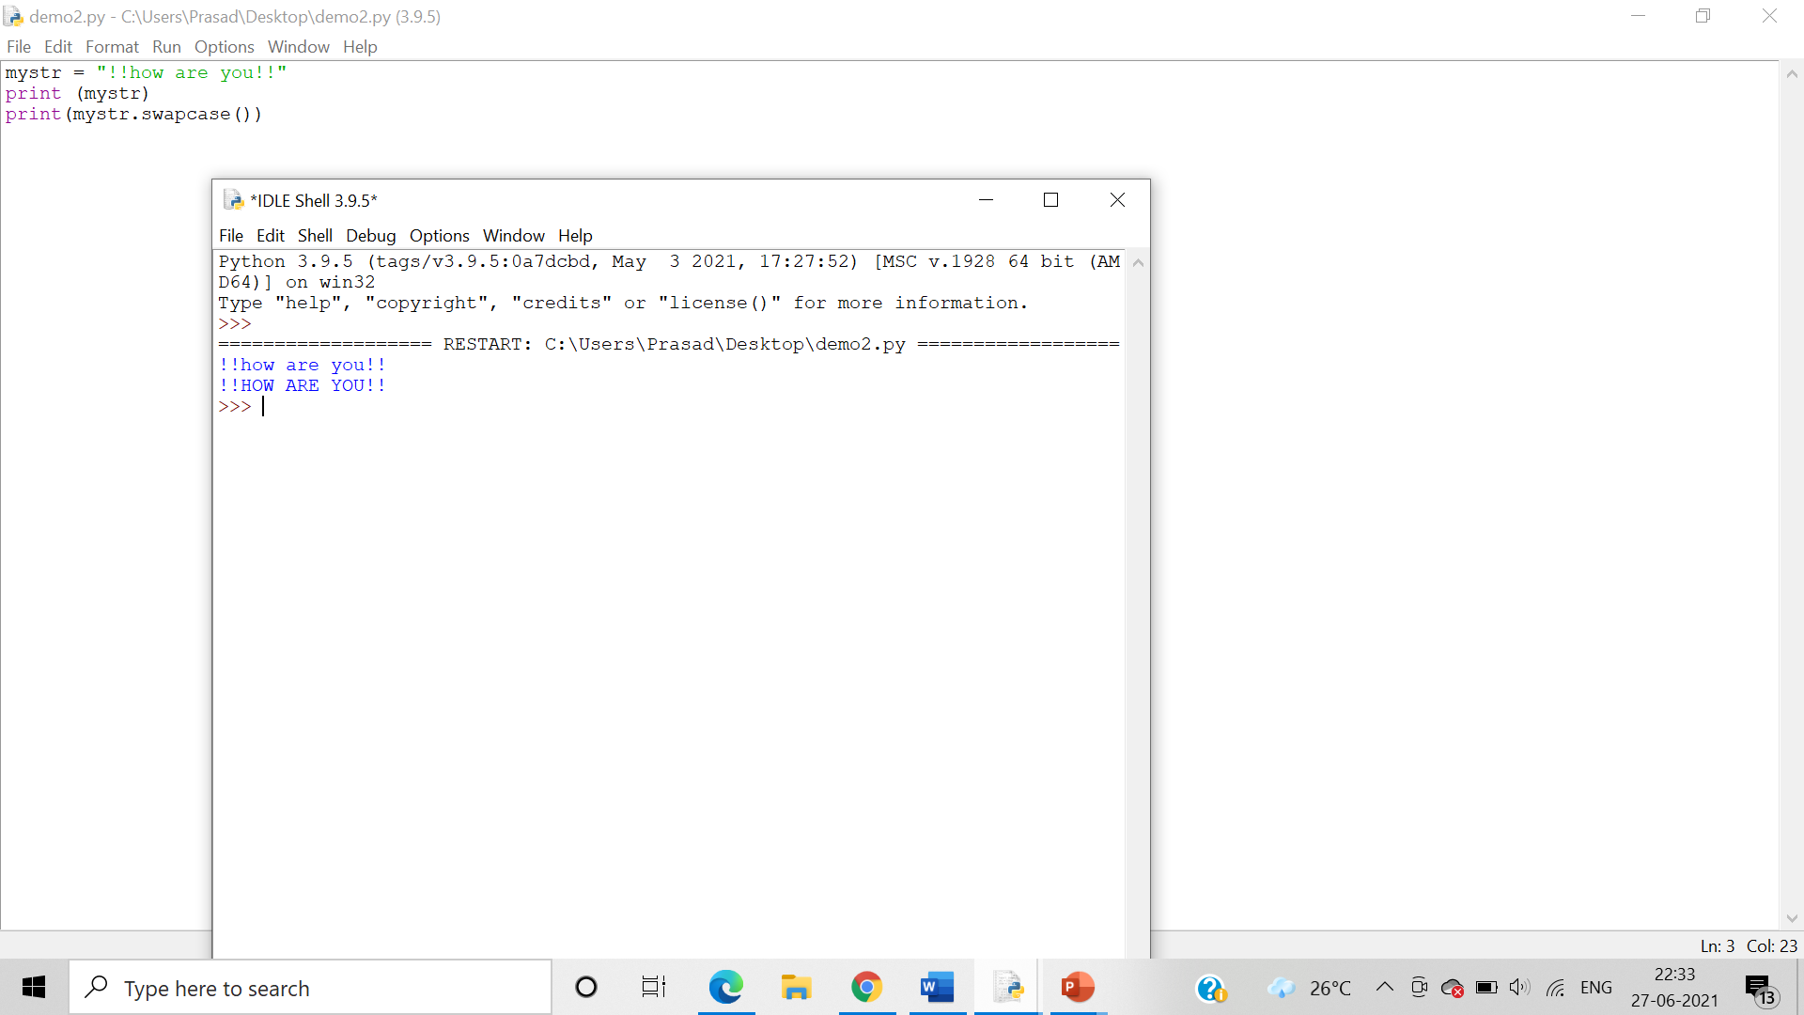

* lowercase

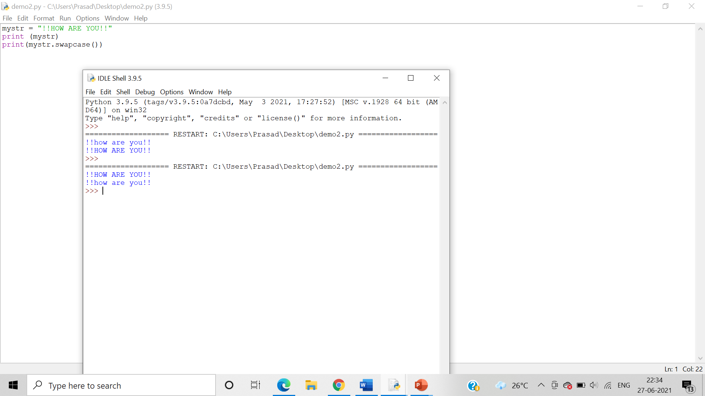

* mixed

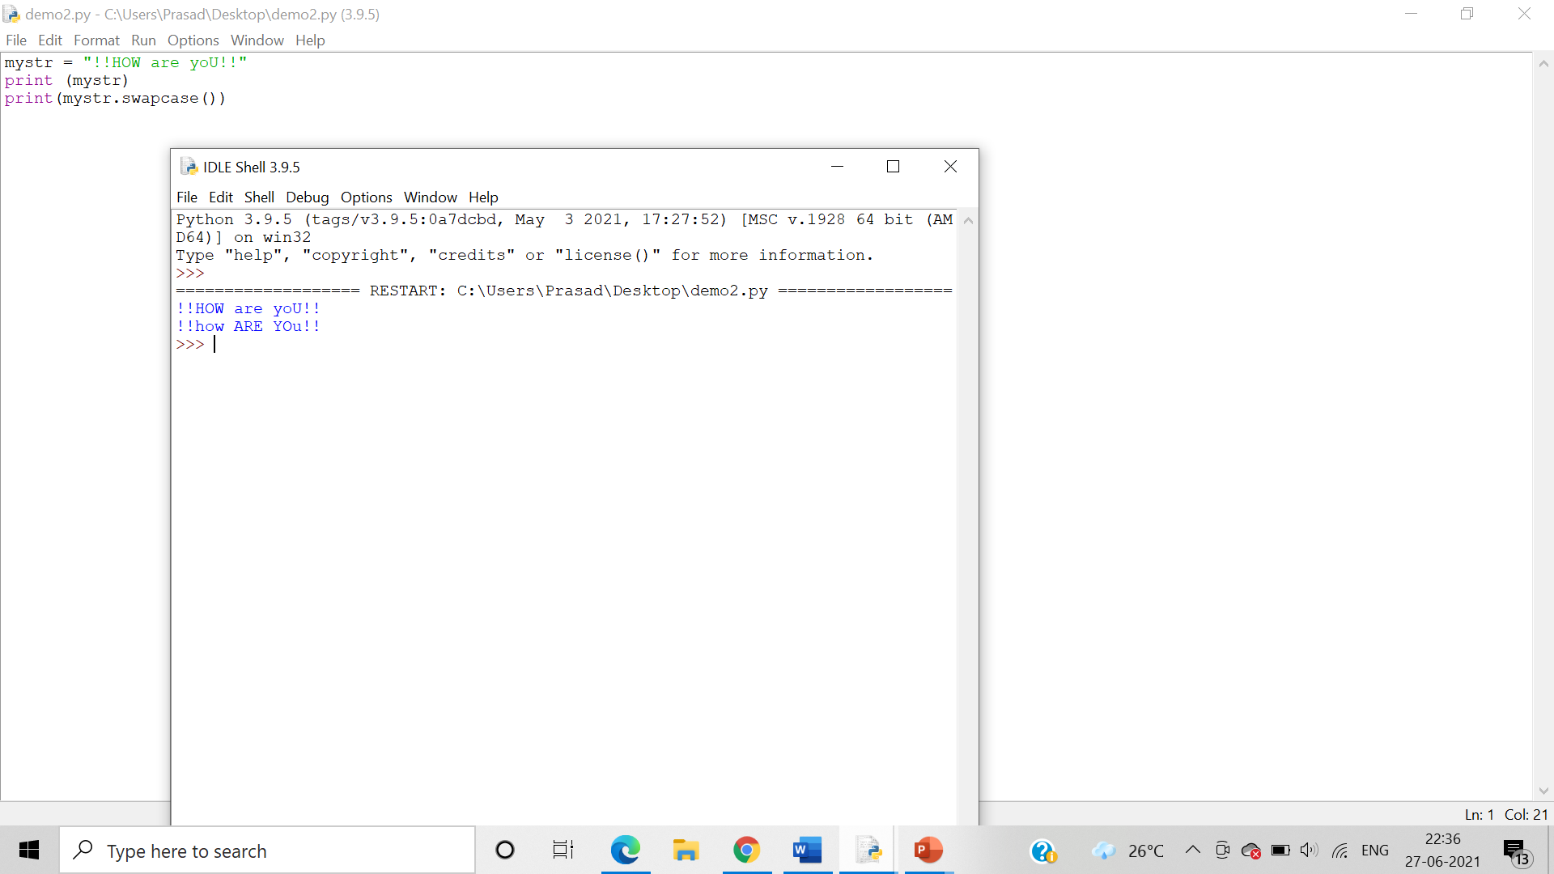

1. center(),ljust(), rjust(), zfill()

Algorithm:- Use the center(),ljust(), rjust(), zfill() string methods to alter and modify the given string.

* center()

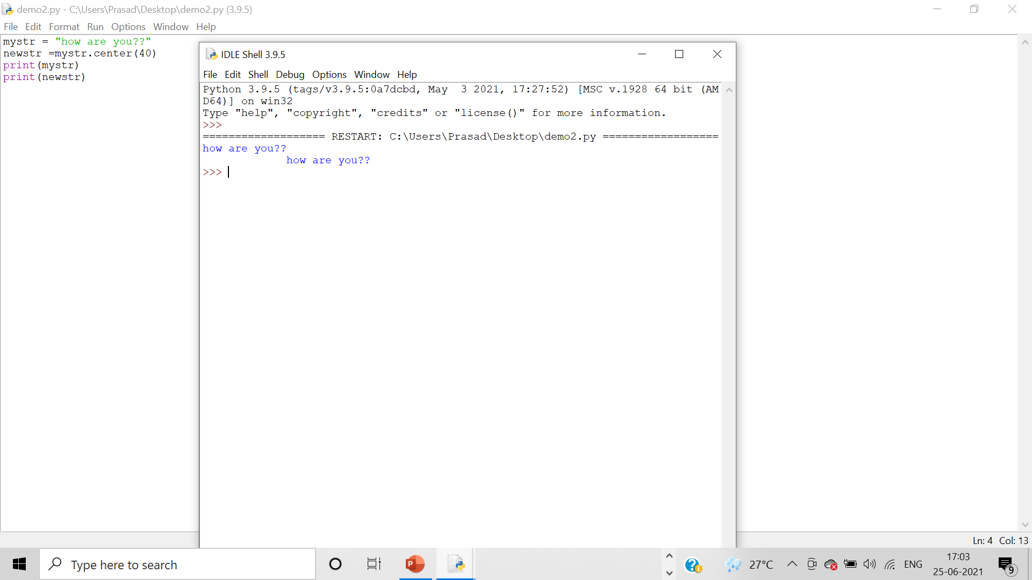

* ljust()

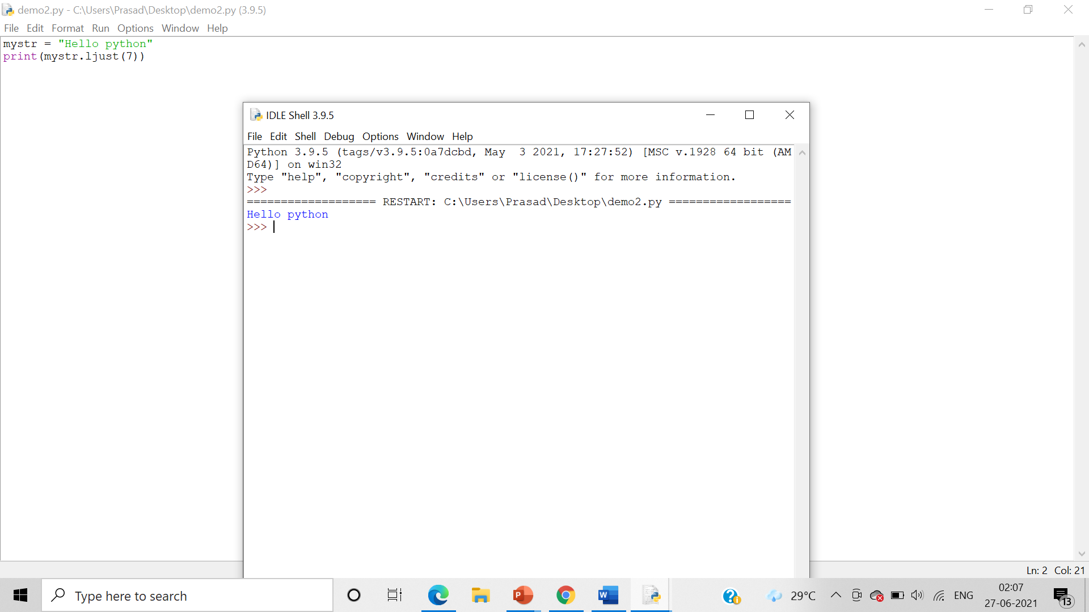

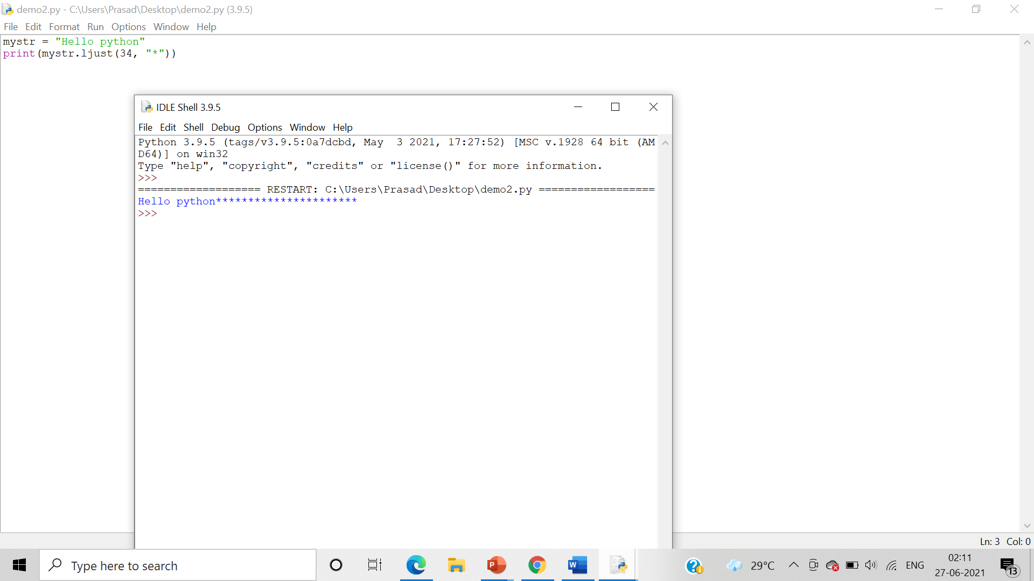

* rjust()

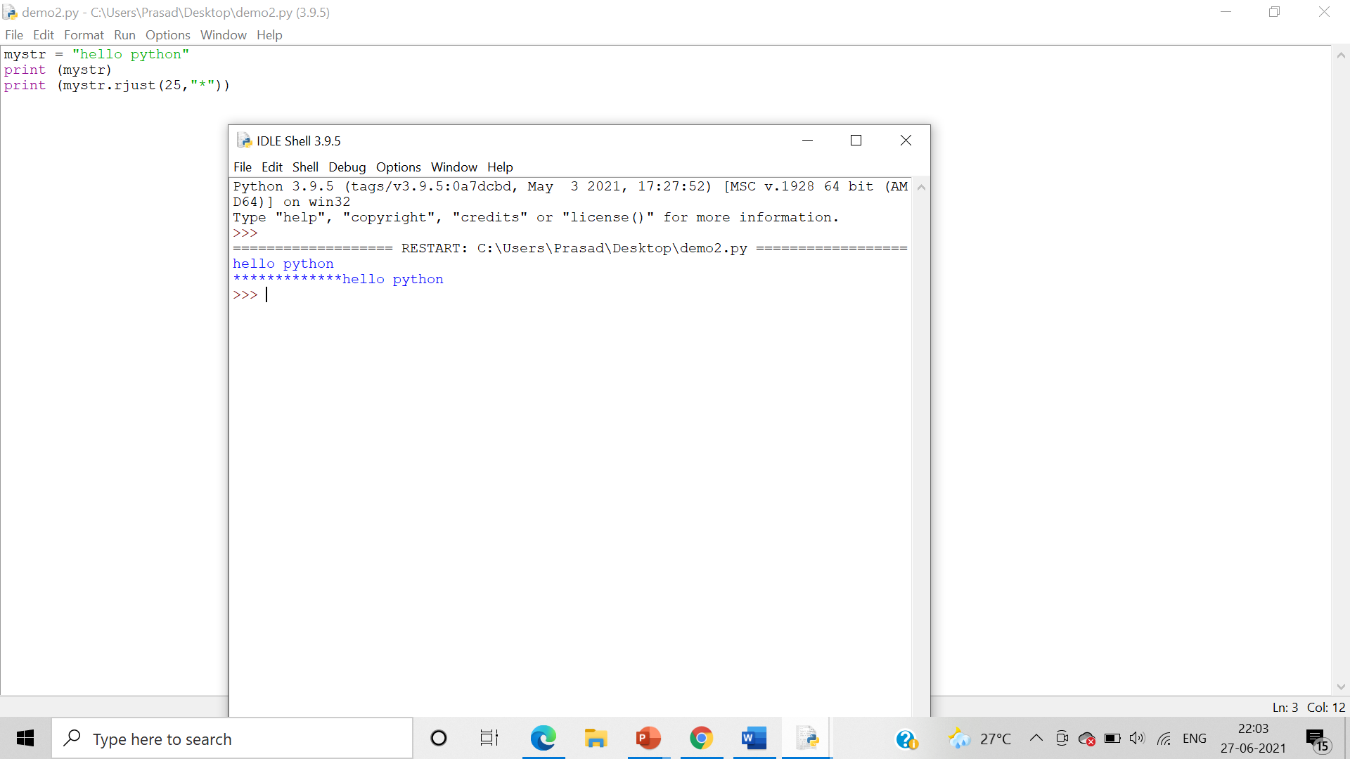

* zfill()

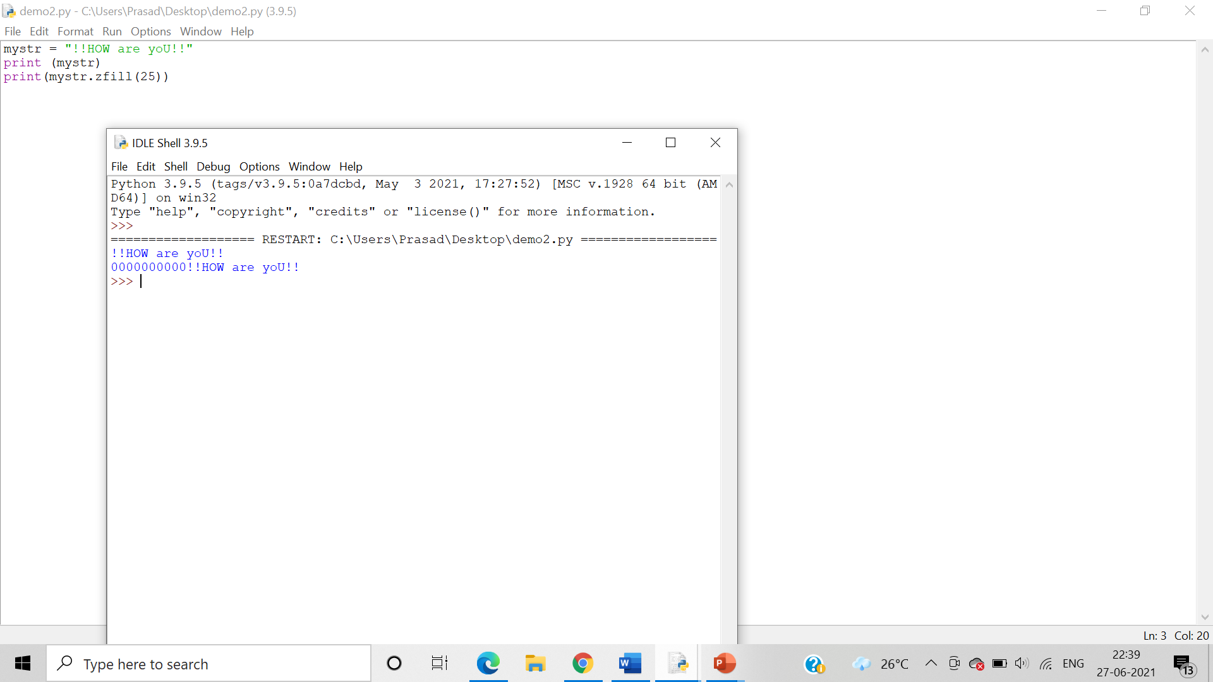

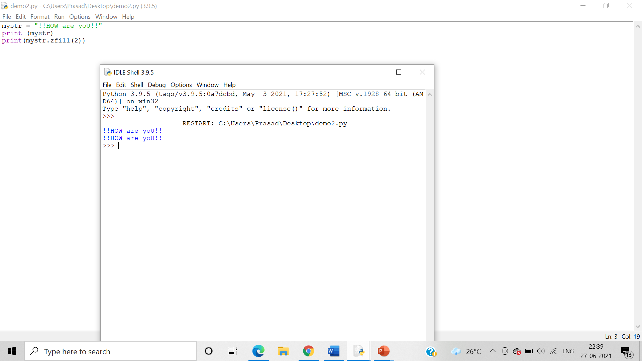

1. count(), replace()

Algorithm:- Use the count() and replace() method to alter and modify the given string.

* count()

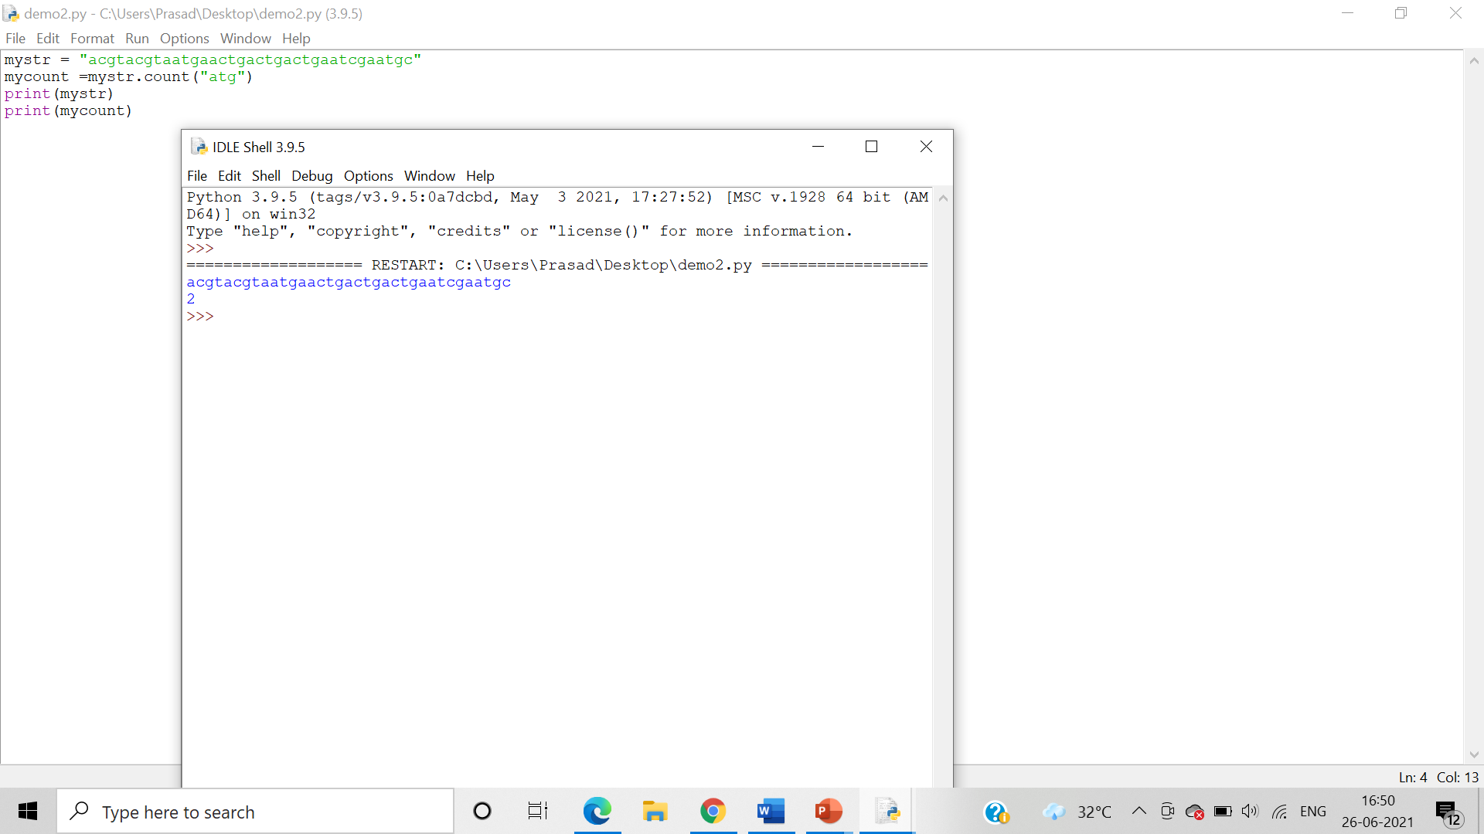

* replace()

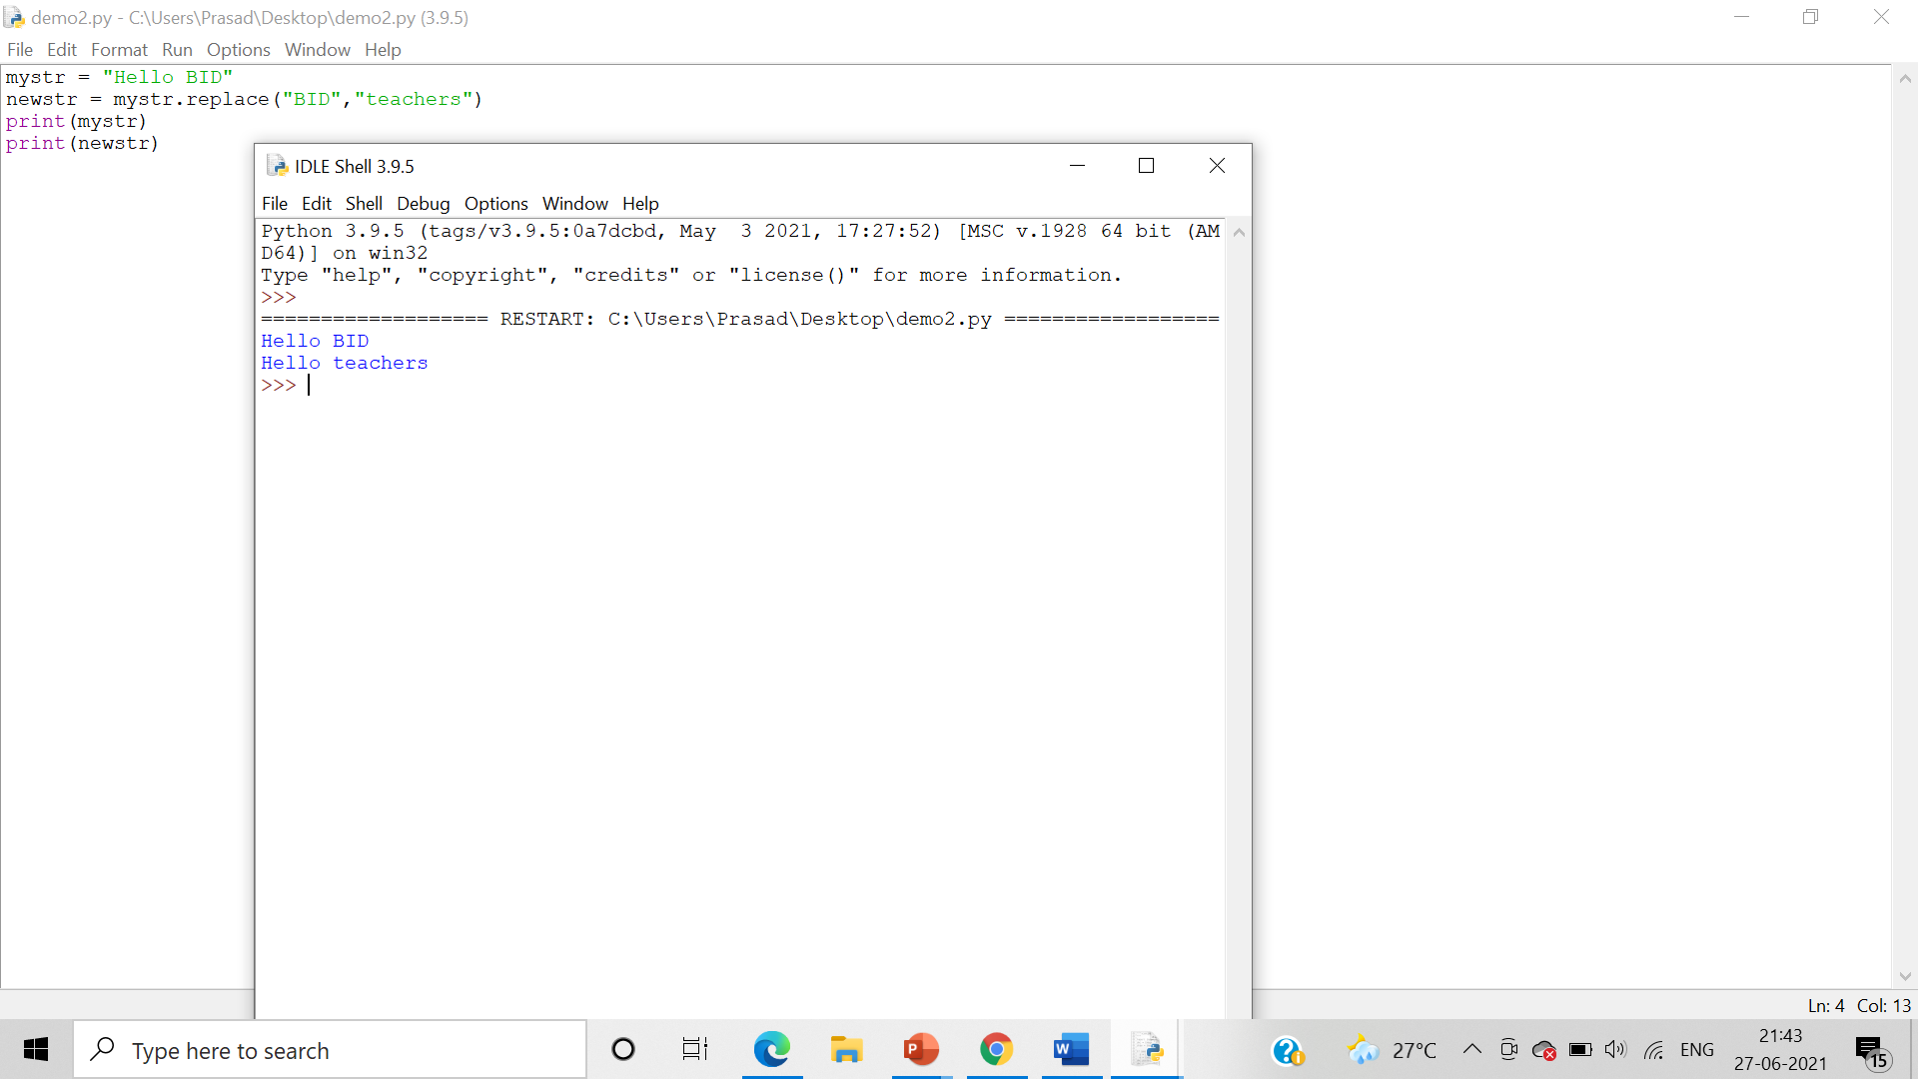

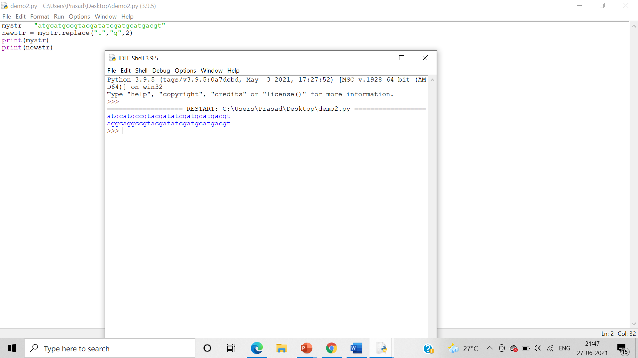

1. endswith(), startswith()

Algorithm:- Use the endswith(), startswith() methods to alter and modify the given strings.

* endswith()

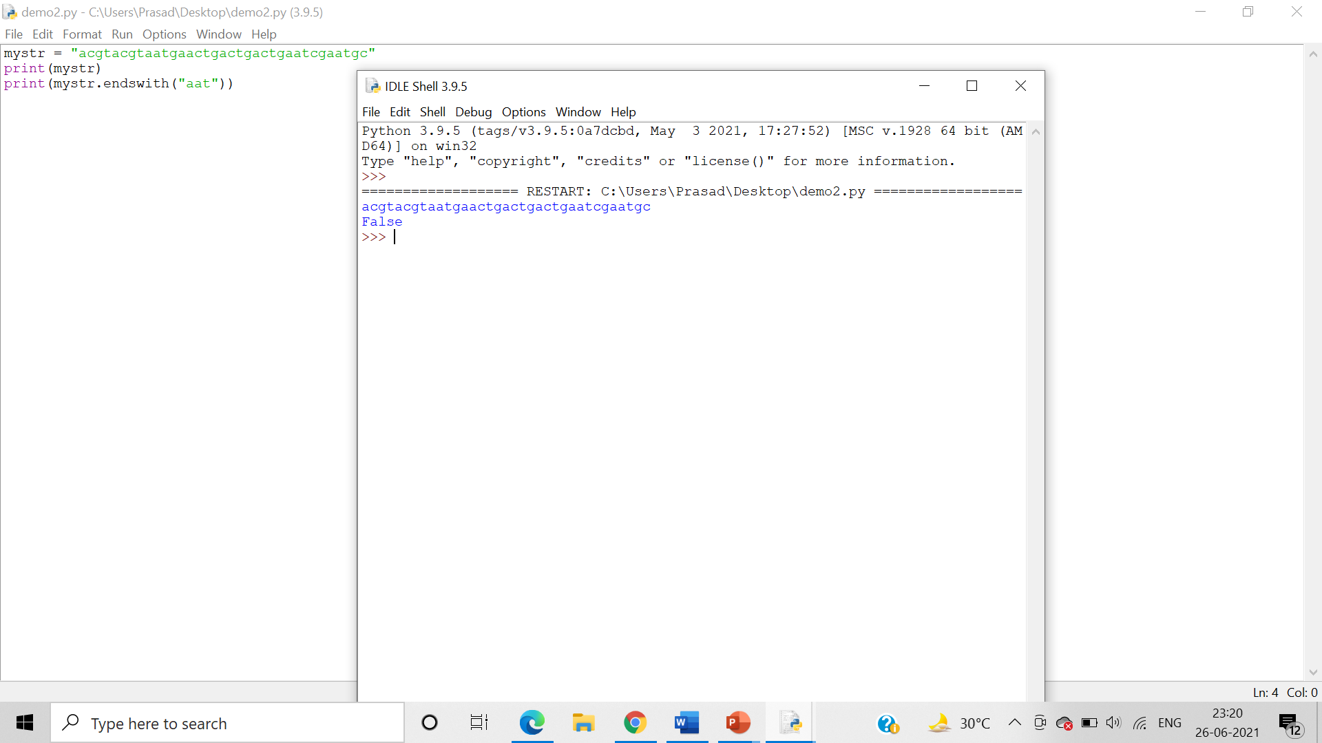

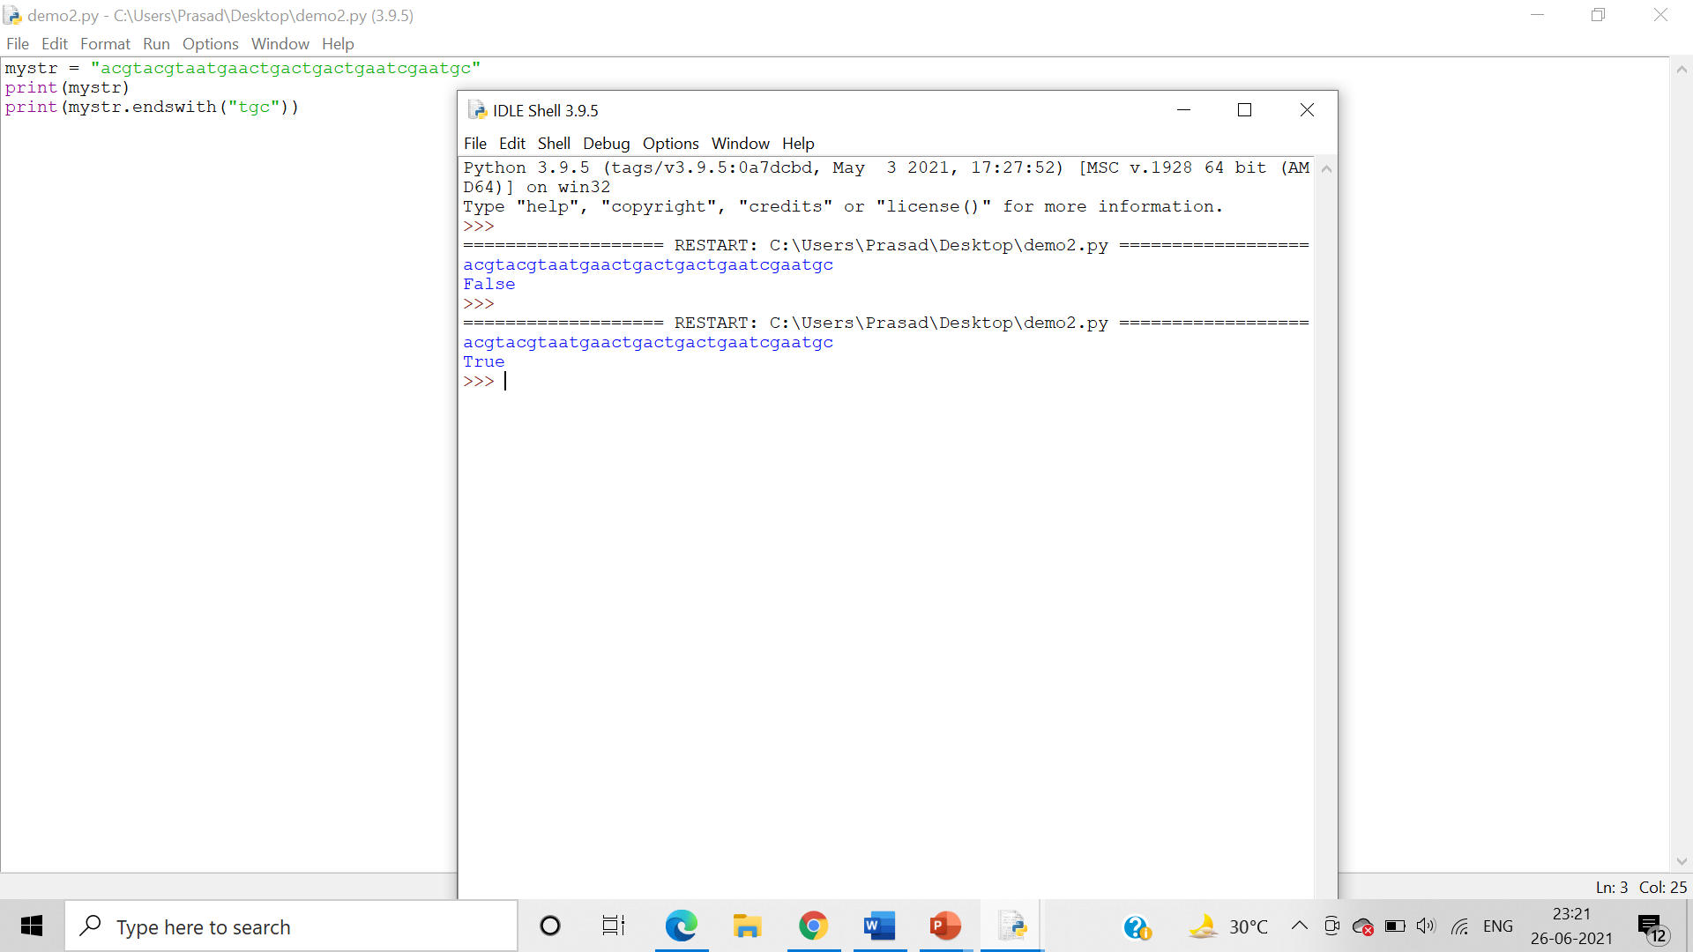

startswith()

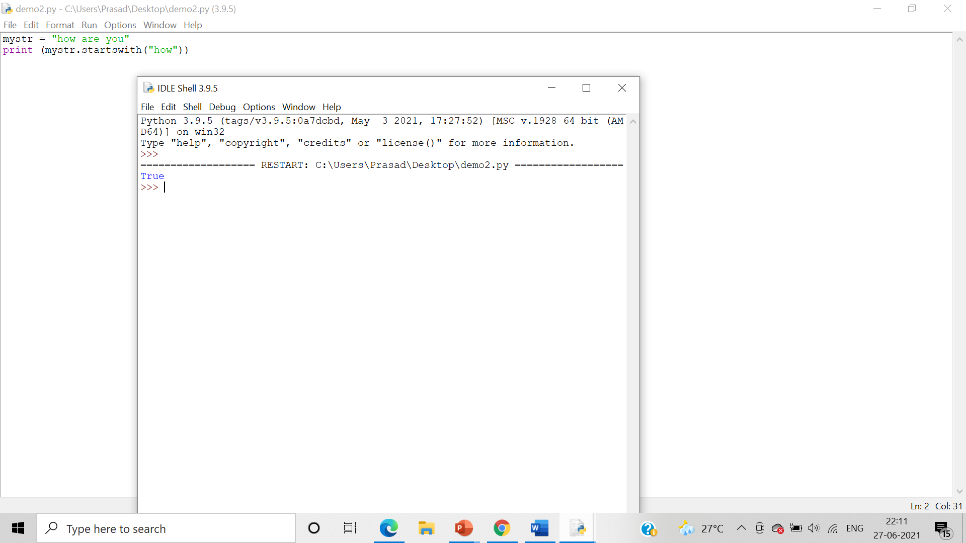

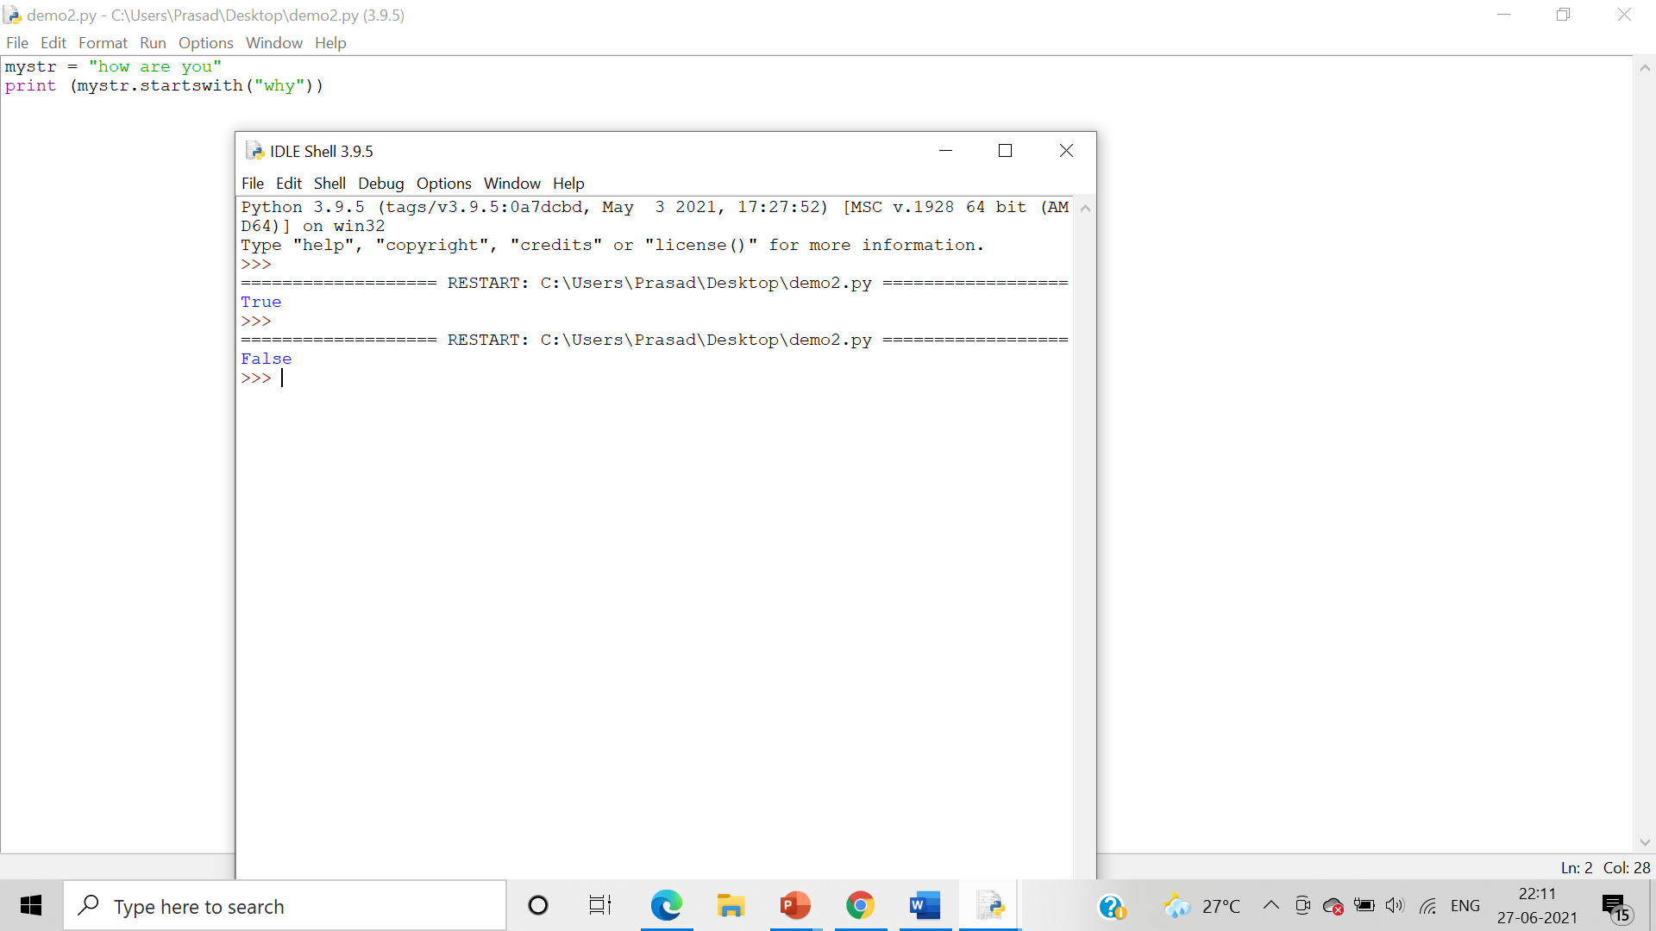

1. expandtabs(), format()

Algorithm:- Use the expandtabs(), format() to alter and modify the given string.

* expandtabs()

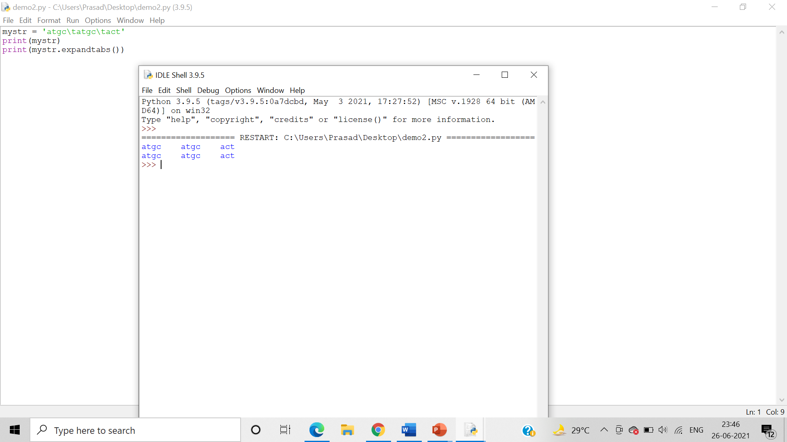

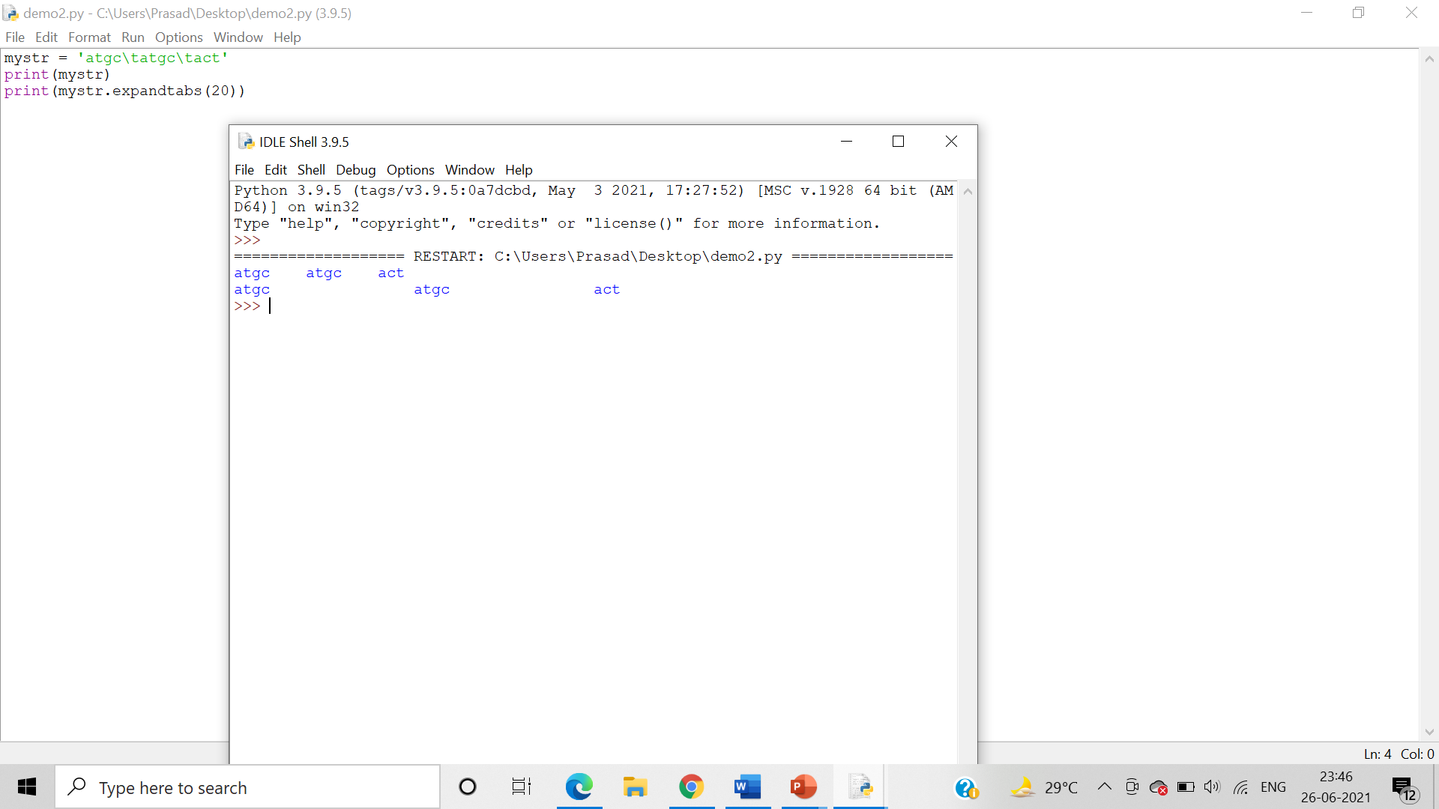

1. find(), rfind(), index(), rindex()

Algorithm:- Use the find(), rfind(), index(), rindex() methods to modify or alter the given string.

* find()

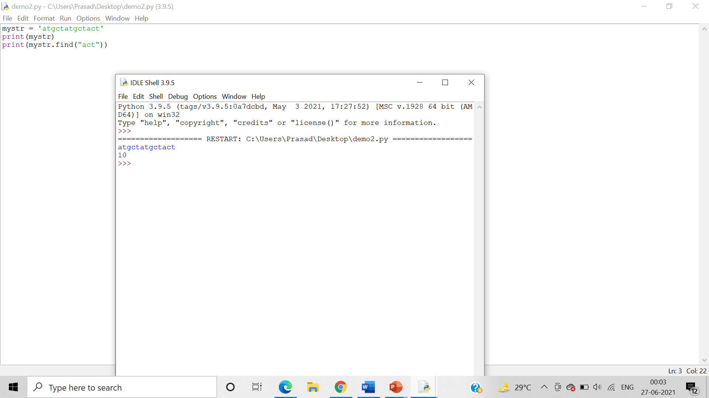

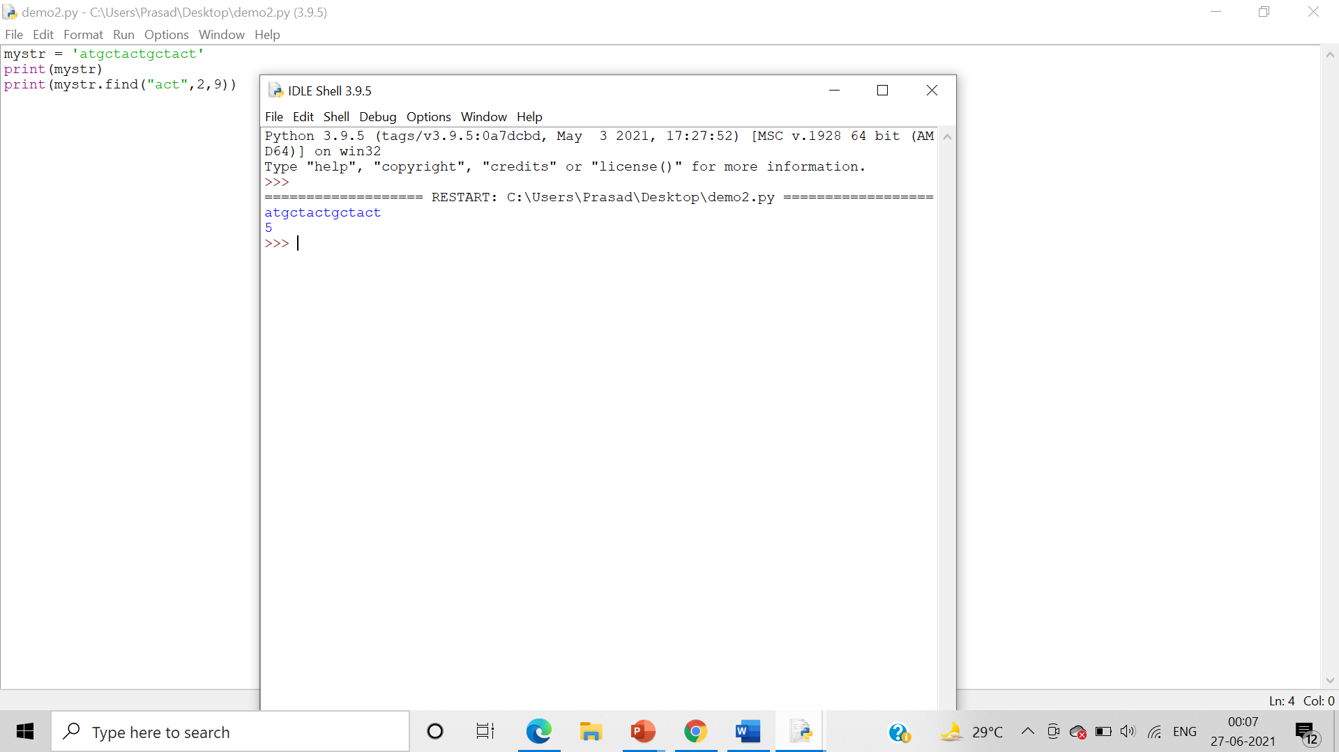

* rfind()

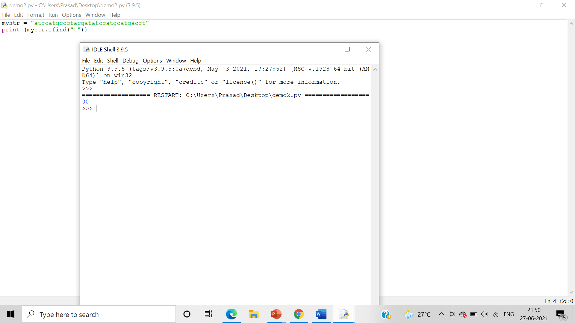

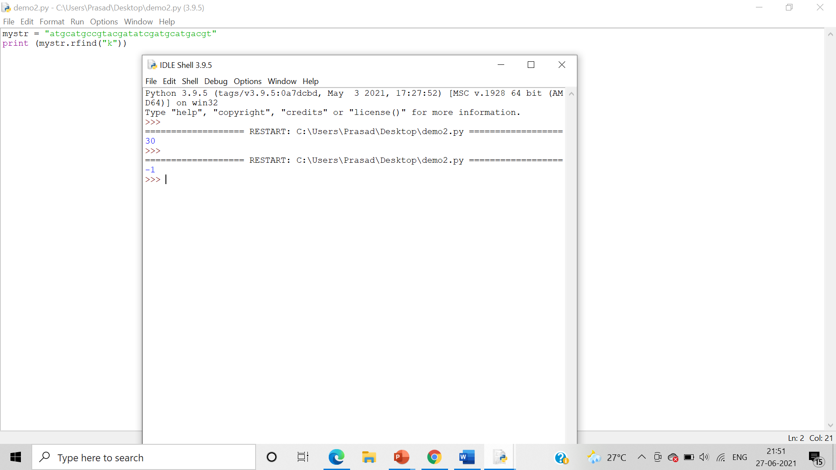

* index()

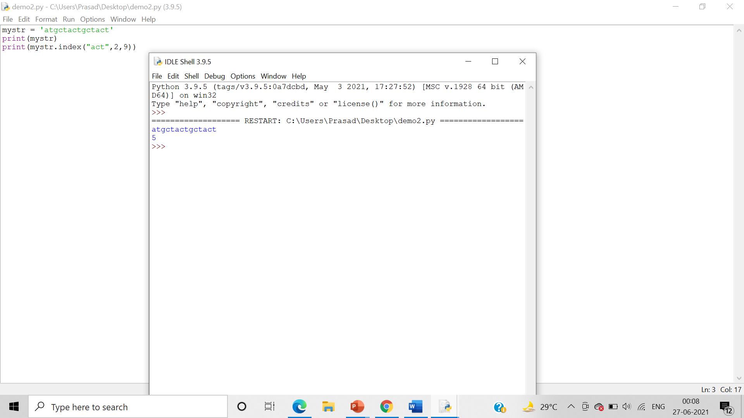

* rindex()

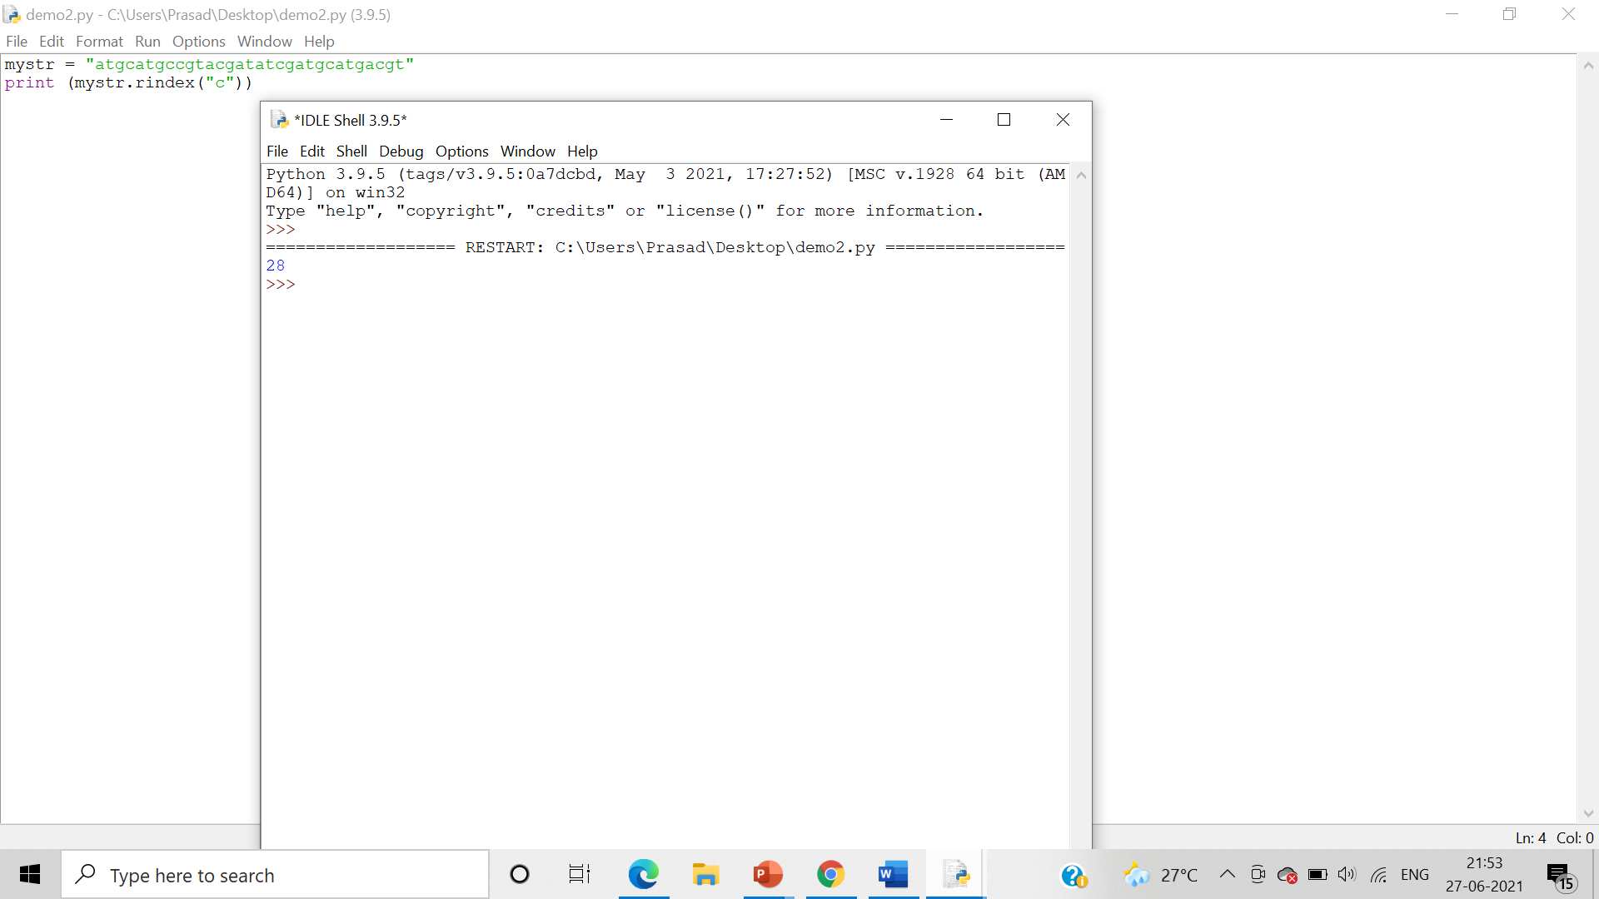

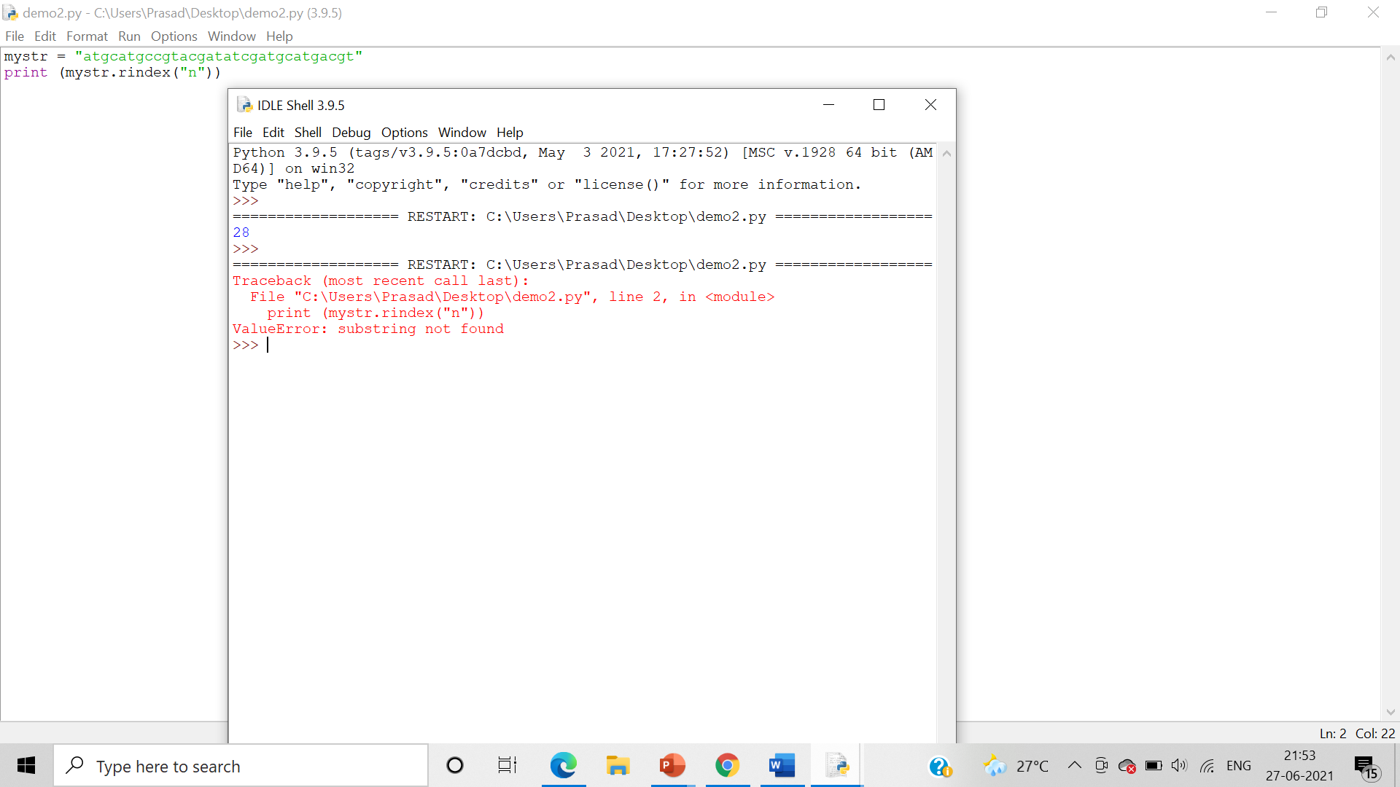

1. isalnum(), isalpha(), isdigit(), isidentifier(), islower(), isnumeric(), isspace, isupper(), istitle()

Algorithm:_ Use the . isalnum(), isalpha(), isdigit(), isidentifier(), islower(), isnumeric(), isspace, isupper(), istitle() string methods to check the class of the given string.

* isalpha()

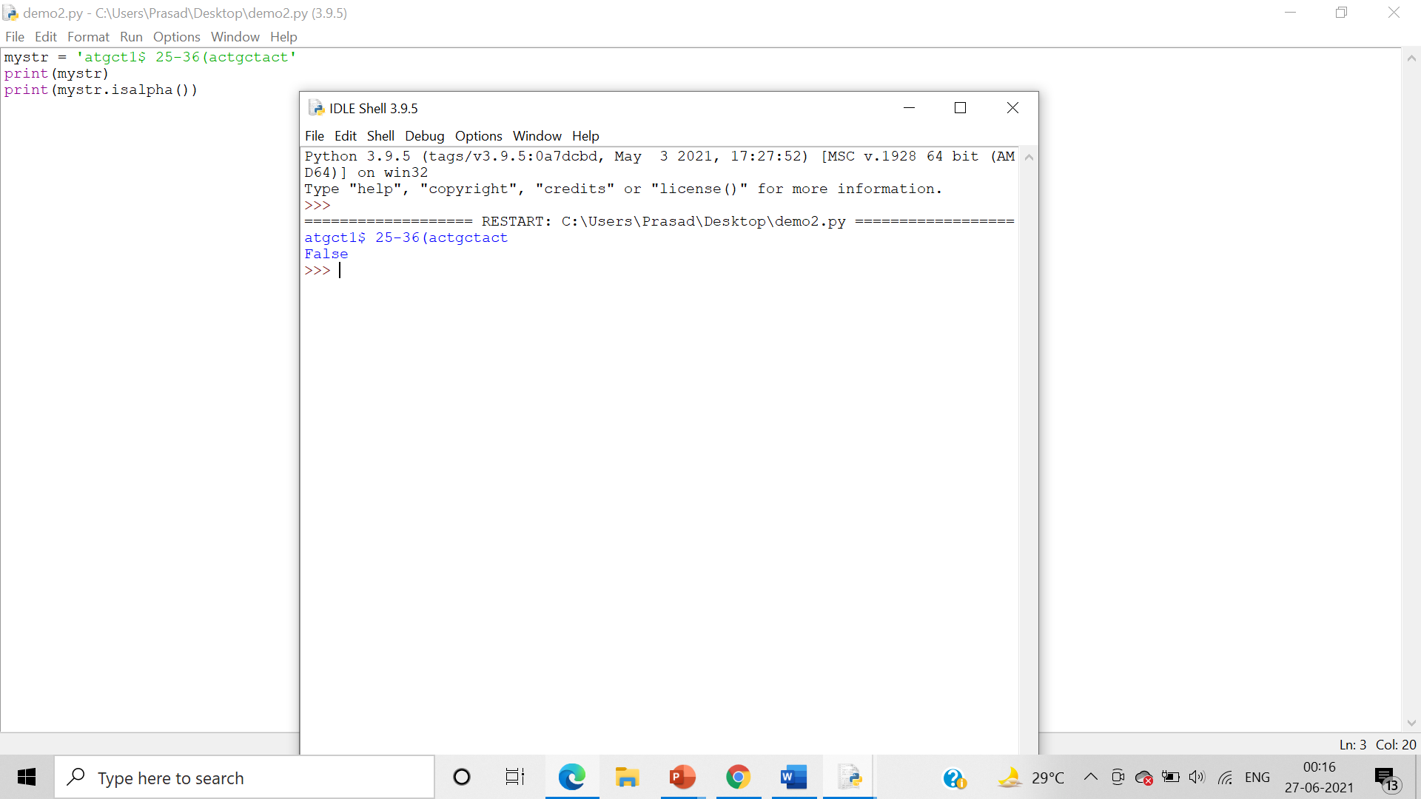

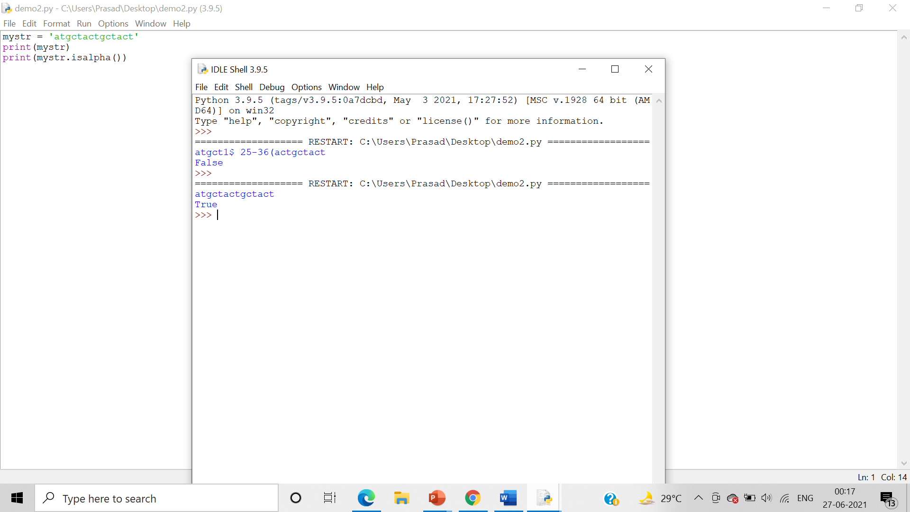

* isdigit()

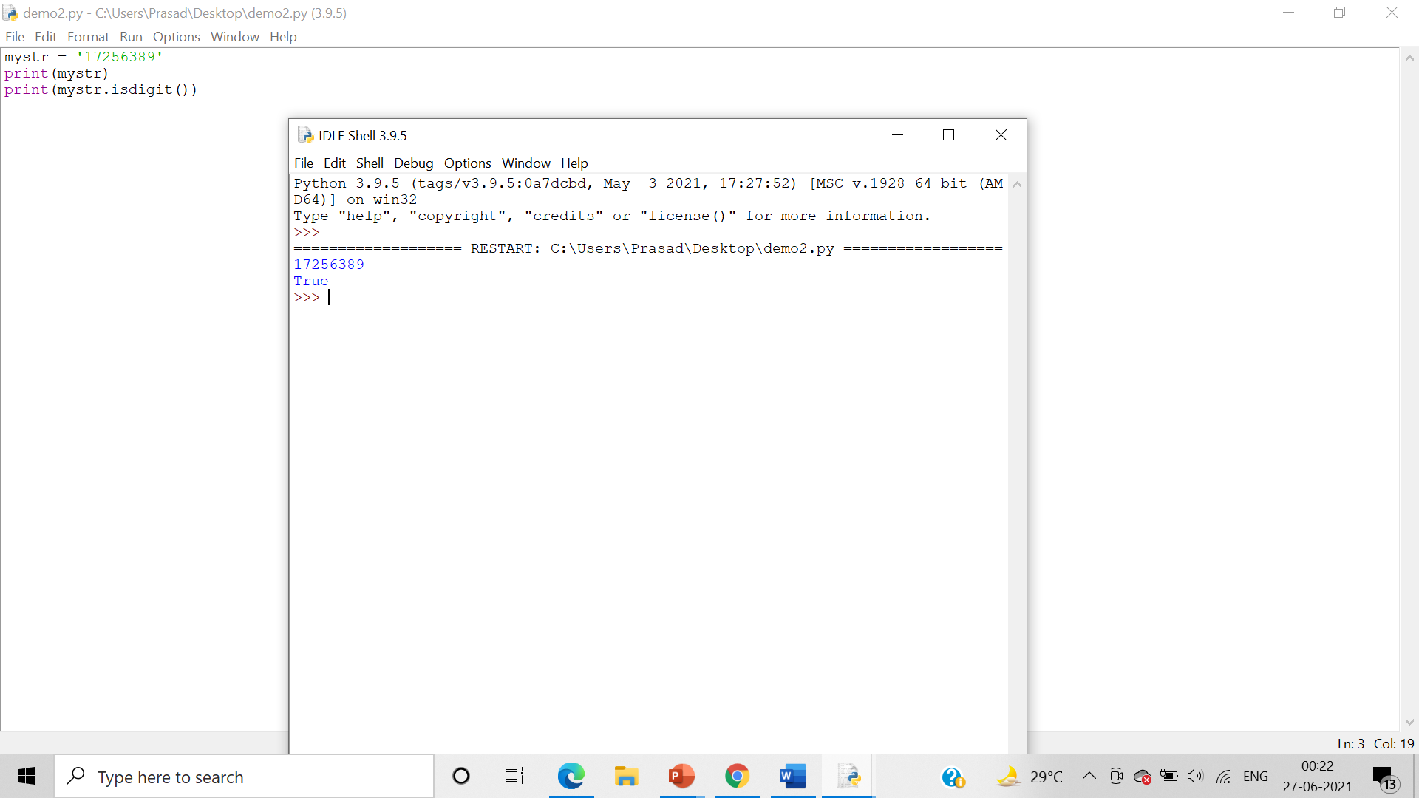

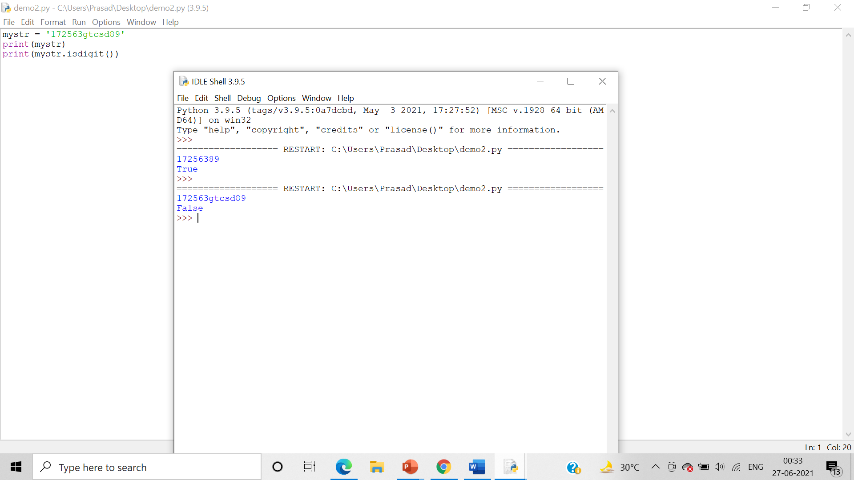

* isidentifier()

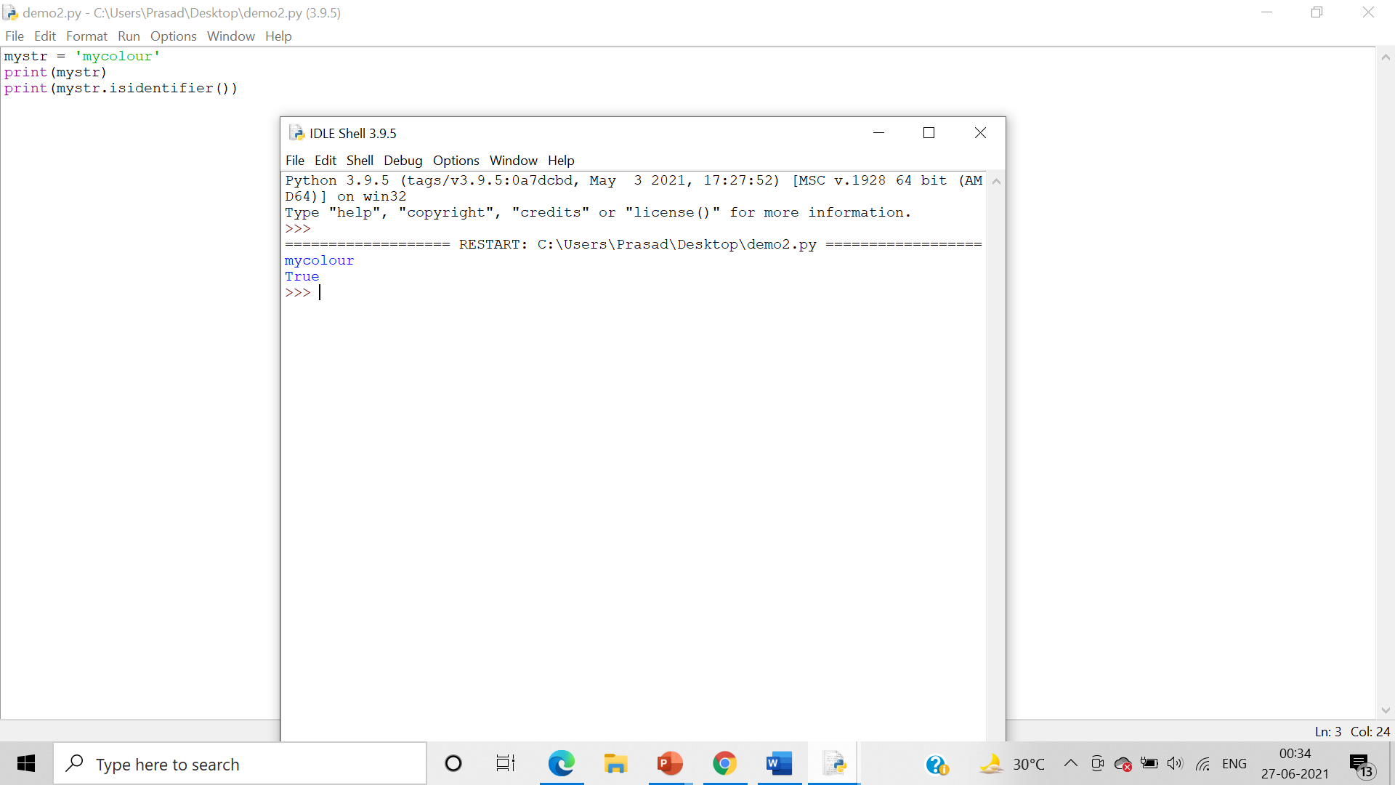

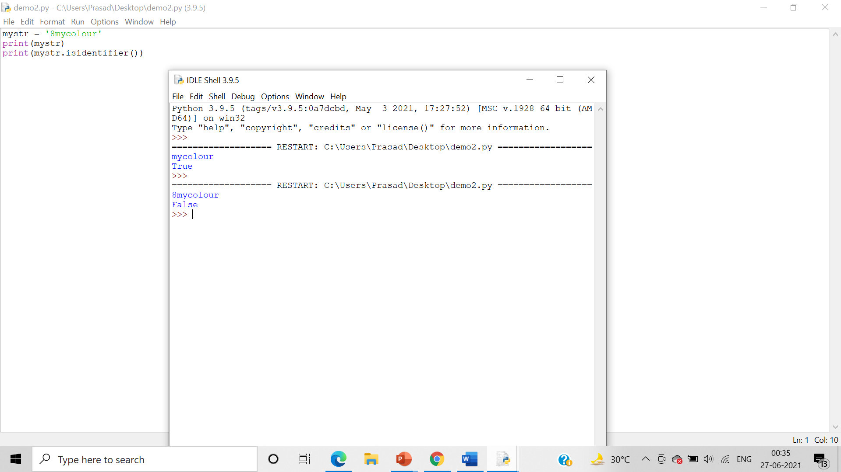

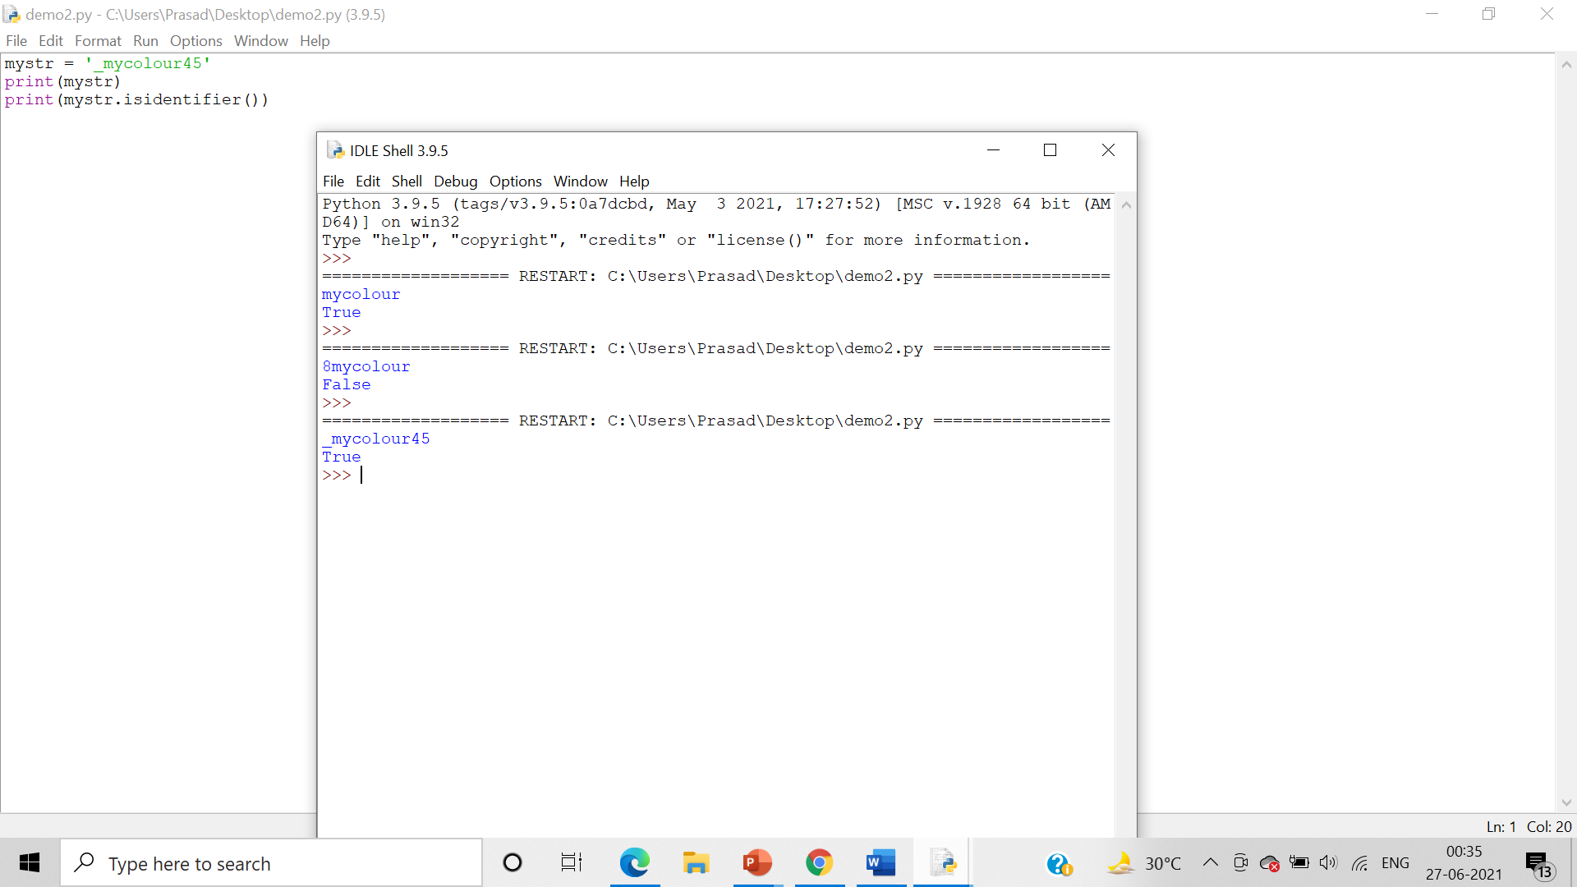

* islower()

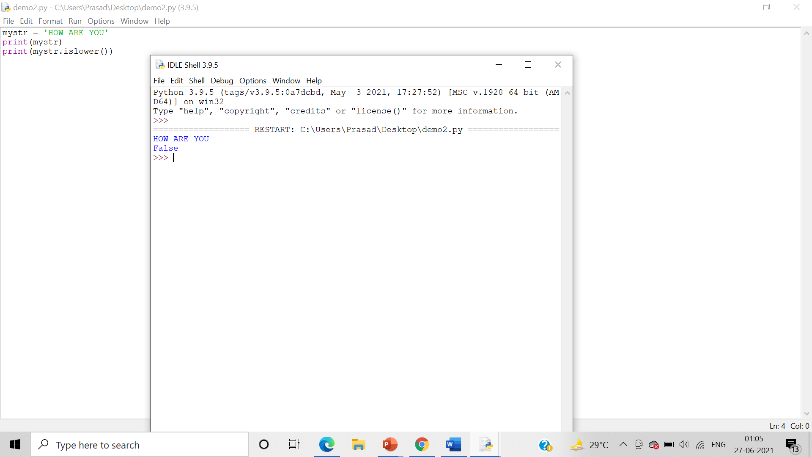

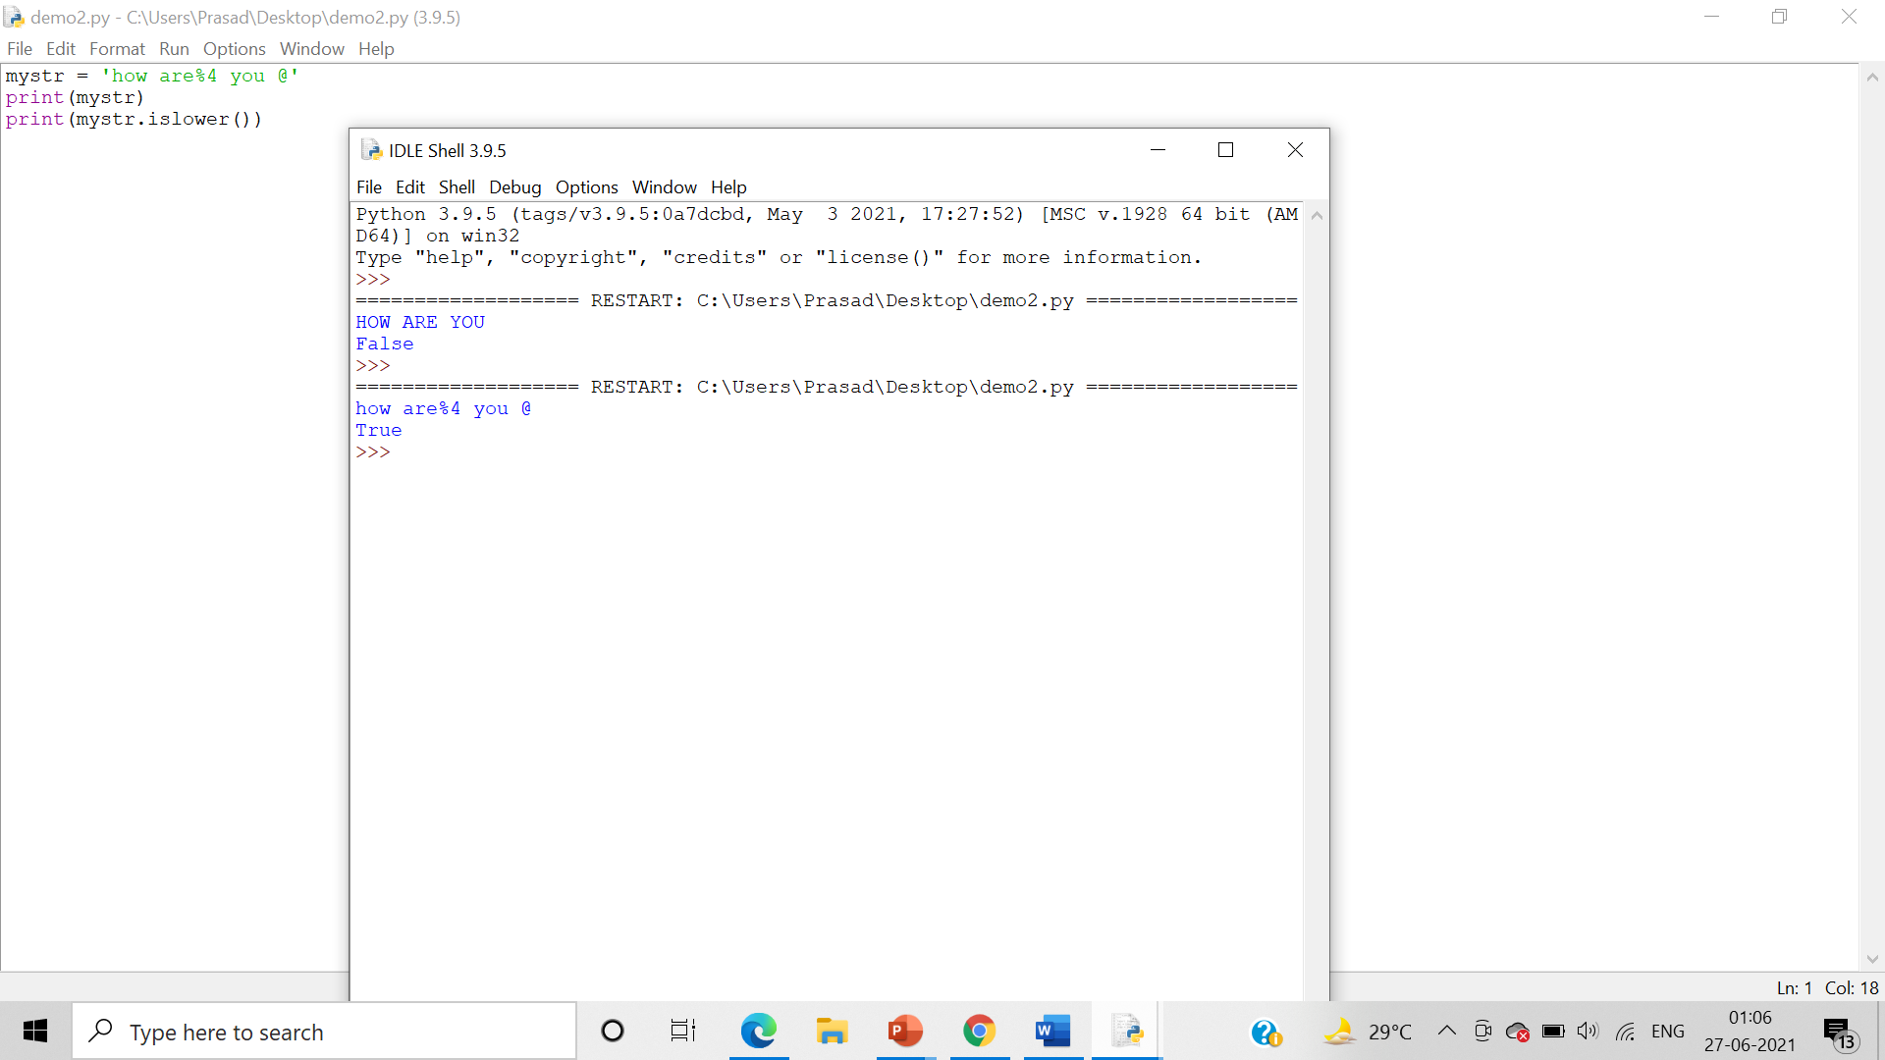

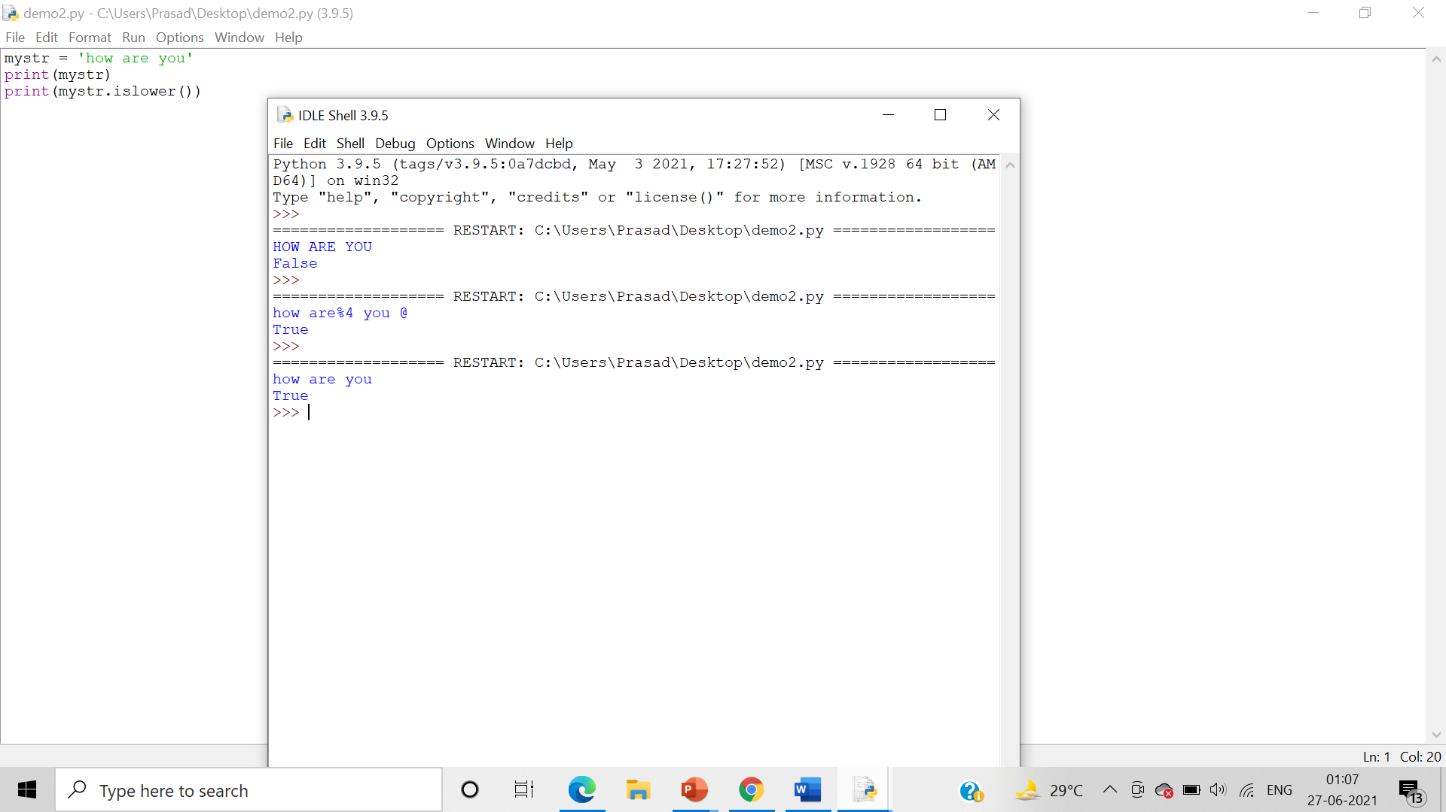

* isnumeric()

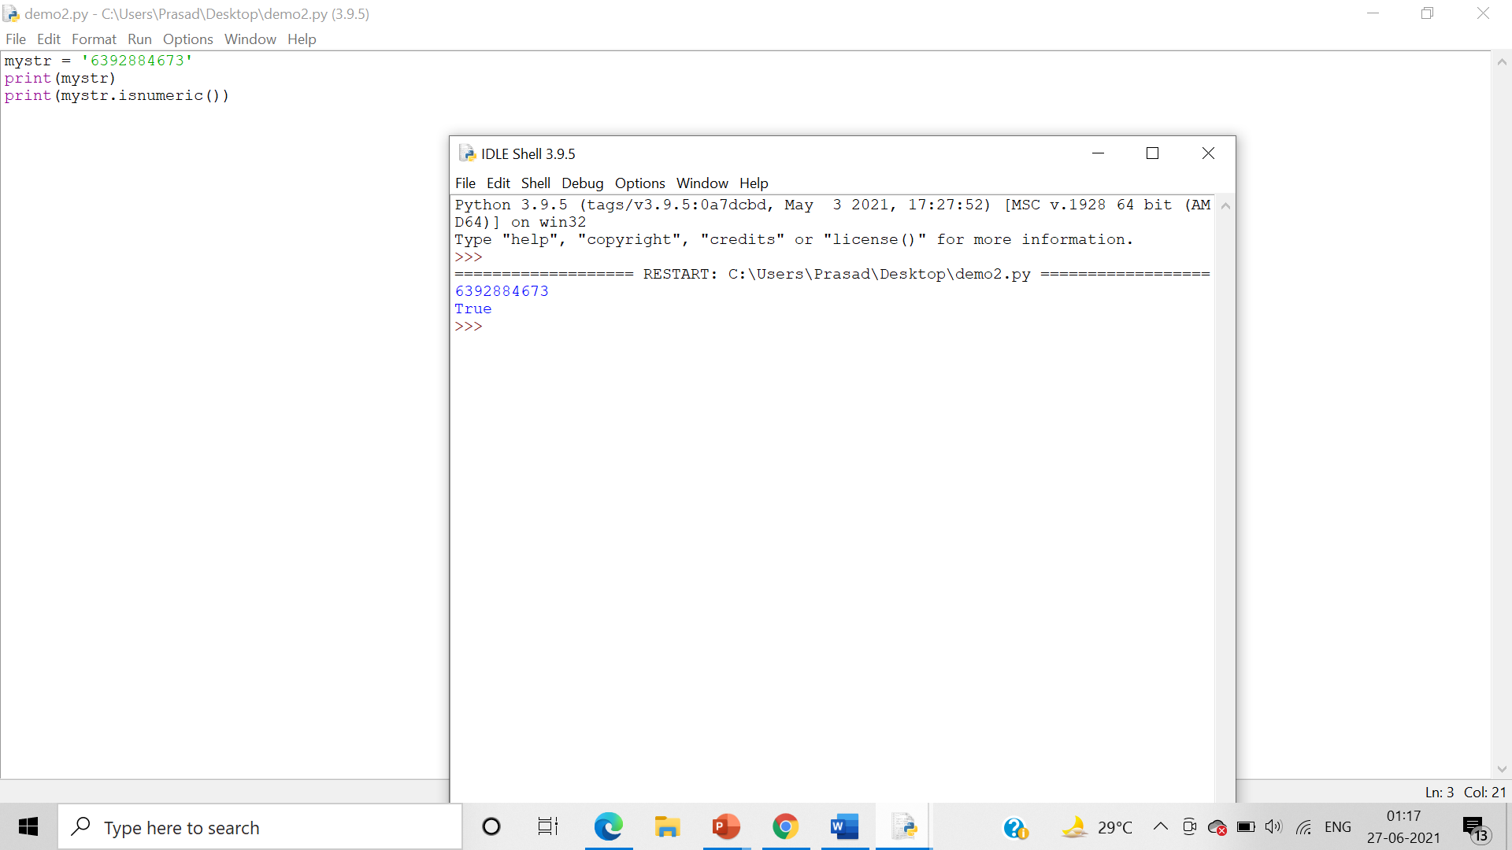

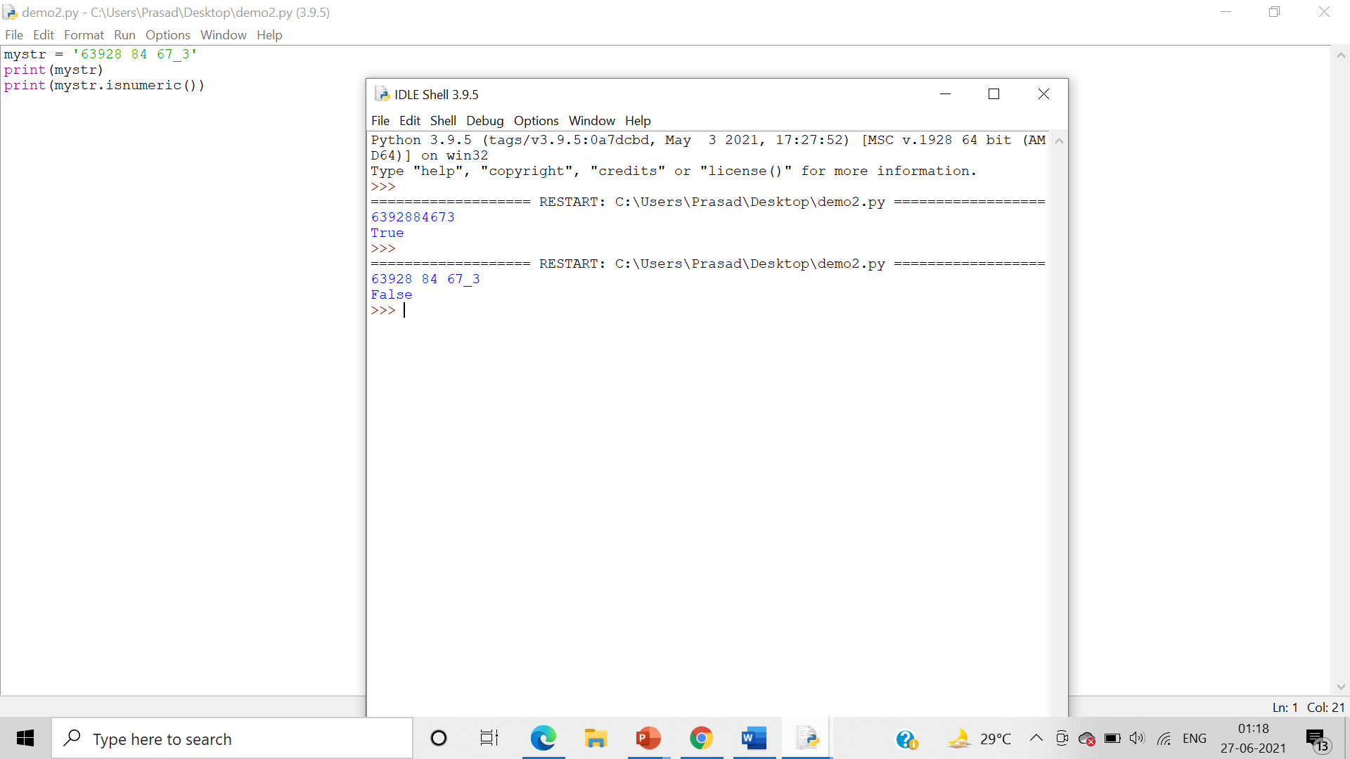

* isspace()

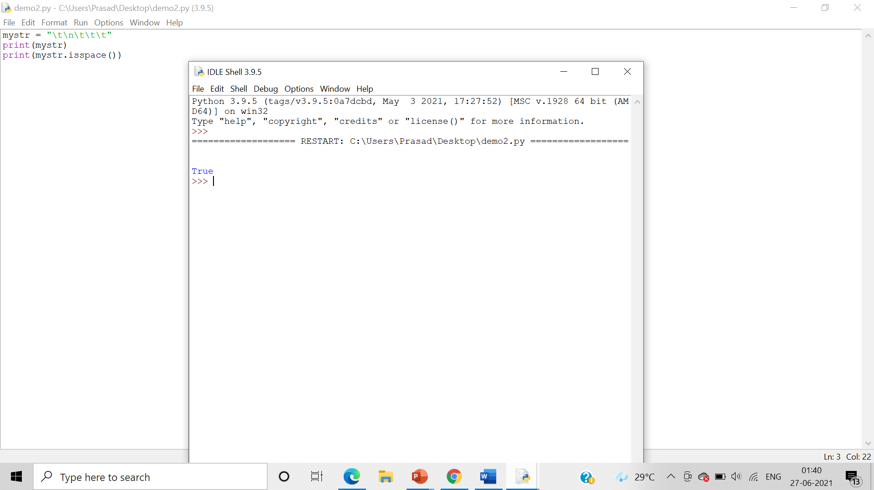

1. lstrip, rstrip, strip

Algorithm:- Use the lstrip, rstrip, strip to alter or modify the given string.

* lstrip

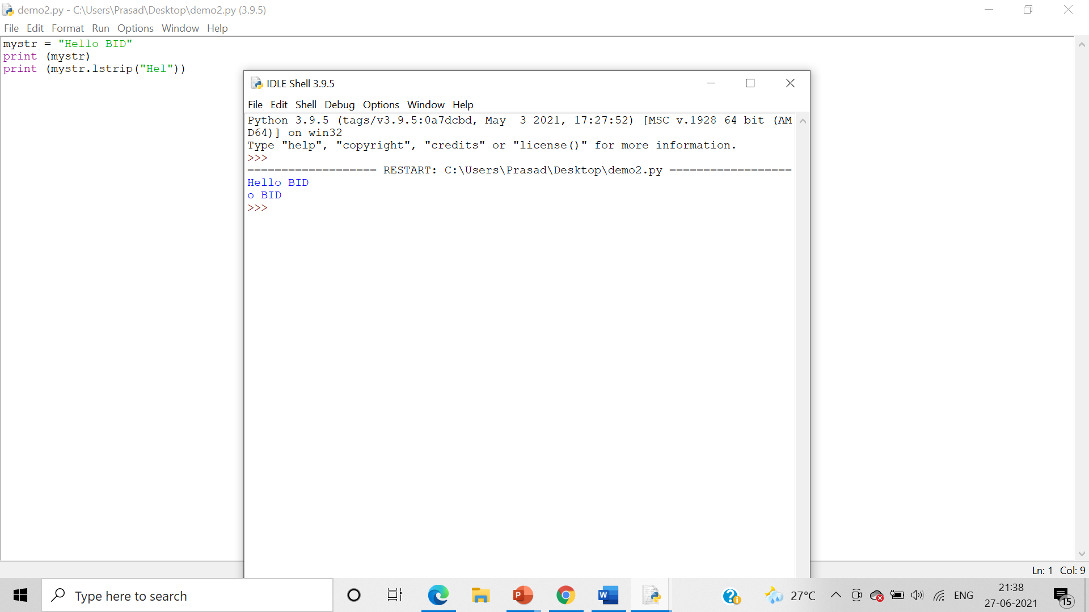

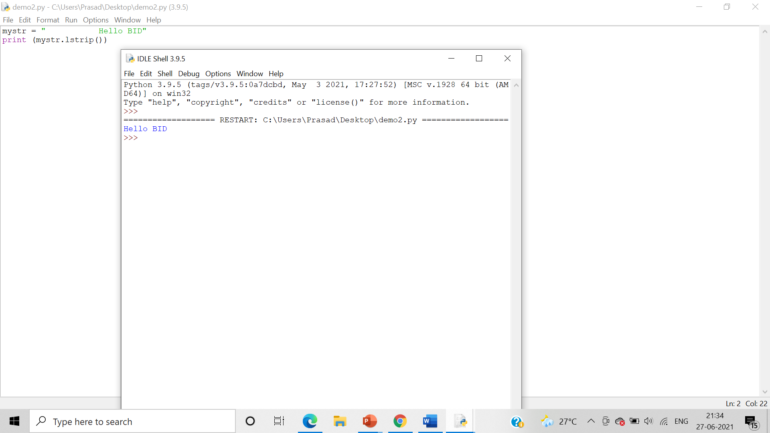

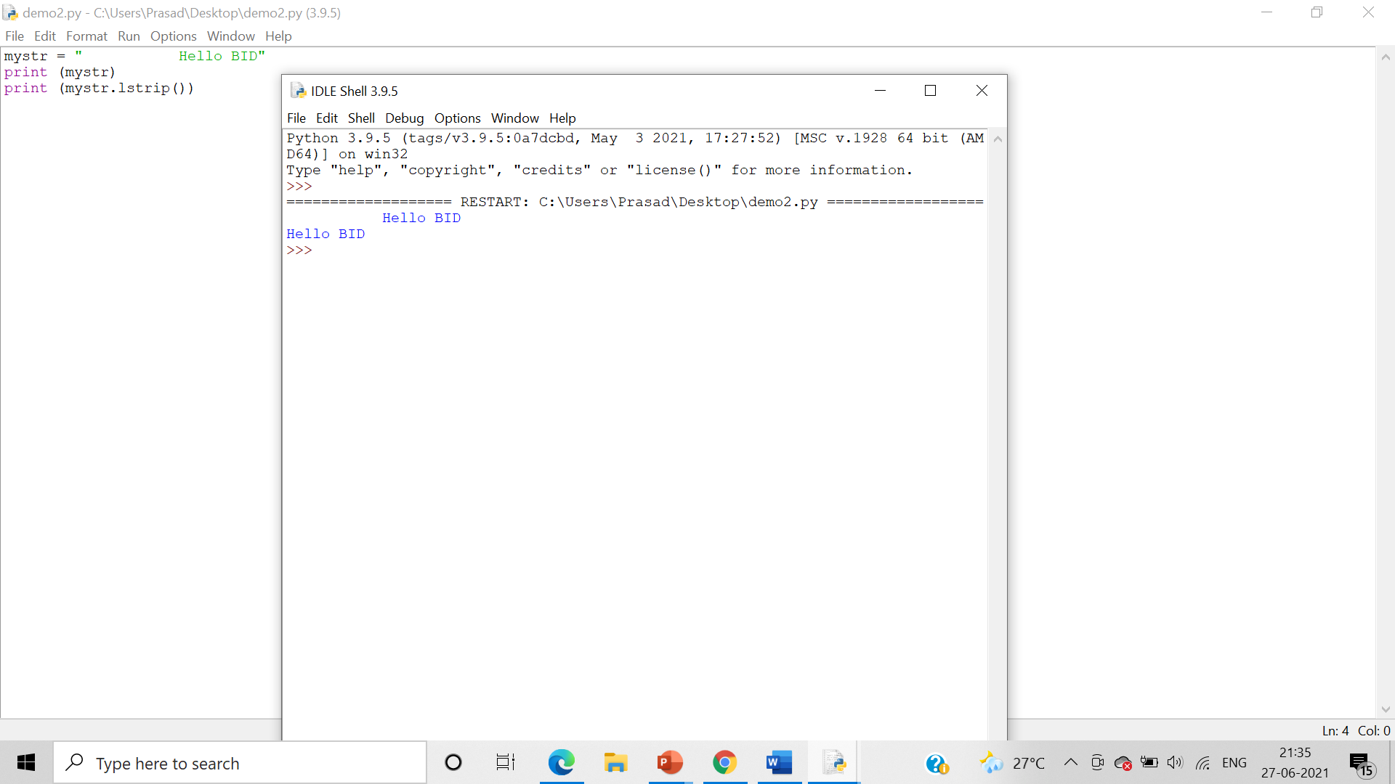

* strip()

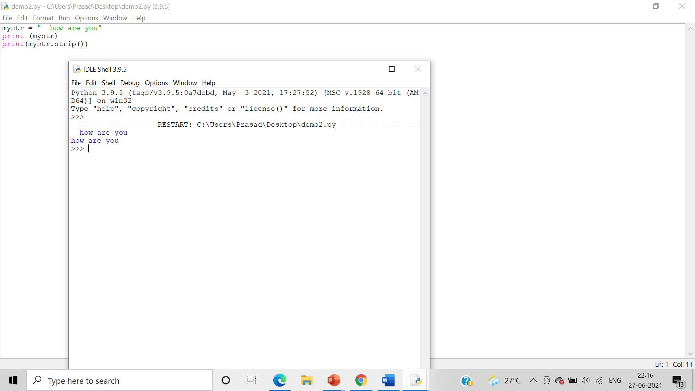

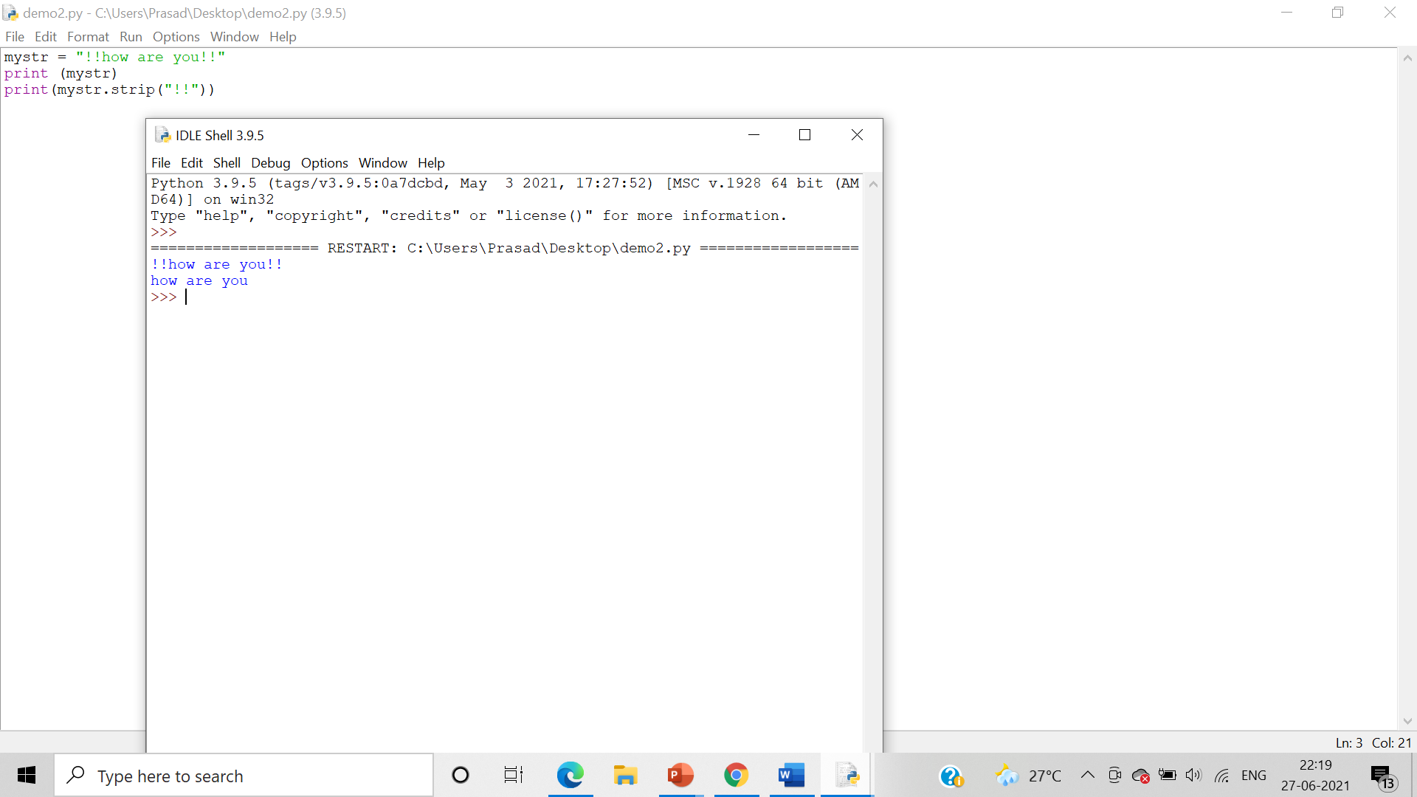

Write set of programs for demonstrating the usage of following Operators

Algorithm: - We use the arithmetic operators (+,-,*,/,**,//) to perform the operations of addition, subtraction, multiplication, division, floor division as well as to find the exponent between 2 variables ‘a’ and ‘b’

1. Arithmetic operators

* Addition (+)

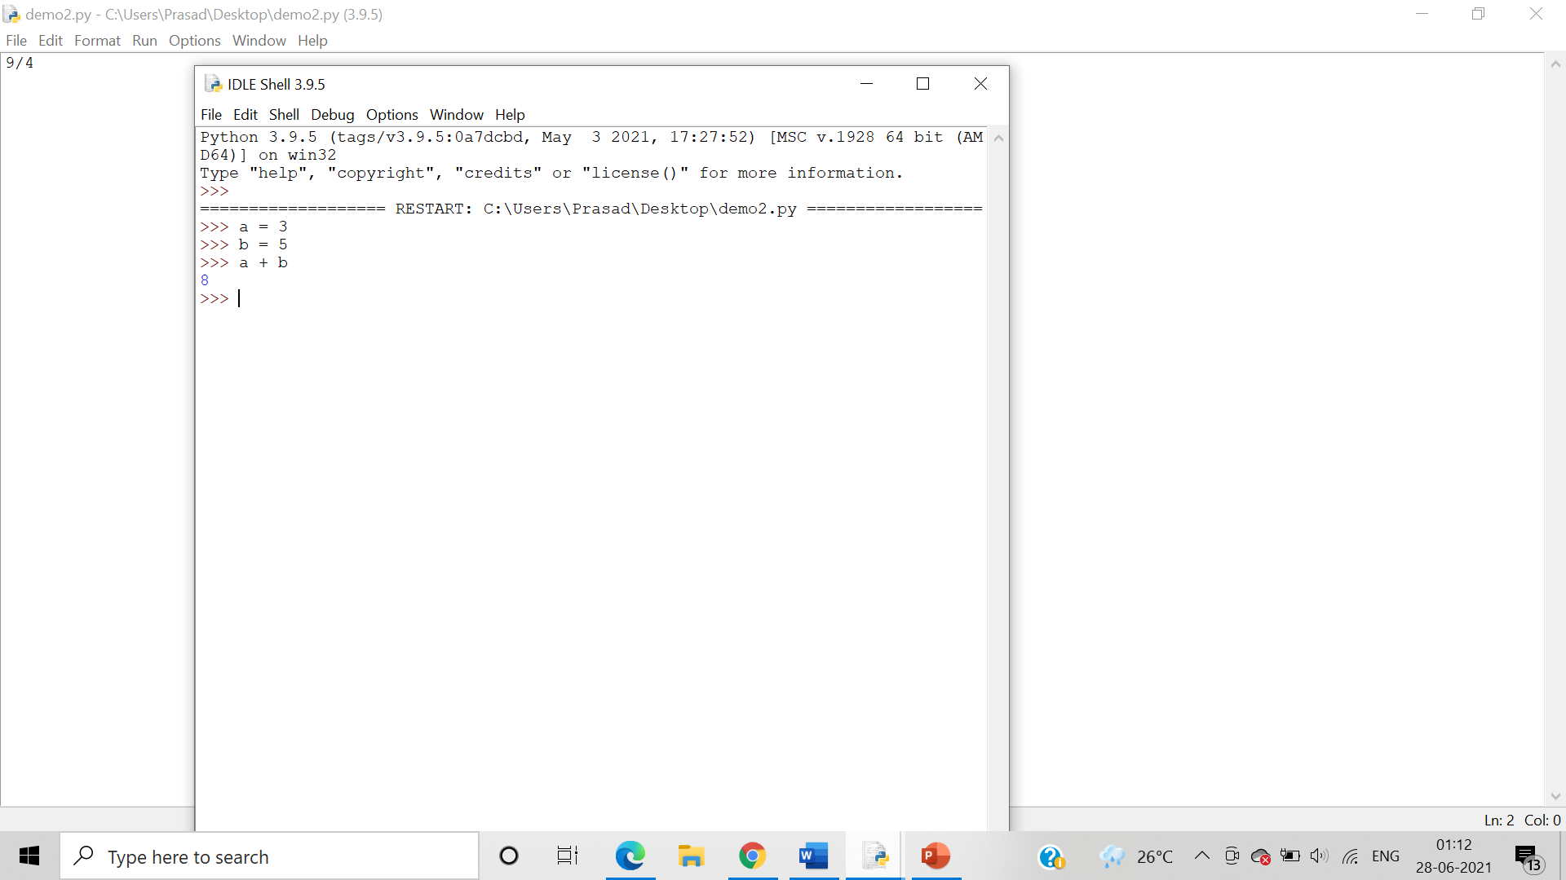

* Subtraction (-)

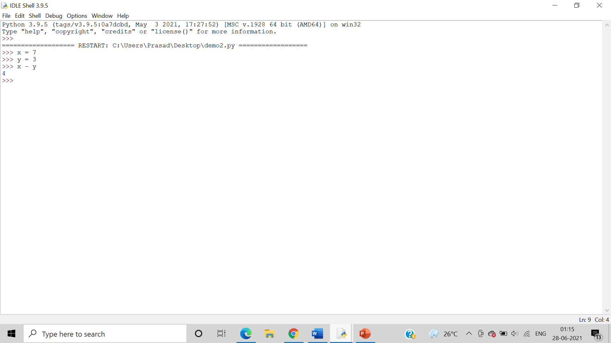

* Multiplication (*)

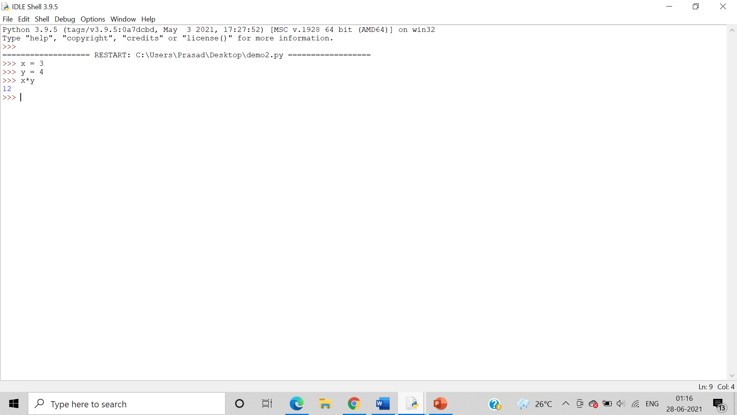

* Division (/)

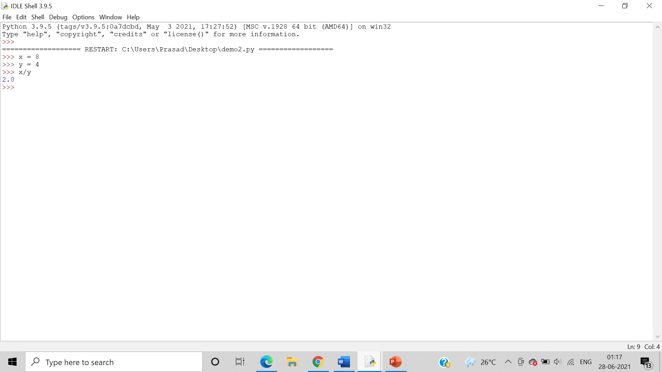

* Modulus (%)

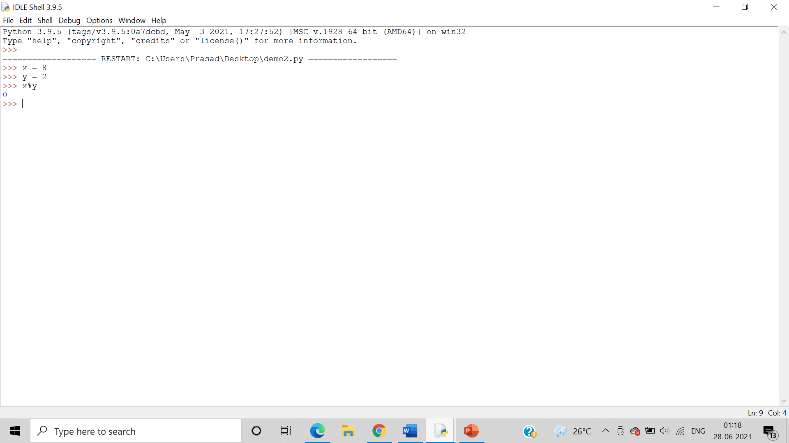

* Exponent (**)

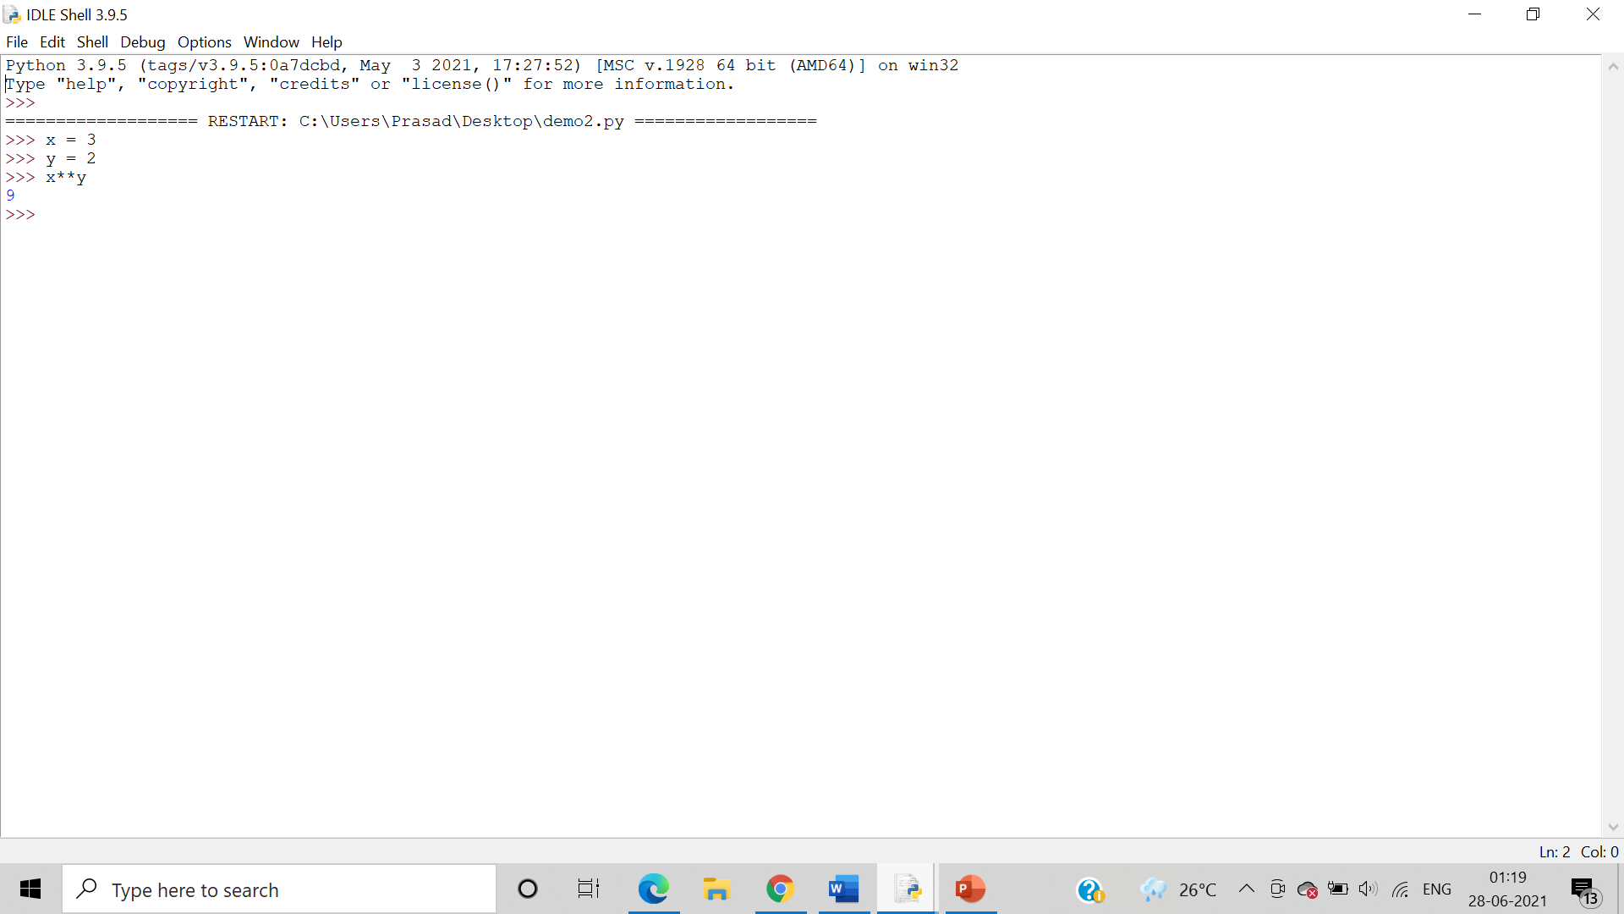

* Floor Division (//)

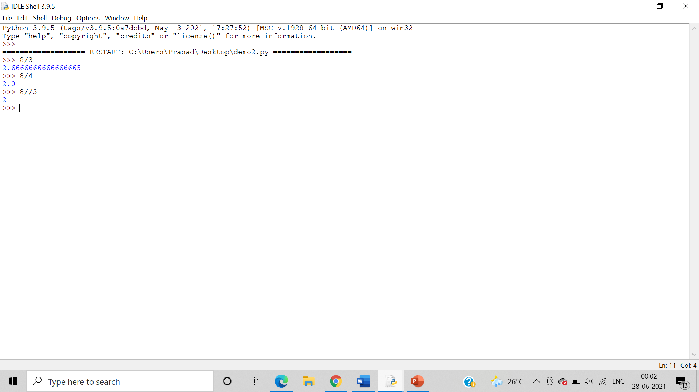

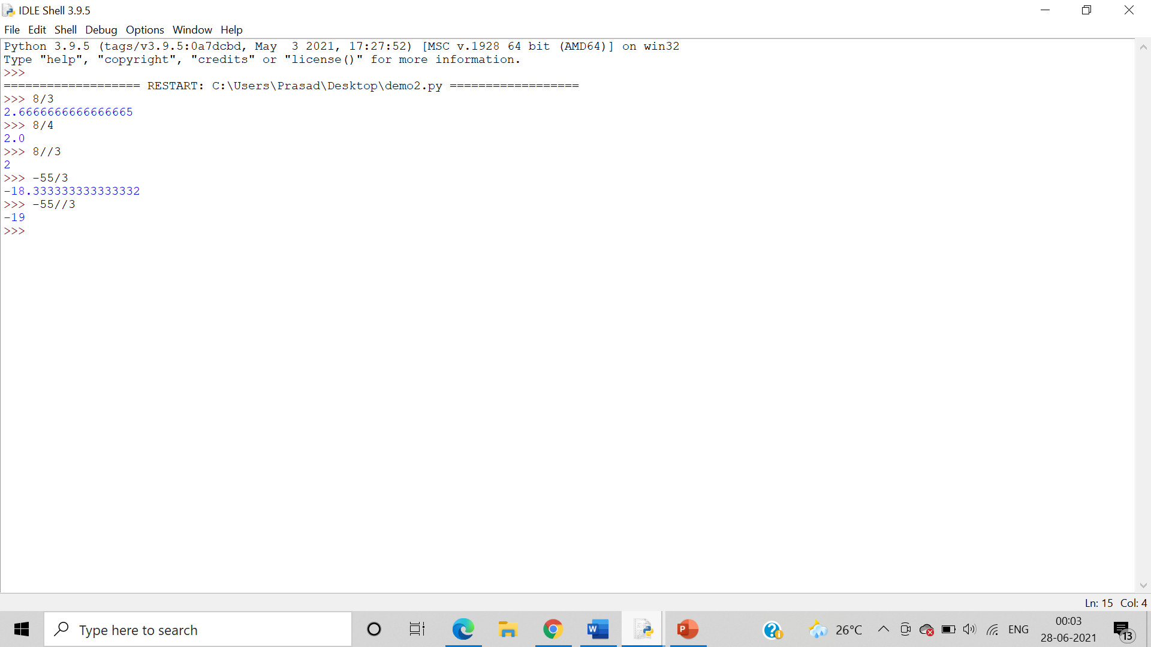

1. Assignment operators

Algorithm: - We use the assignment operators (=, +=, -=,*=, /=, **=, //=) to perform the operations of addition, subtraction, multiplication, division, floor division as well as to find the exponent of the variable a with a integer.

* =

When we type x = 5, that time we **assign** value of x as 5.

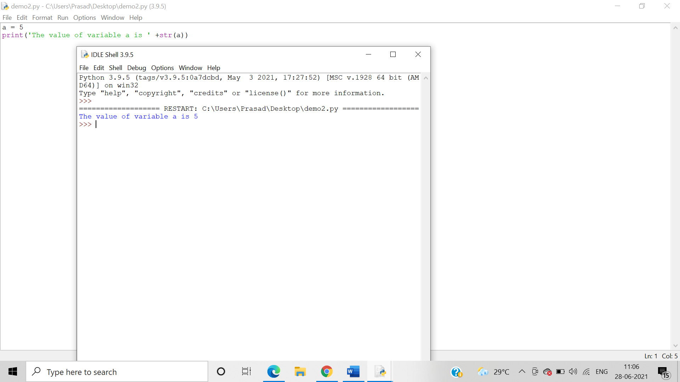

* +=

When we type x+=5, it means x = x + 5.

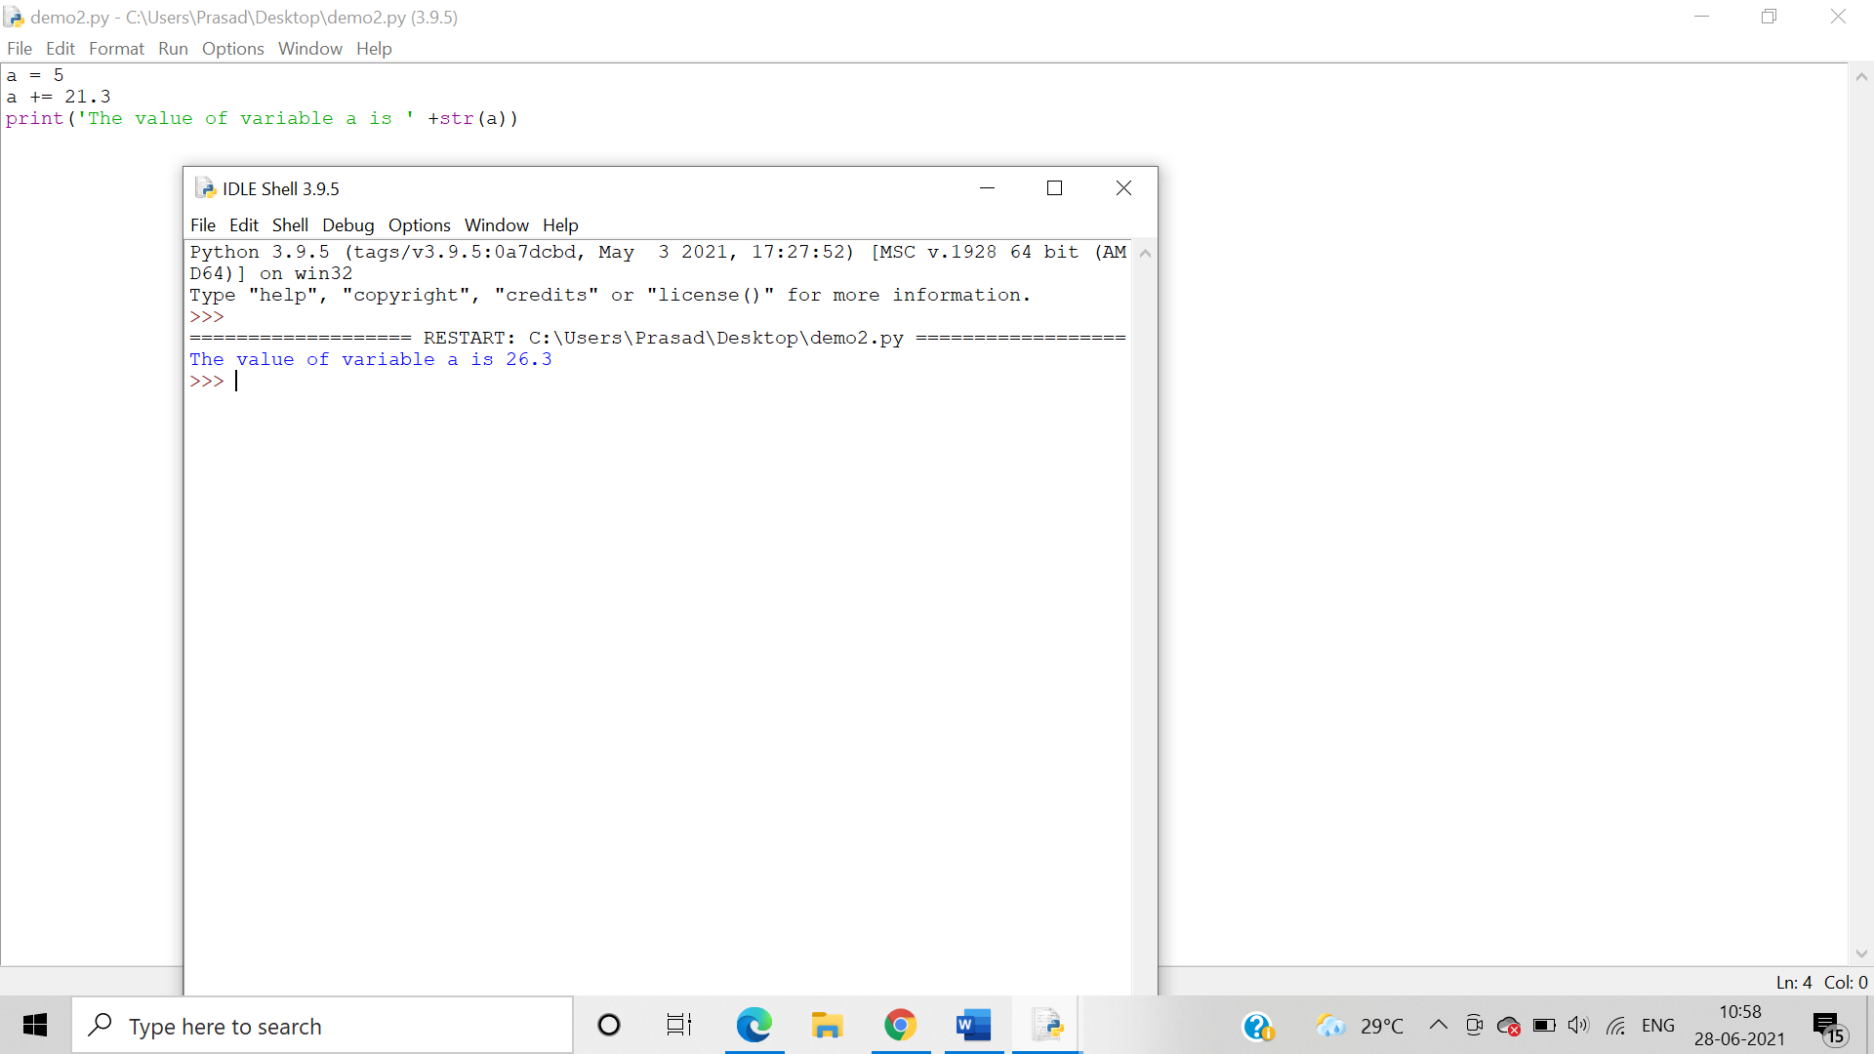

* -=

When we type x-=5, it means x = x - 5.

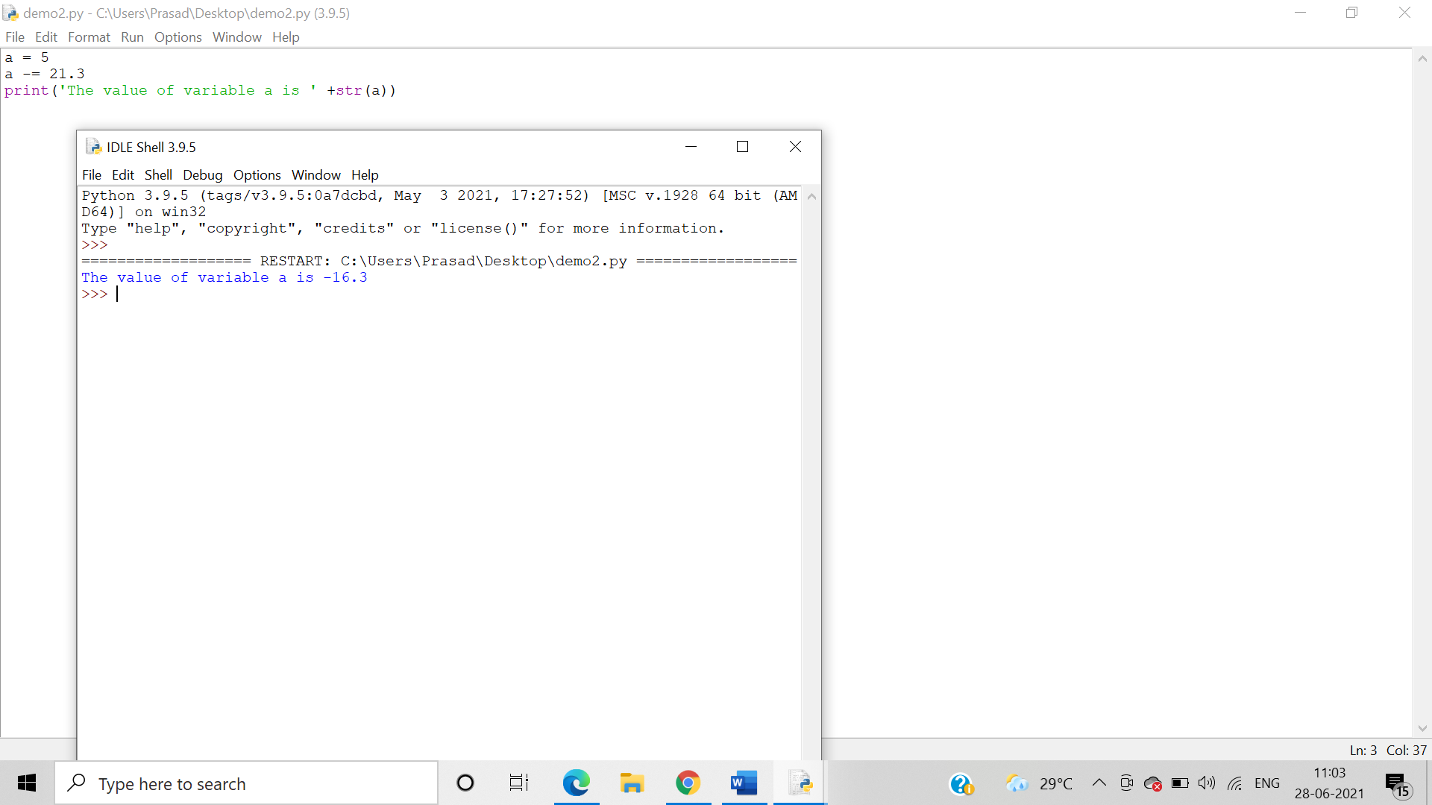

* *=

When we type x*=5, it means x = x * 5 .

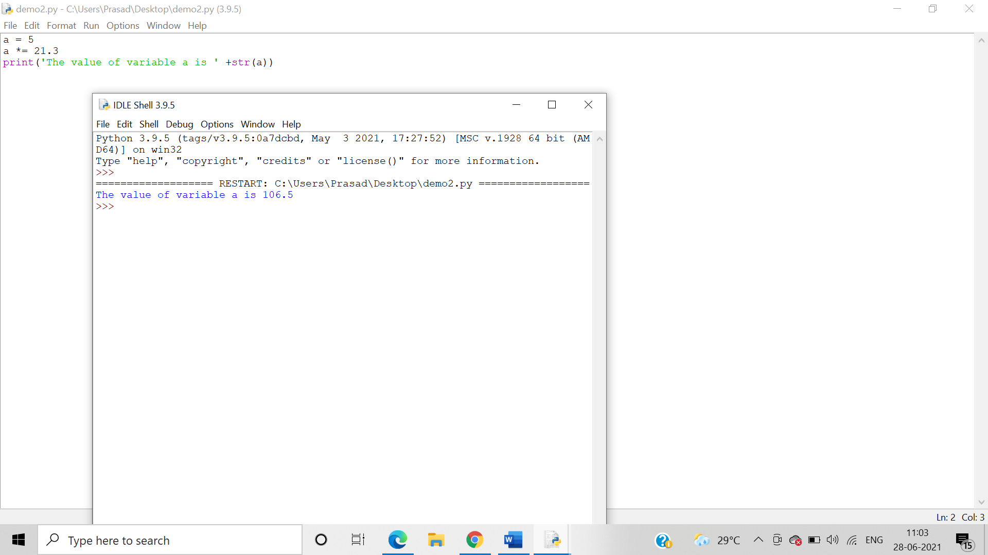

* /=

When we type x/=5, it means x = x / 5.

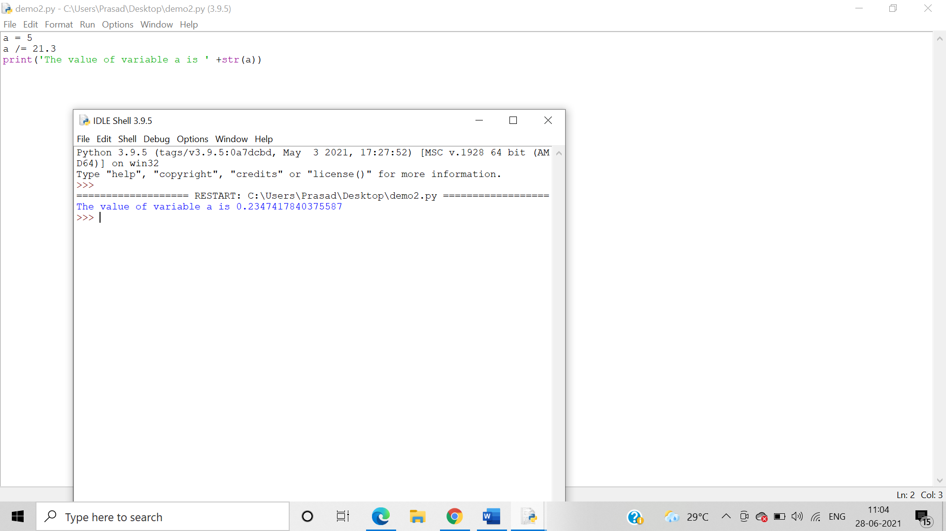

* %=

When we type x%5, it means x = x % 5.

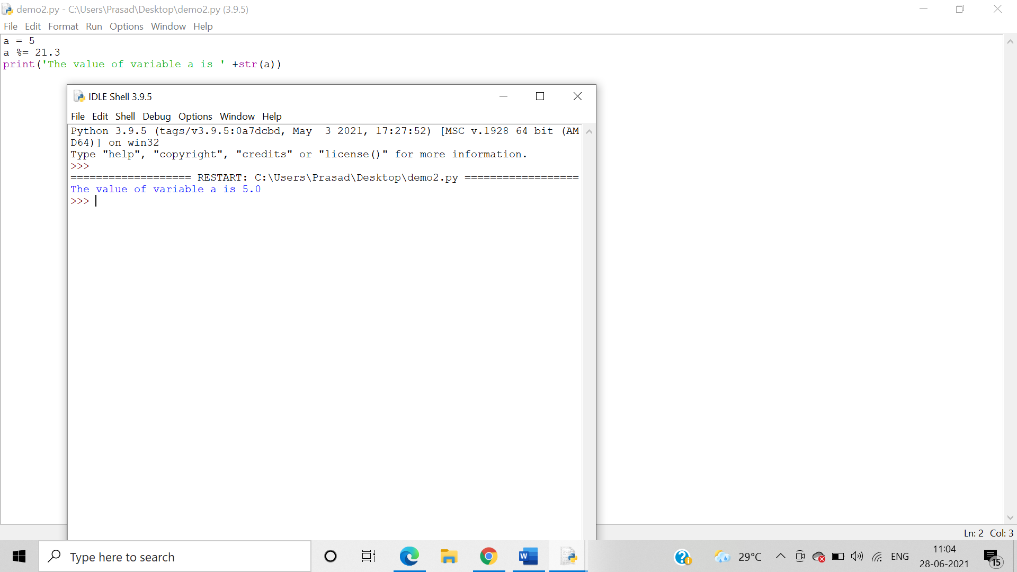

* //=

When we type x//=, it means x = x // 5.

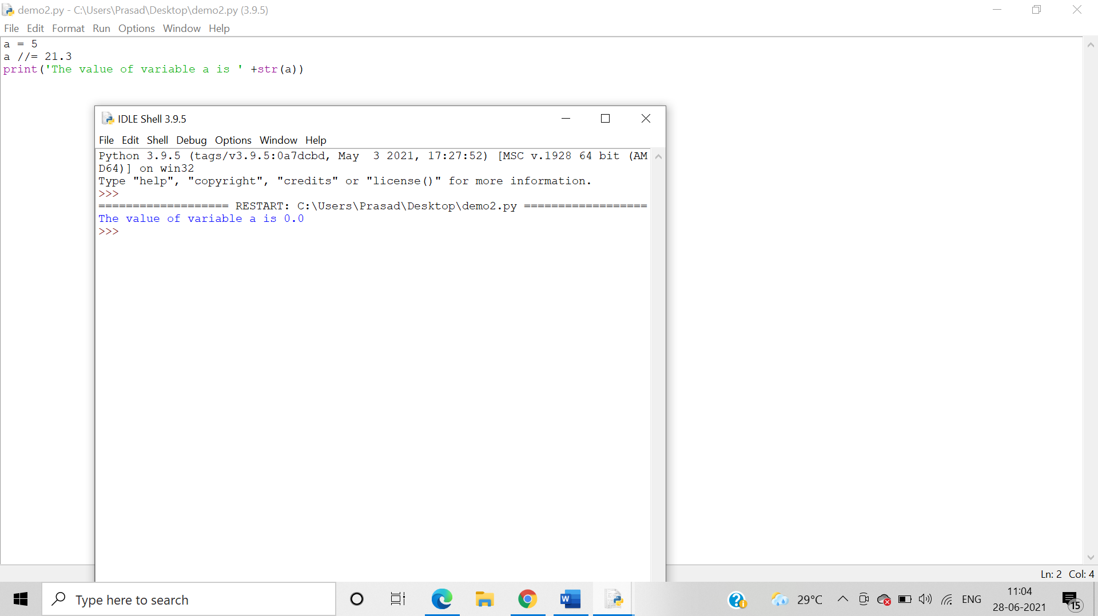

* **=

When we type x**=, it means x = x**5

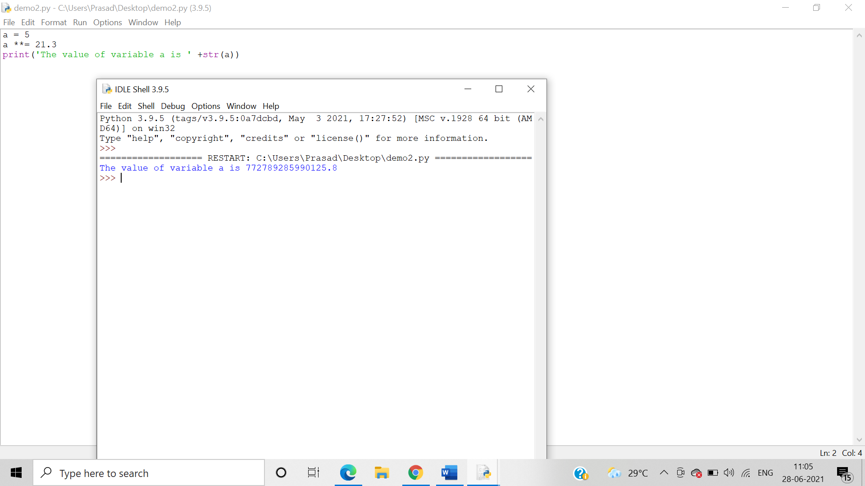

1. Logical operators

Algorithm: - Logical operators are used on conditional statements (either True or False). They perform **Logical AND, Logical OR** and**Logical NOT**operations. In a Logical AND operator Logical operator returns True if both the operands are True else it returns False. In a Logical OR operator**,** Logical or operator returns True if either of the operands is True. Logical not operator work with the single Boolean value. If the Boolean value is True it returns False and vice-versa.

* AND

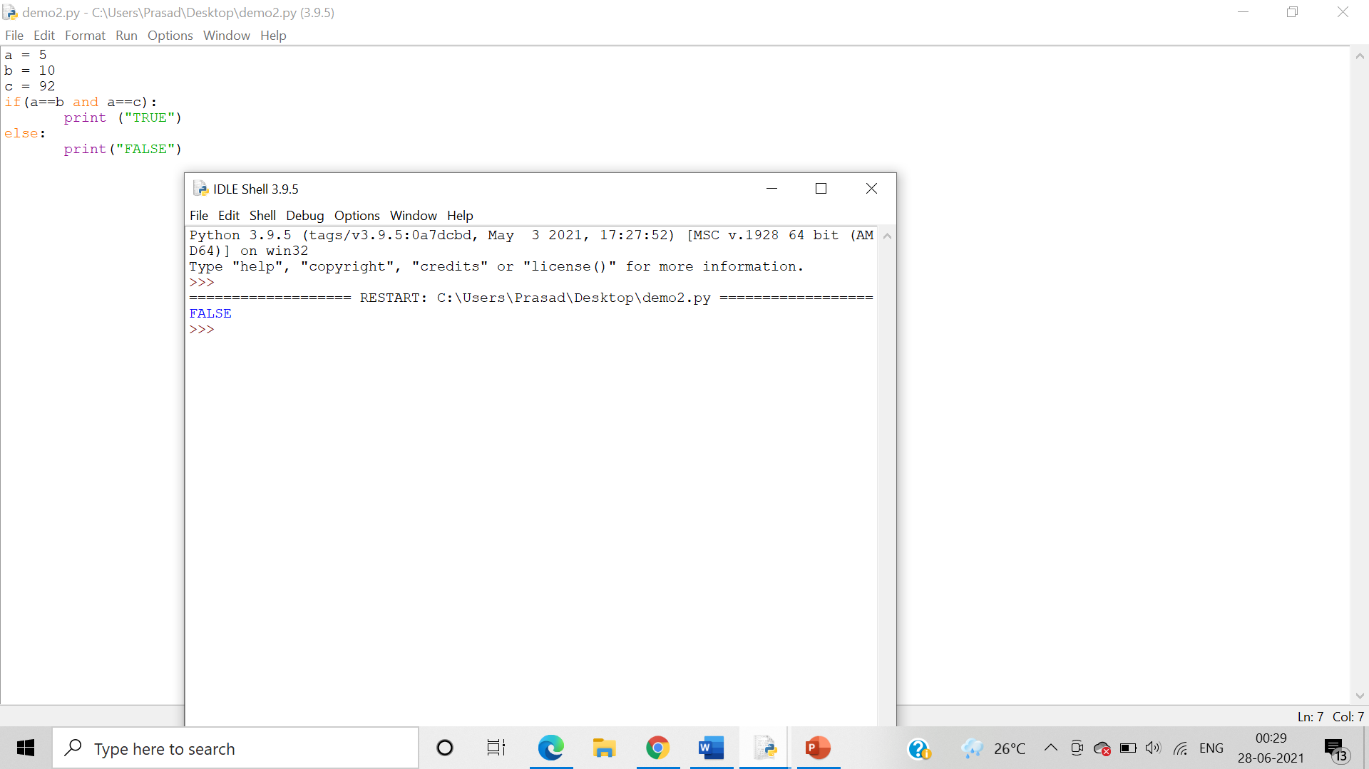

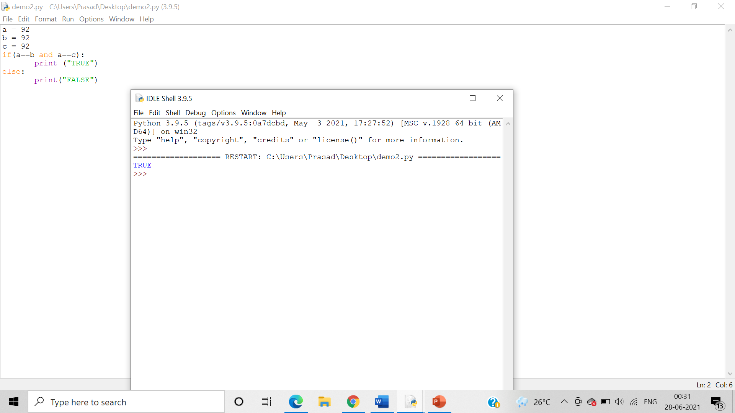

* OR

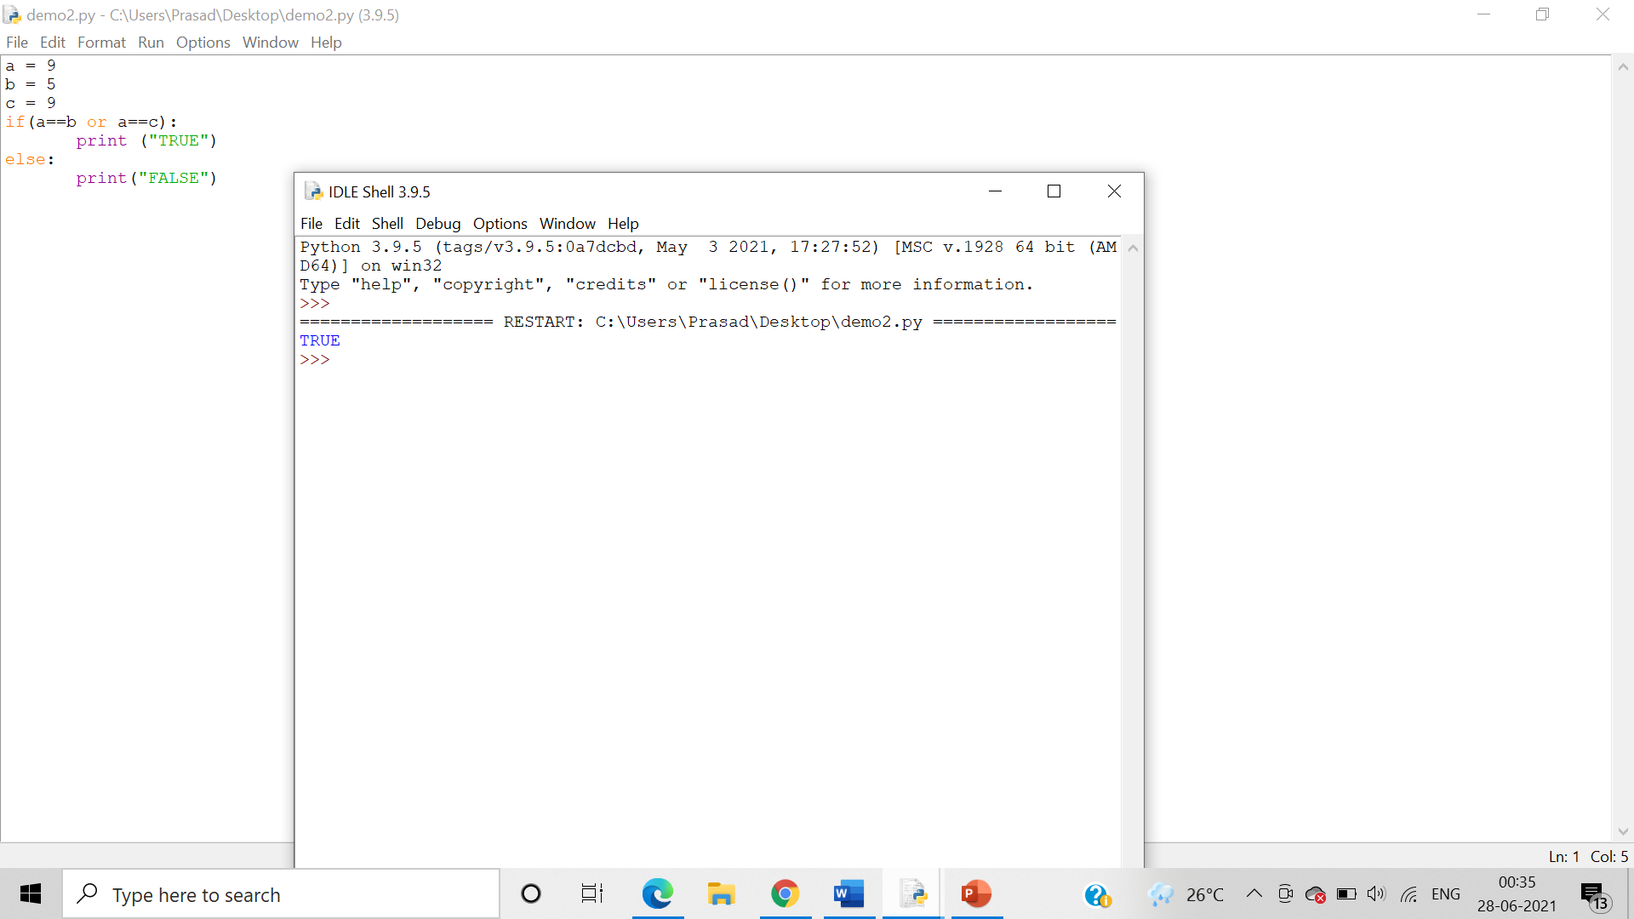

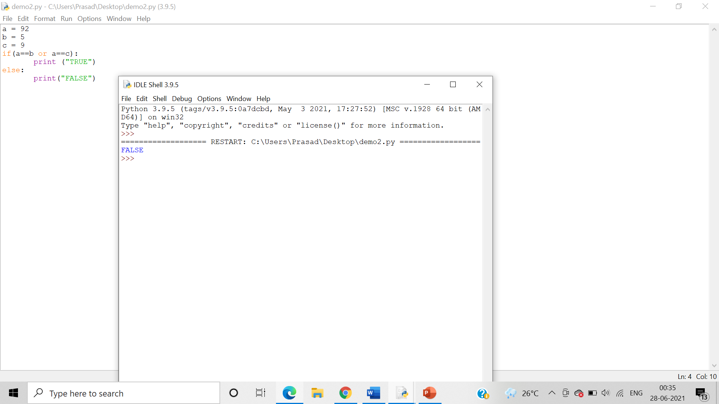

* NOT

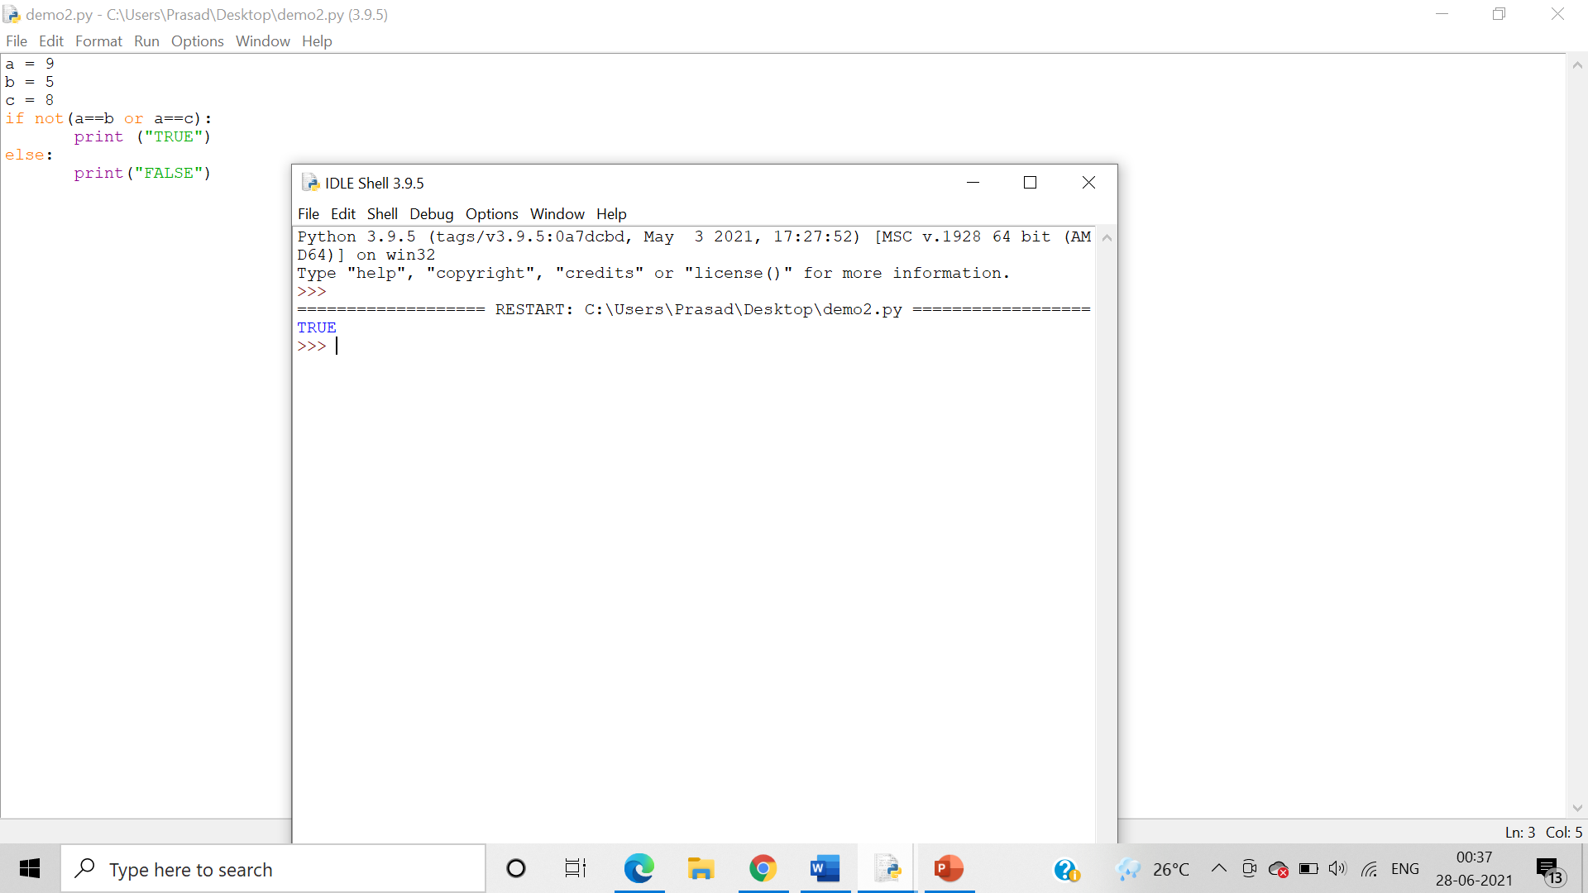

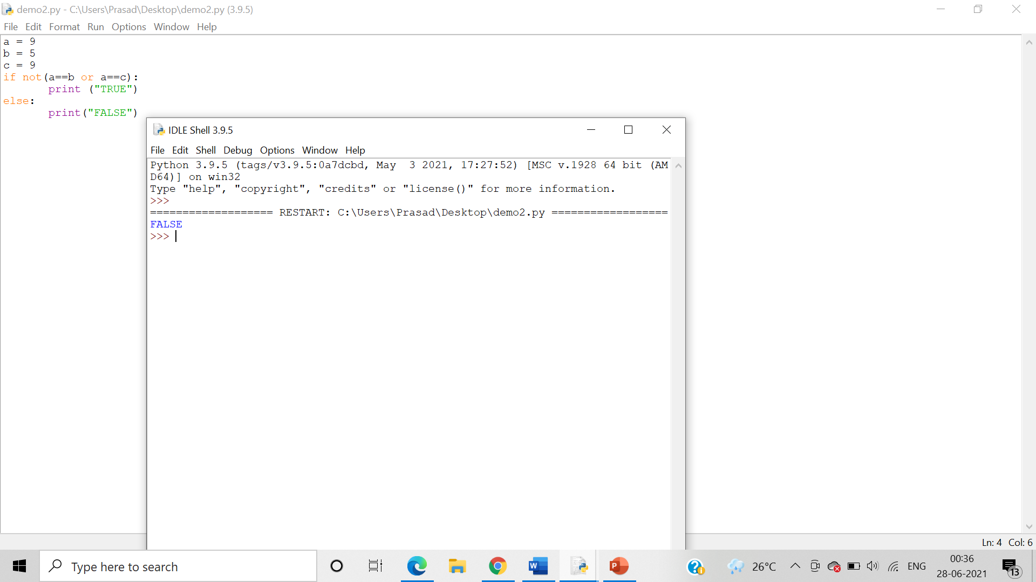

1. Membership operators

Algorithm: - The ‘in’ operator is used to check if a value exists in a sequence or not. It evaluates to true if it finds a variable in the specified sequence and false otherwise. In a NOT IN membership operator, the output evaluates to true if it does not finds a variable in the specified sequence and false otherwise.

* in

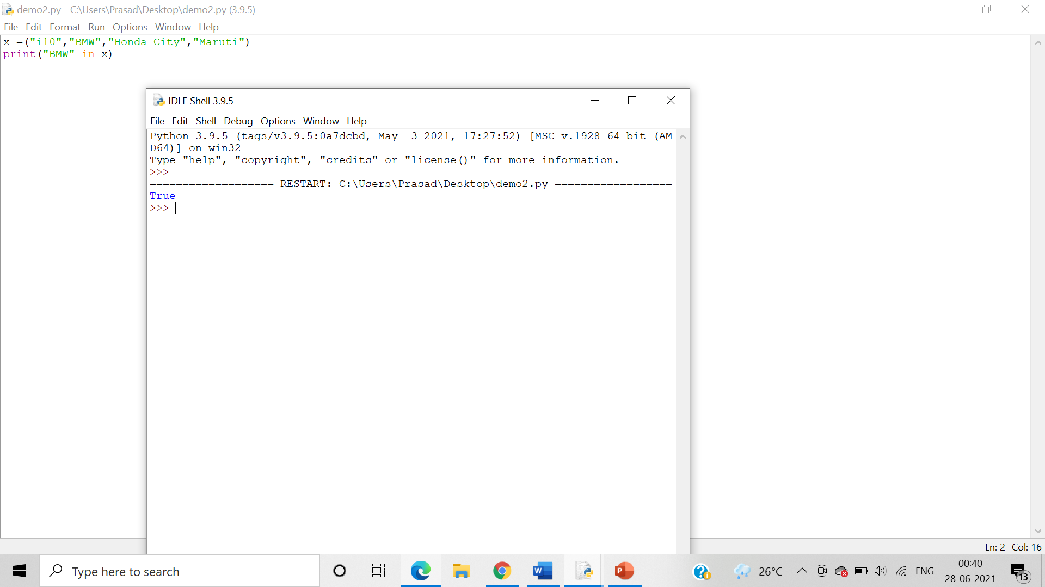

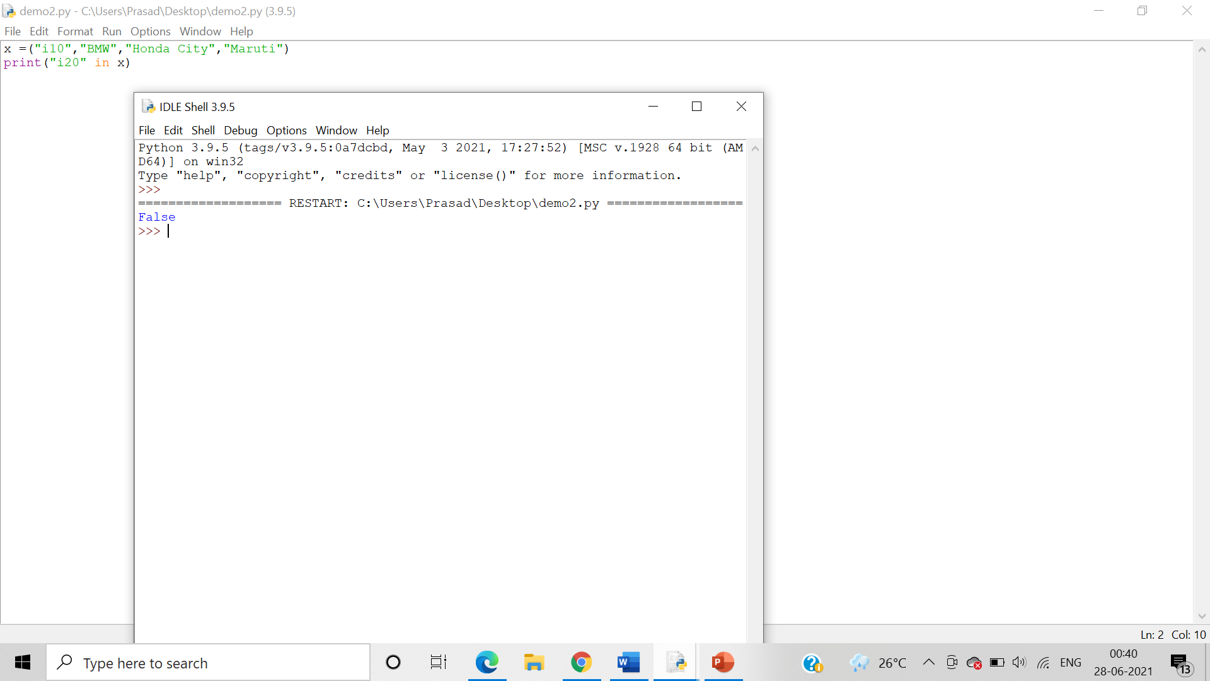

* not in

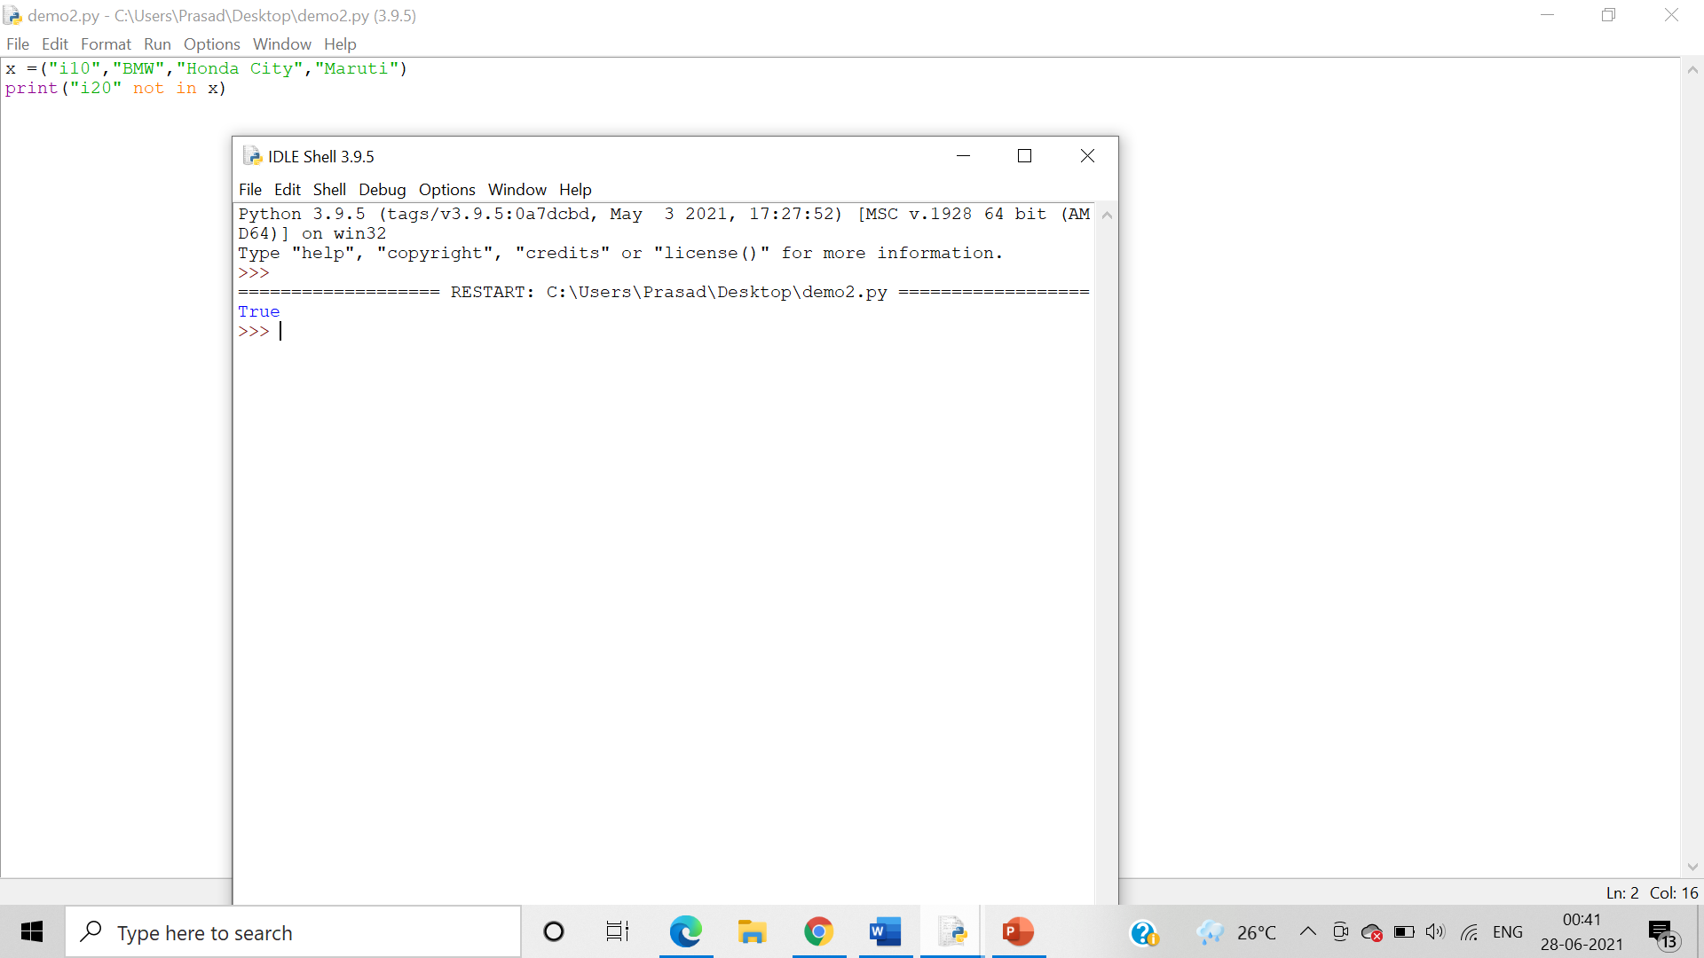

Using strings:

* in

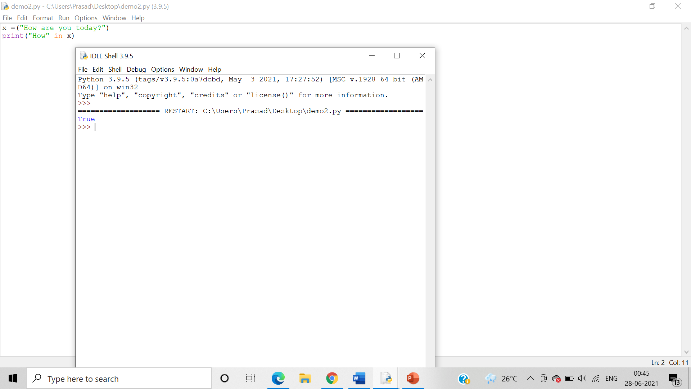

* not in

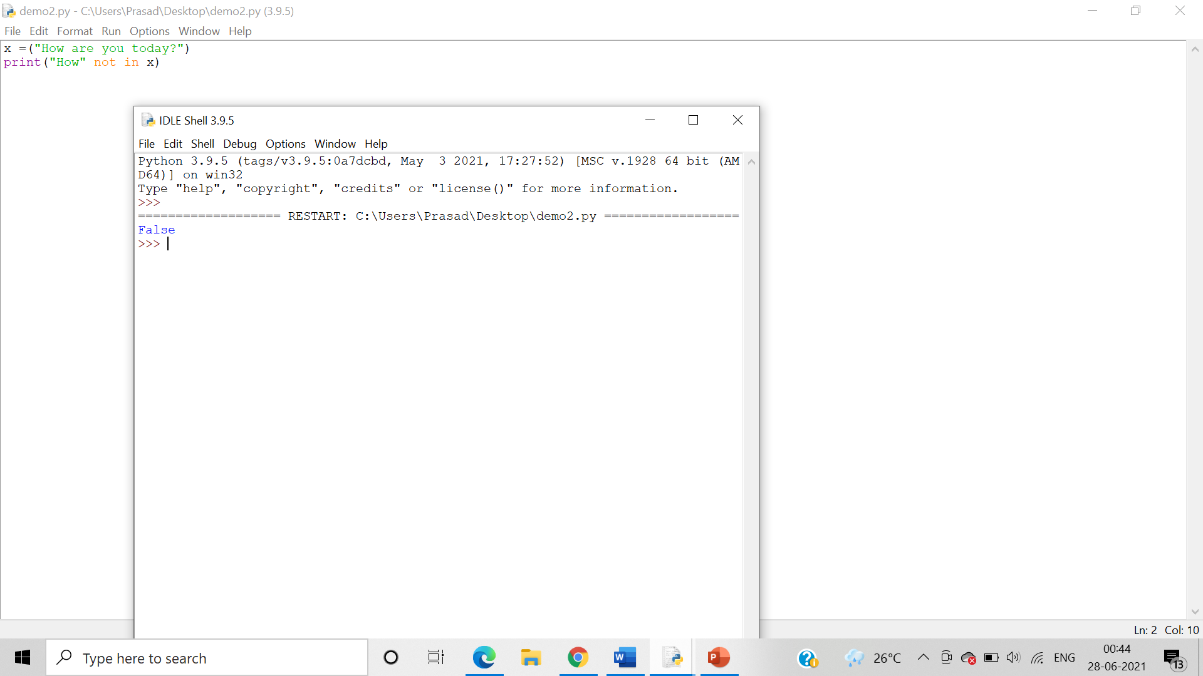

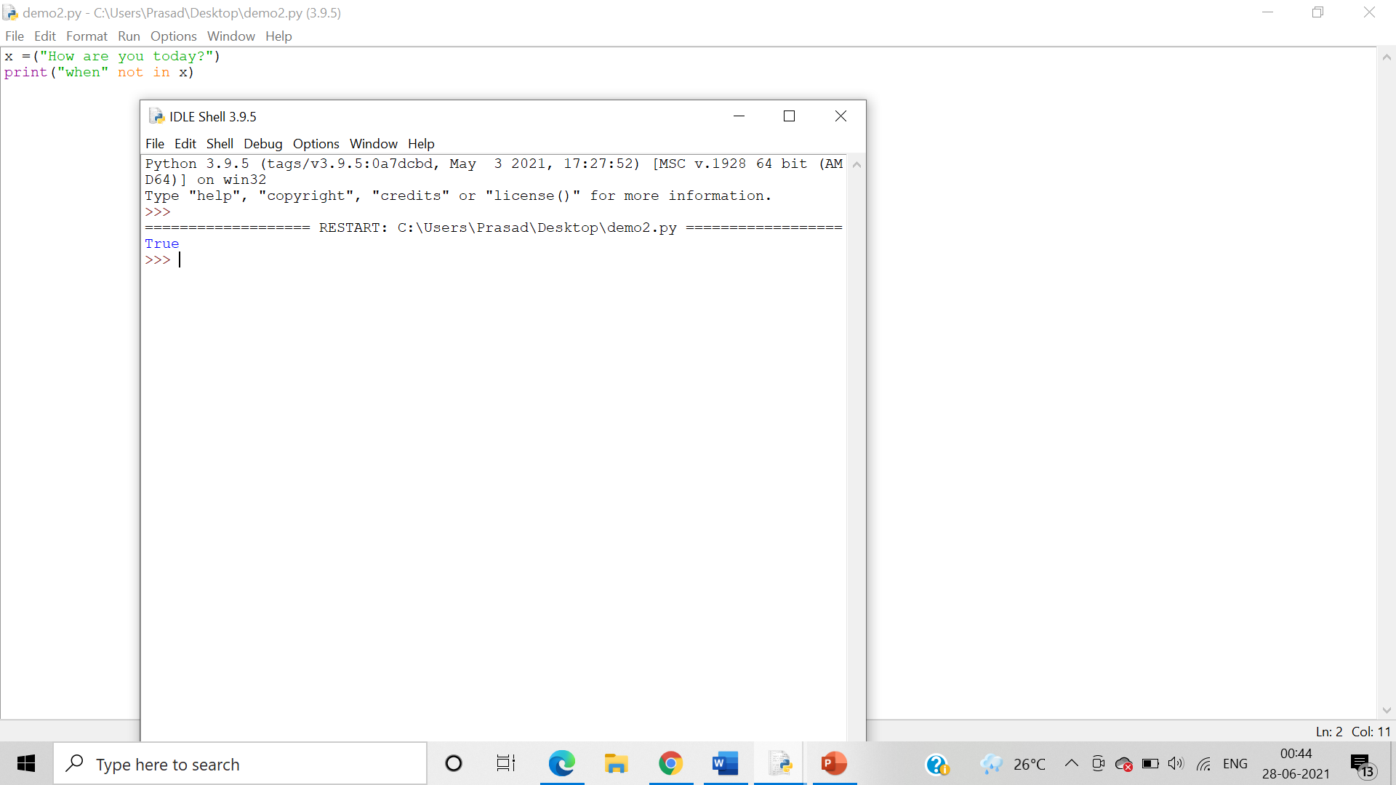

1. Identity operators

Algorithm: - In Identity operators, the IS Identity operator Evaluates to true if the variables on either side of the operator point to the same object and false otherwise. While, the IS NOT Identity operator evaluates to false if the variables on either side of the operator point to the same object and true otherwise.

* is

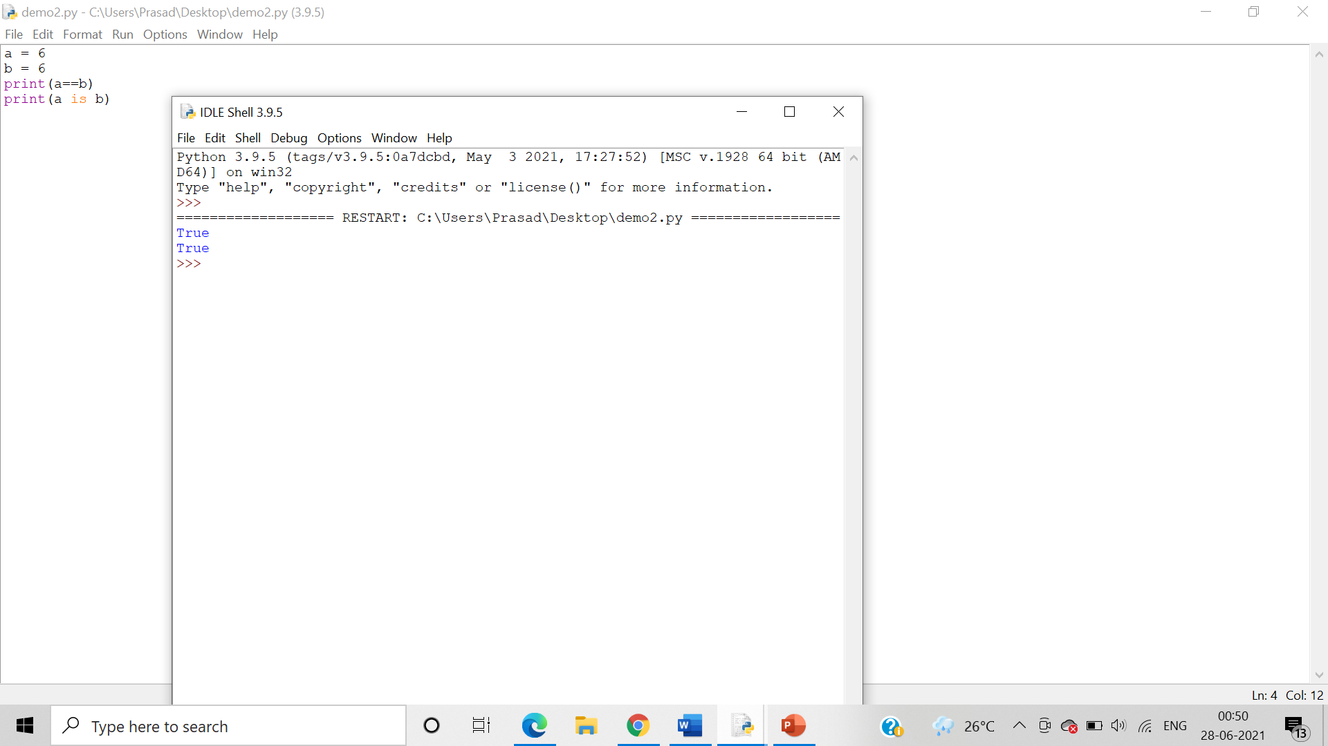

* list

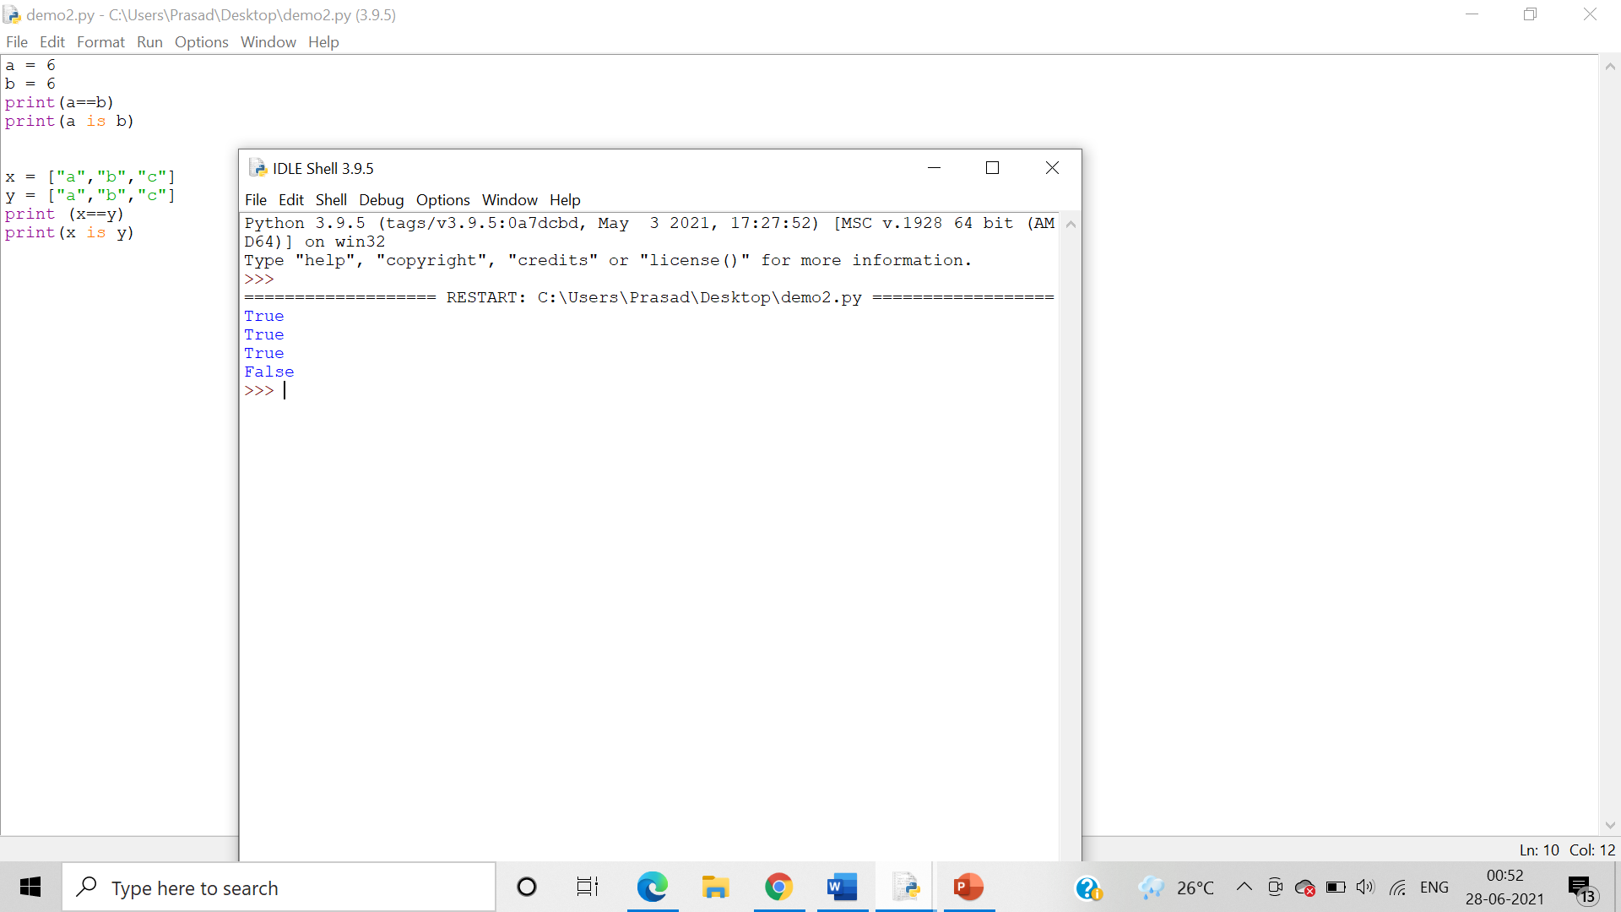

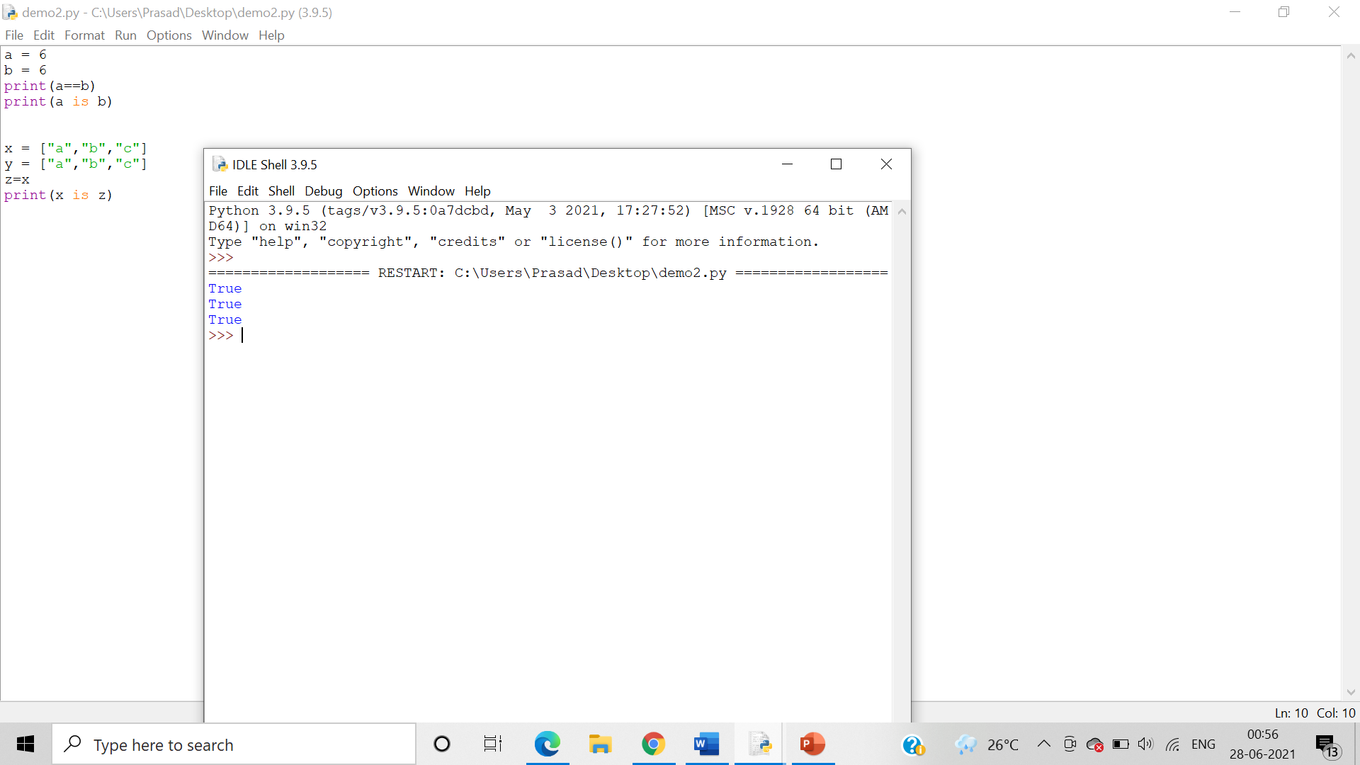

* tuple

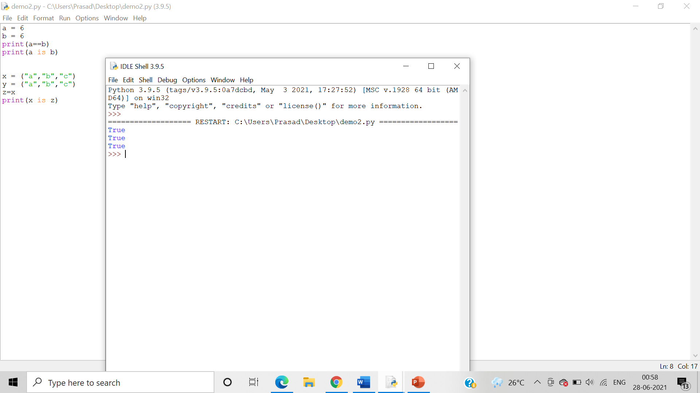

* character

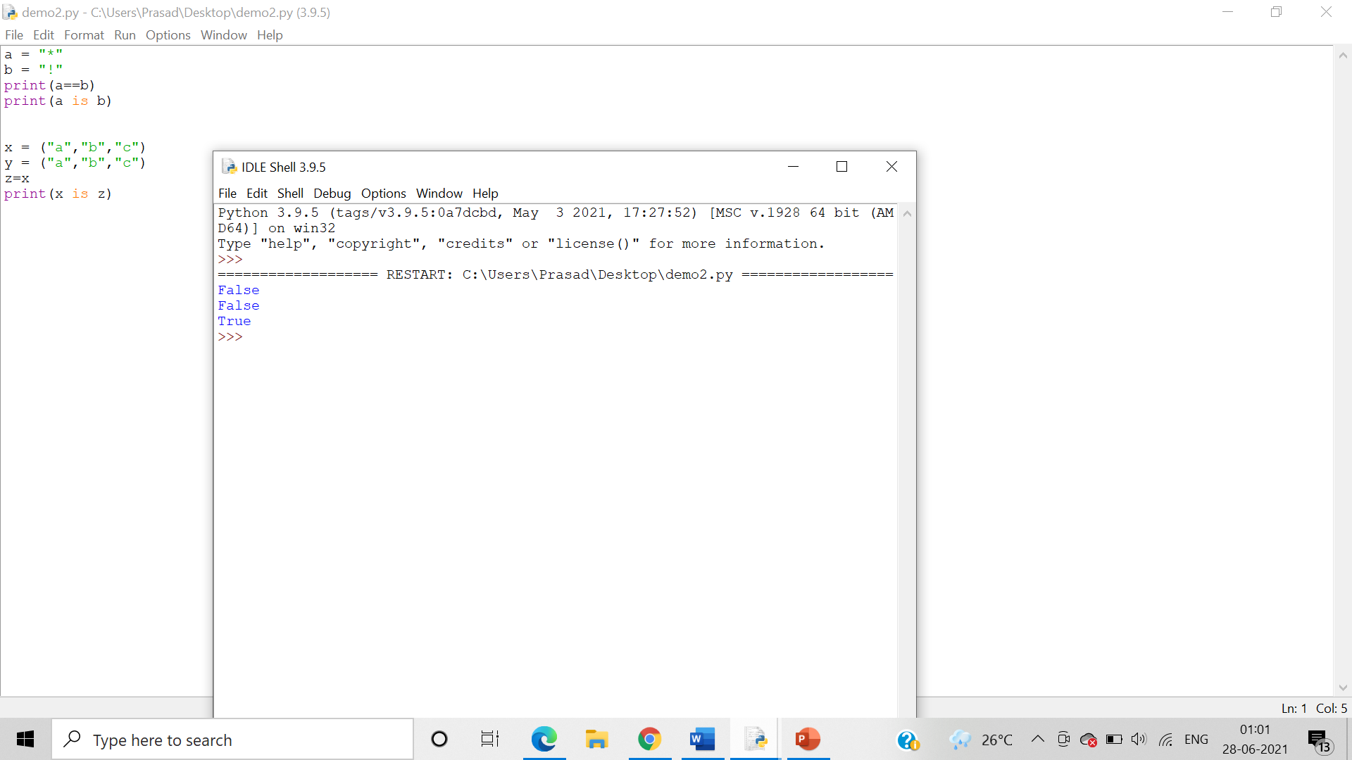

* is not

